AZ-400 Devops:

---------------------

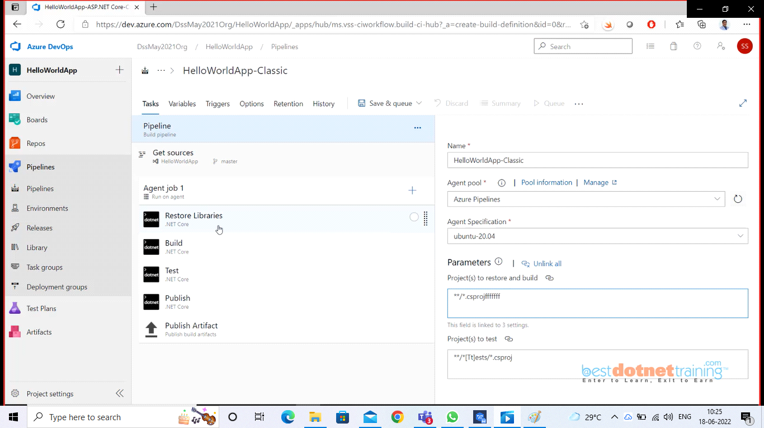

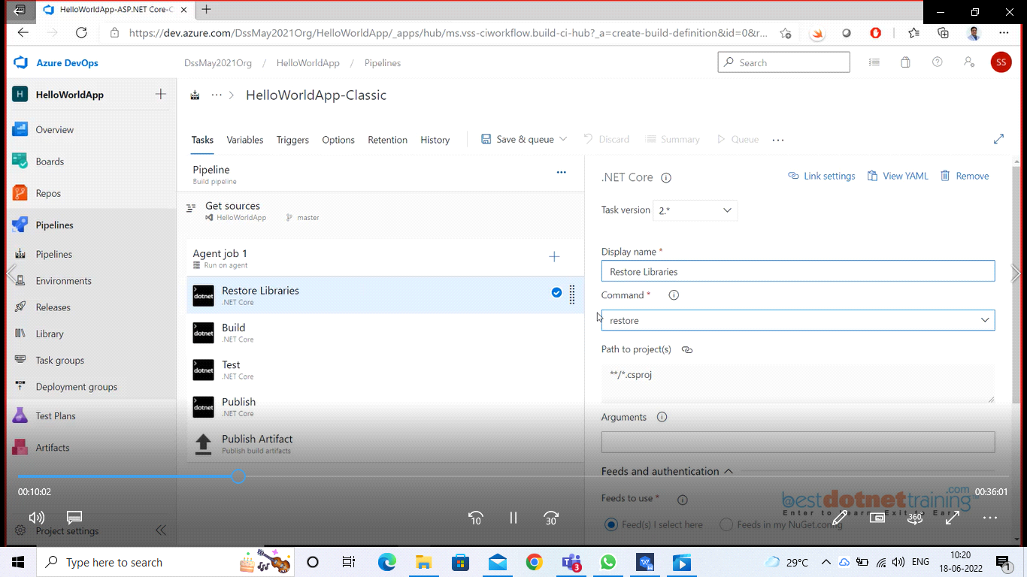

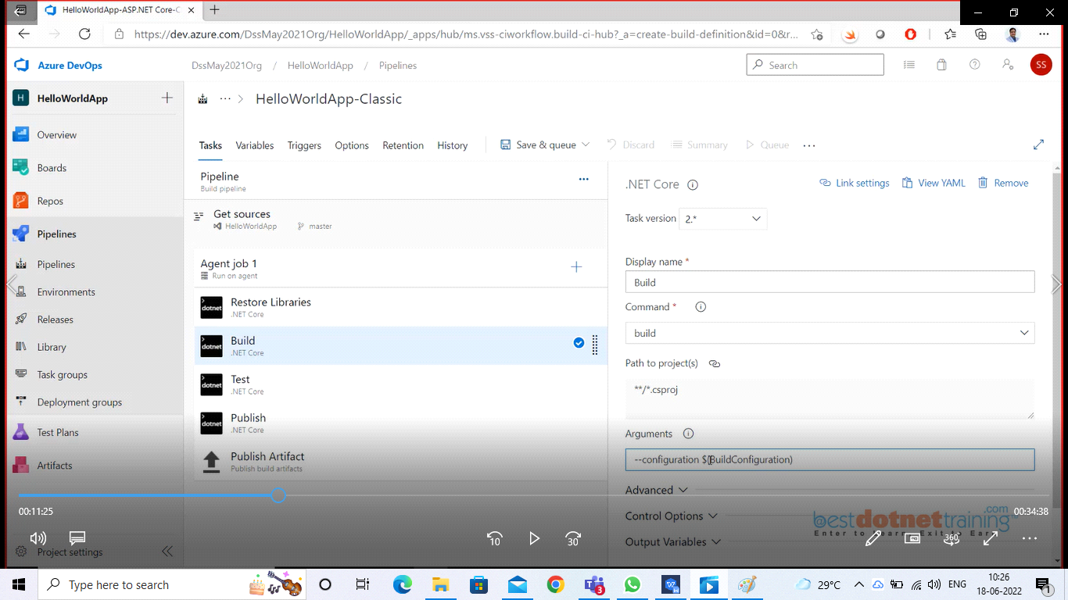

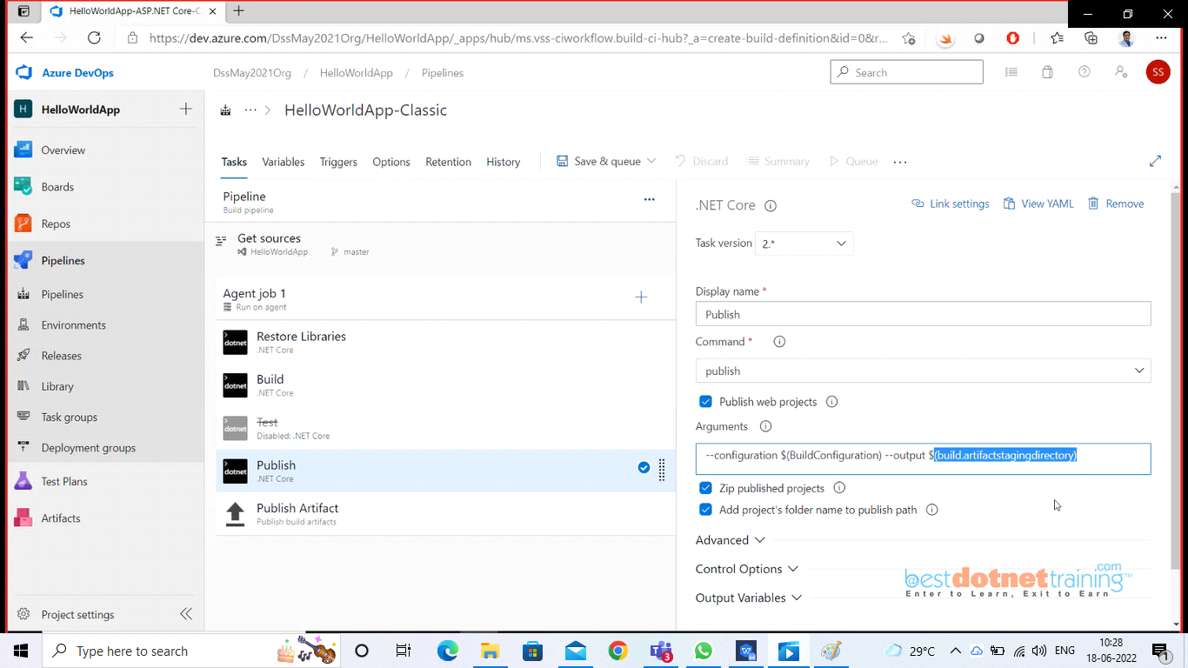

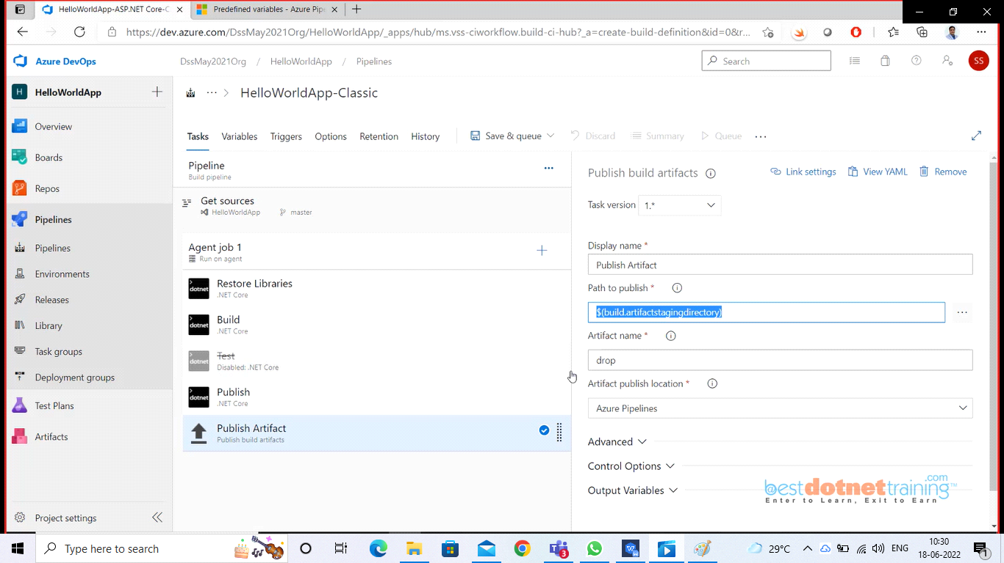

Once all the properties set for the tasks (nothing changes as of now) we are using default settings except we disabled test task. Now we will click on Save & Queue.

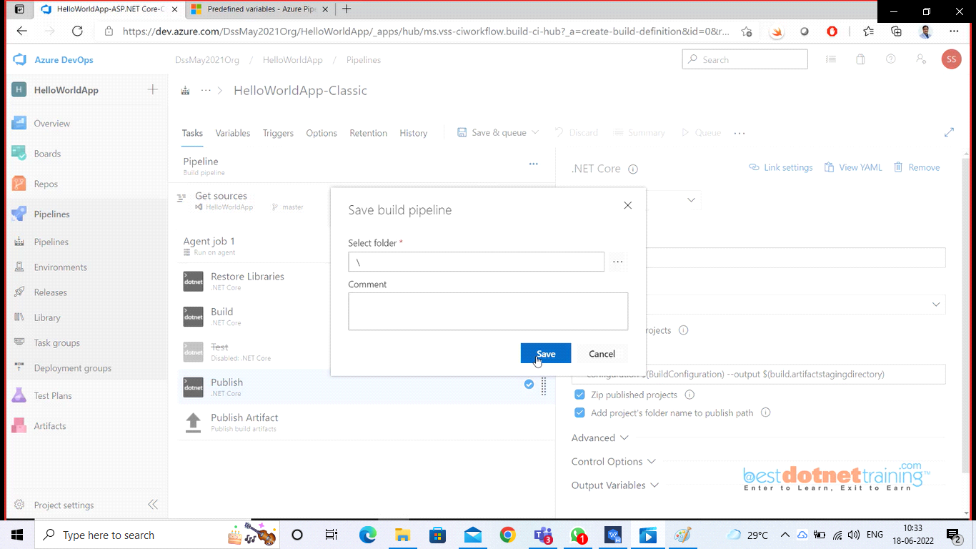

Once saved, we can only Queue the pipeline not run as below:

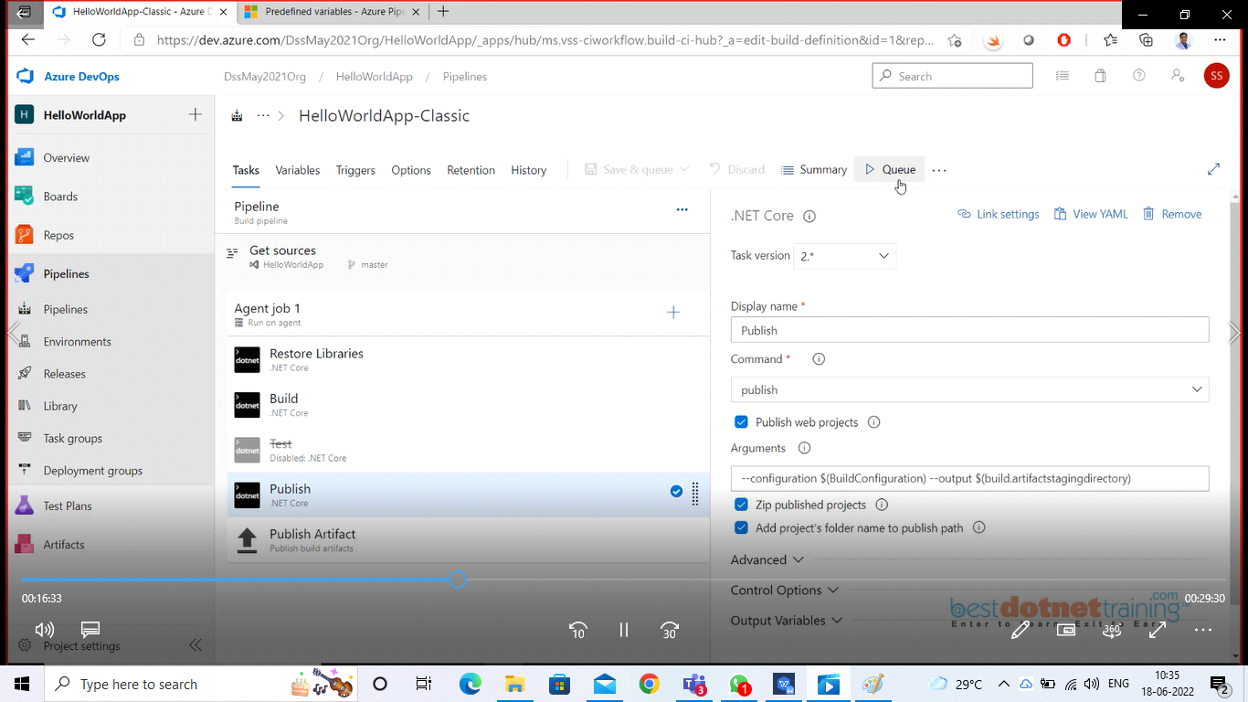

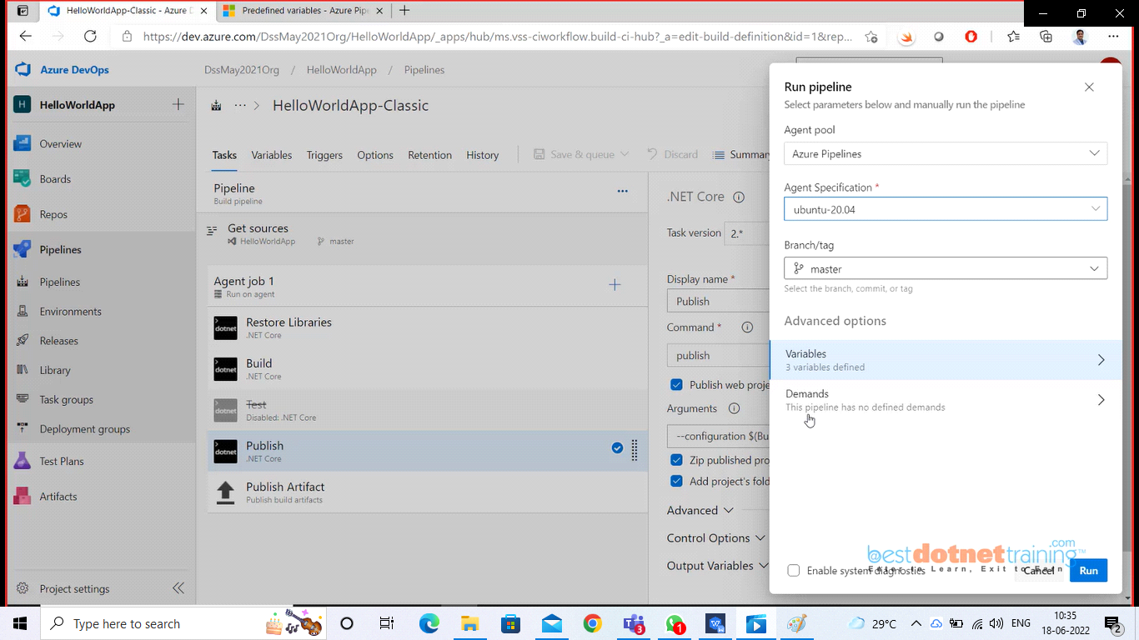

You can hit the Run button at right bottom of the page. It will queue the pipeline as below:

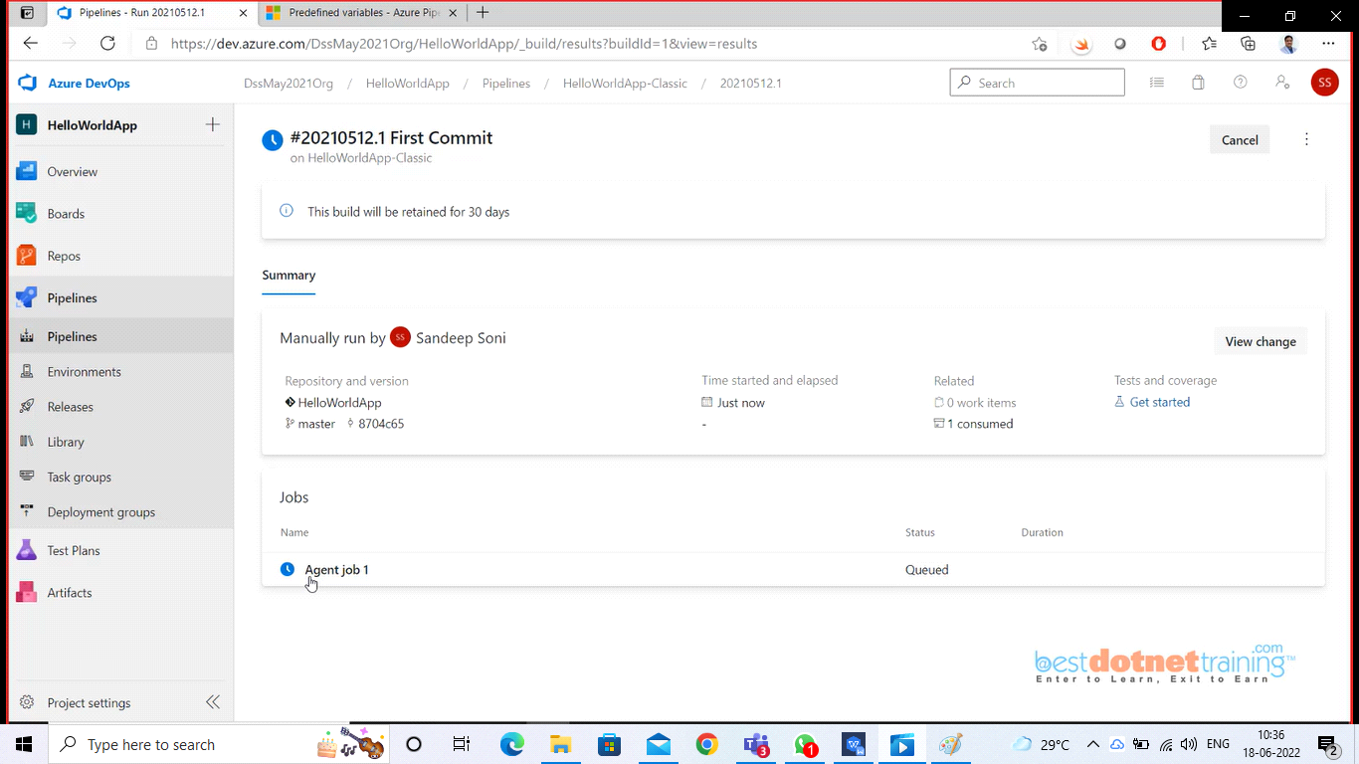

See the above image it is showing Agent job 1 as Queued. We can click on the Agent job 1

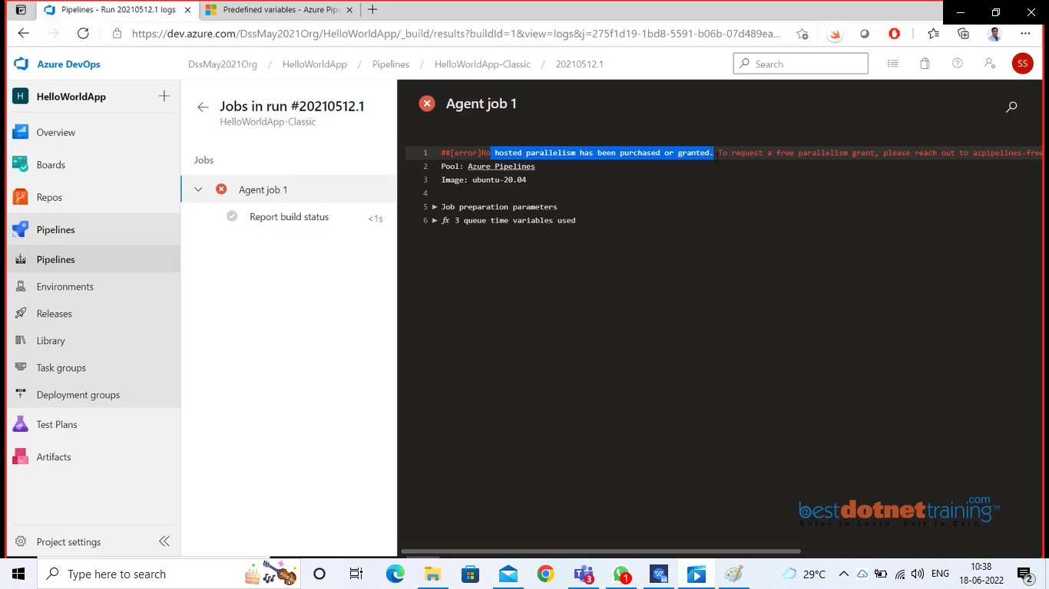

You can see one error “No hosted parallelism has been purchased or granted”. To request a free parallelism grant, please reach out to azpipelines-freetier@microsoft.com with your name and organization.

This issue is wanted created by Microsoft. Because lot of people are misusing the free microsoft hosted agent microsoft has disabled by default the ability to run the pipeline.

To check this go to your organization --> organization settings --> billing and look at parallel jobs as showing below:

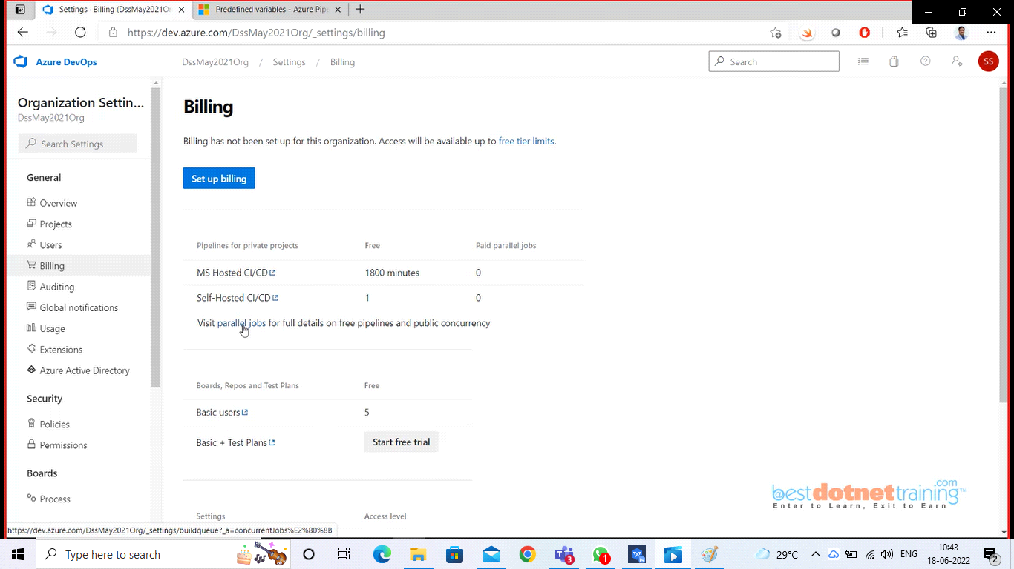

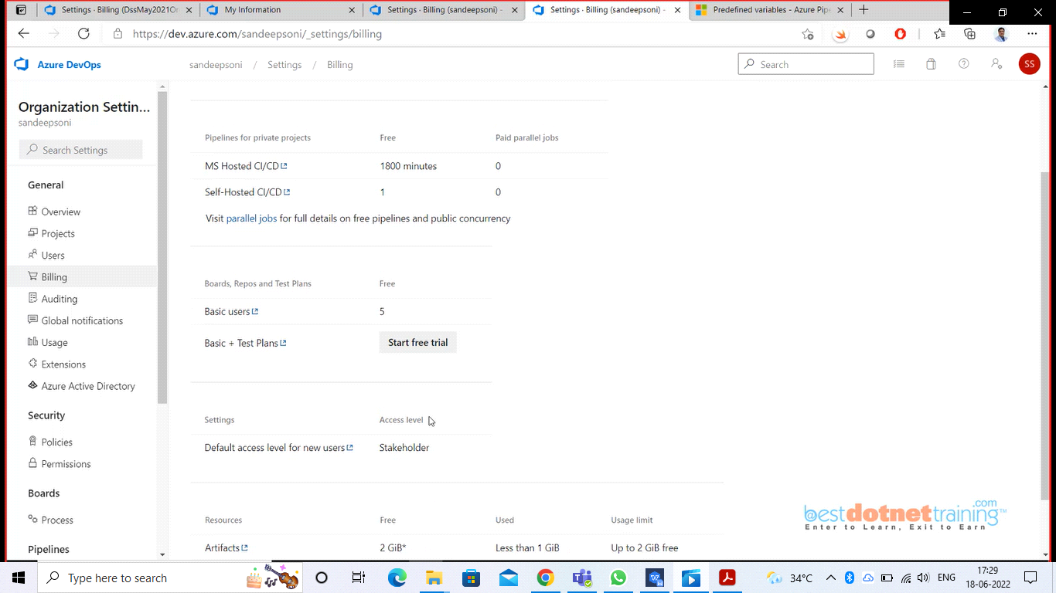

You can see for private project “0” parallel jobs and same for public “0” parallel jobs as below: now we need to either buy parallel jobs (or) send a mail to microsoft asking for parallel jobs then they will check your genuineness and might provide you parallel job. (azpipelines-freetier@microsoft.com)

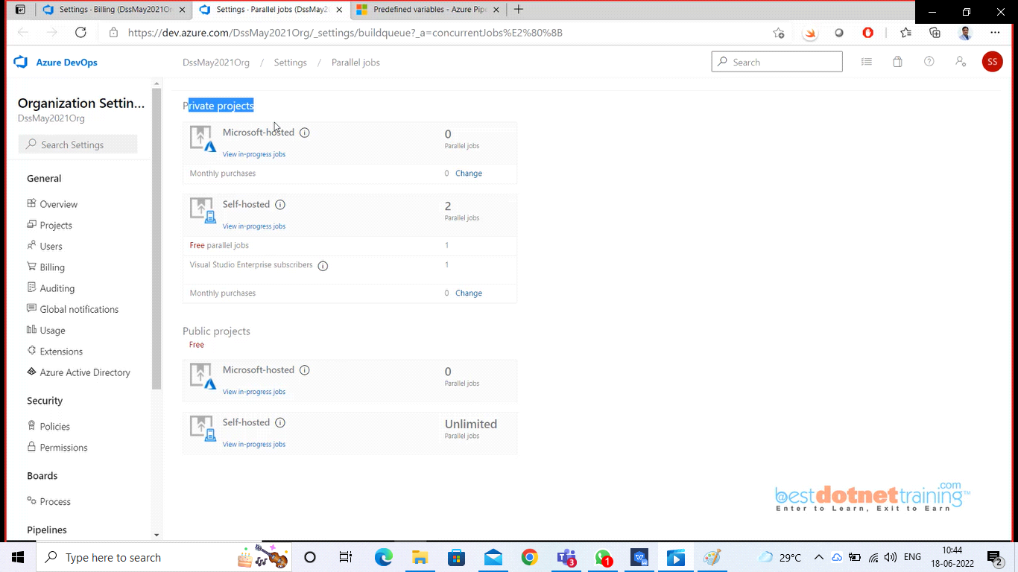

Once you get access to free parallelism jobs, you can verify as below:

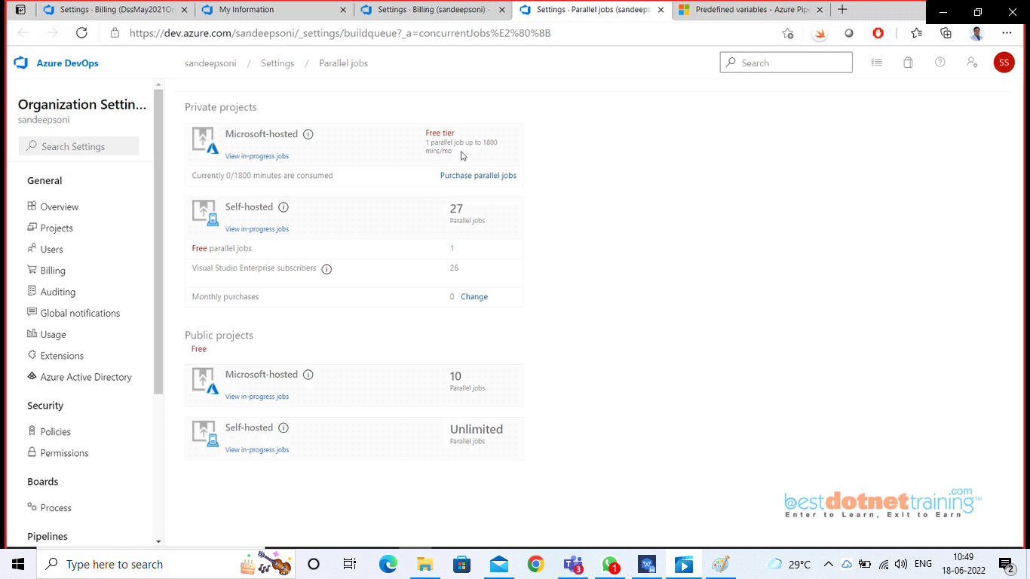

And if you run agent again you will see below screen :

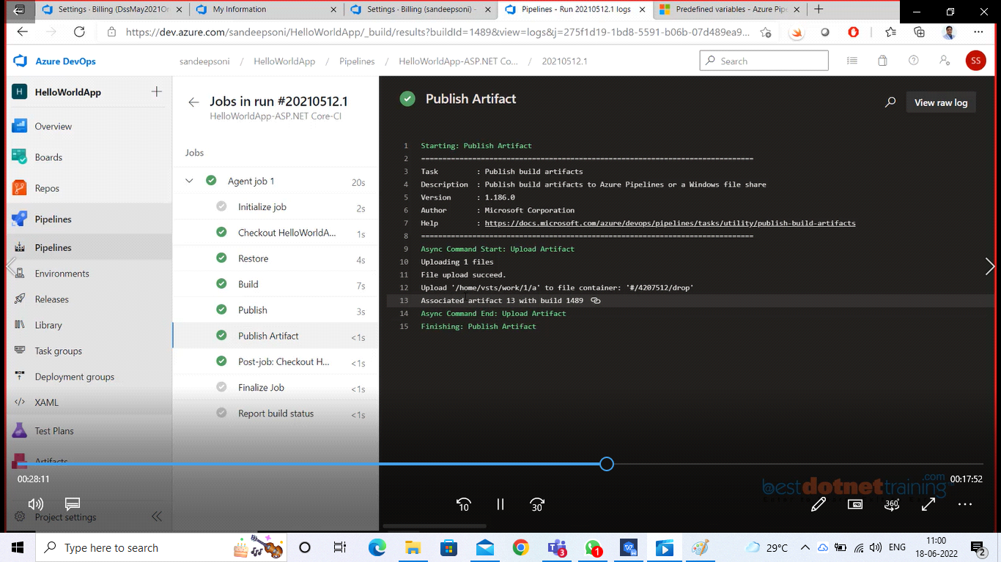

Where the artifacts are generated, you can check them from artifacts of publish task as below: you can download the generated published code also as shown below:

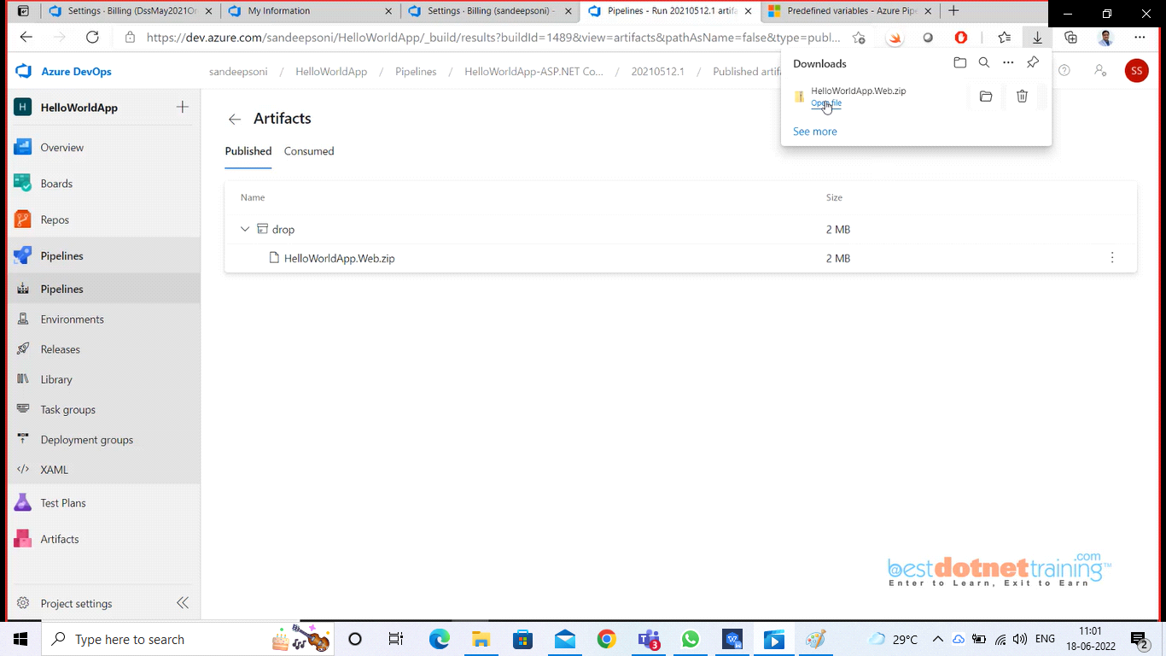

Actually, you can go to pipelines and check as below: if you run pipeline one more entry can be seen.

You can click on any run, and you will get different published code for every run. So internally azure devops is storing the artifacts.

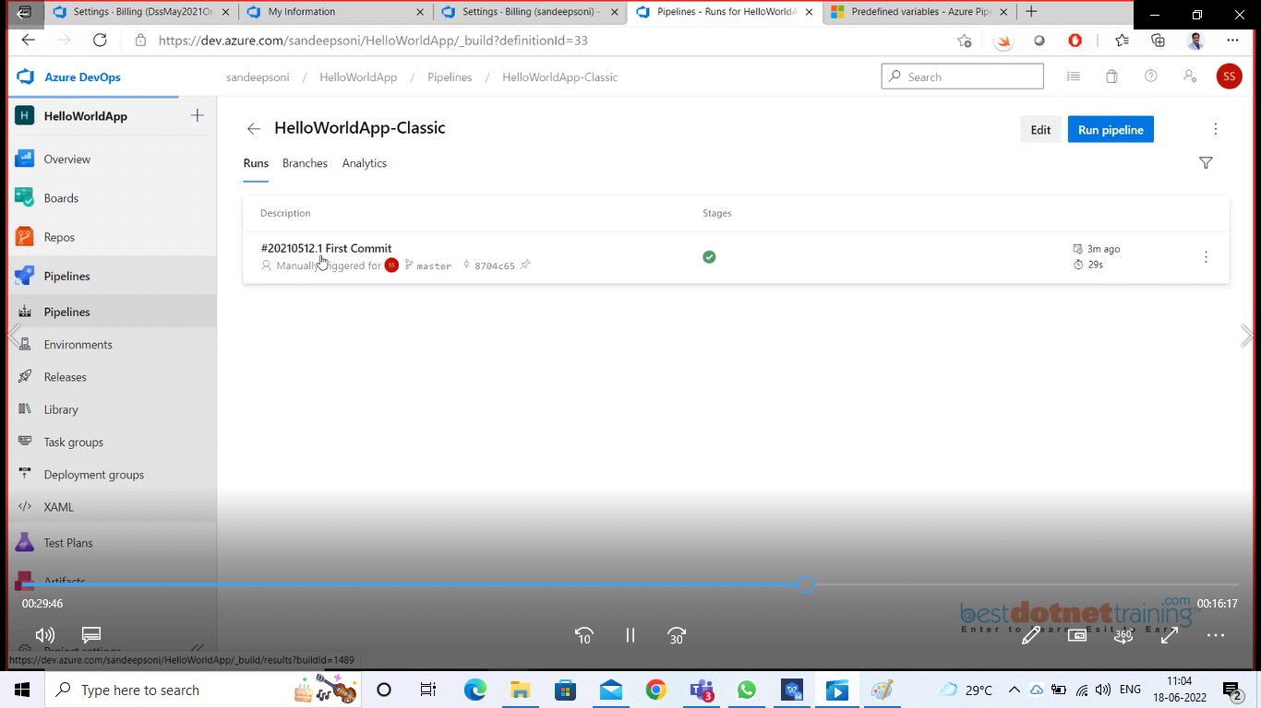

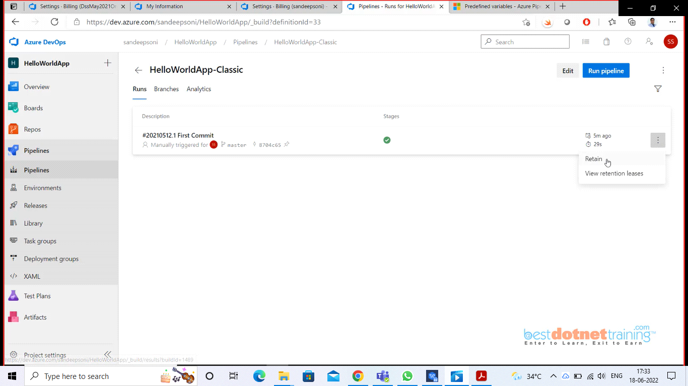

Right now, you cannot delete the run there is a policy that at least 3 Runs should be available. If you want to delete please click on “view retention leases” and you see below screen shot here you delete both the options ‘Branch policy’ and ‘Pipeline retention settings’ and if you now go back you will see delete option for the run as shown in next screen shot to below one.

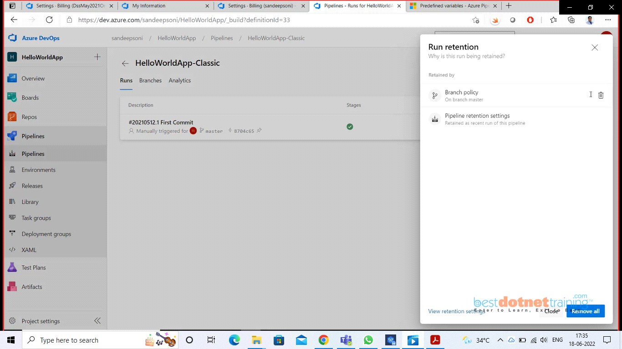

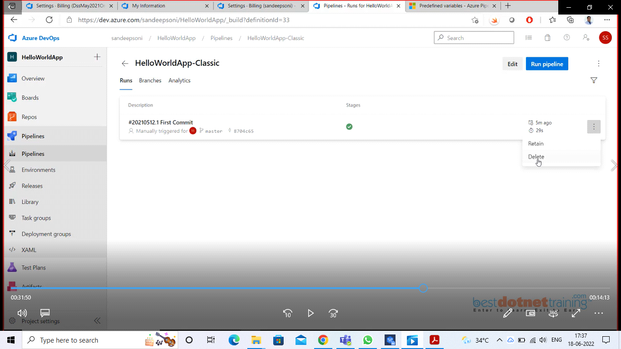

So, once the run is deleted automatically the artifact generated will also be deleted.

Now, edit the pipeline and you can add tasks here. I will add script command as shown with below option:

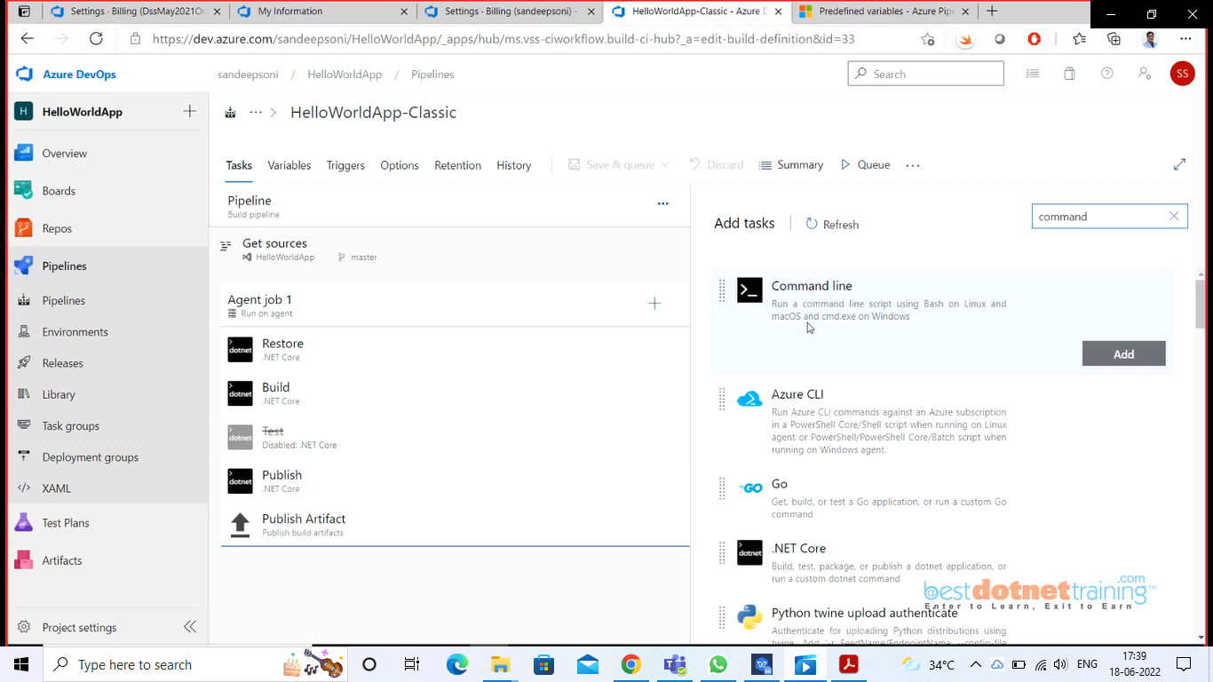

I added to print “build no, name and build id”. So for every build the 3 parameters will be printed when the run is executed:

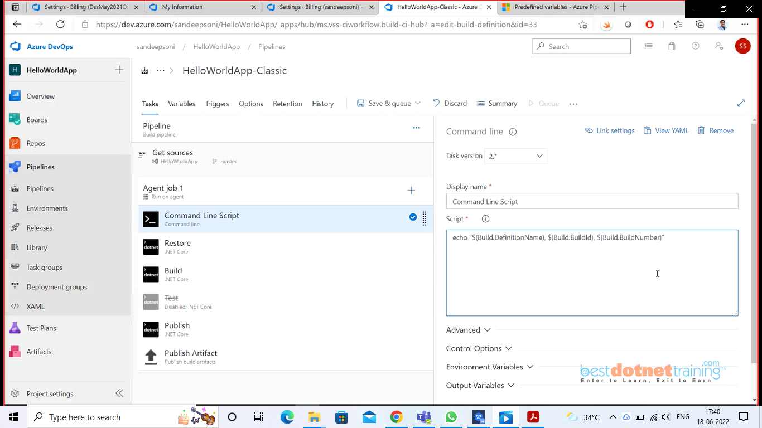

When you search for any task if it is available, we can add it to task list. If it is not available, it will install from microsoft marketplace. For example, if you try for file creator, by default it is not available,

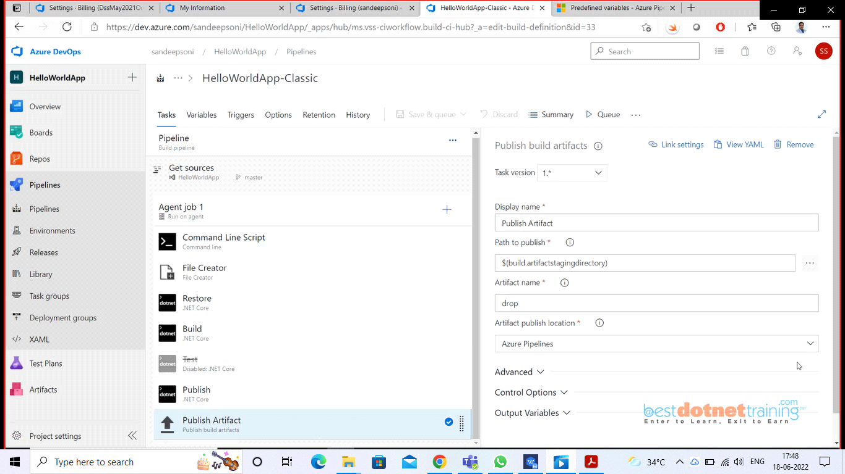

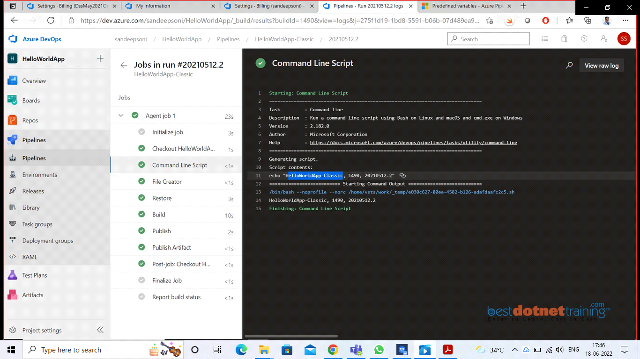

so, we added task Command Line Script and printed Name, Build Id, Build Number as highlighted in blue. Here we also have created File creator and it will be created in Artifact staging directory (/home/vsts/work/1/a/build-info.txt) which will be done by publish Artifact task. so go and check in your drop artifact under Agentjob1. just do refresh and click on Agentjob1 you see 1 artifact link click on that, which will shop drop as below:

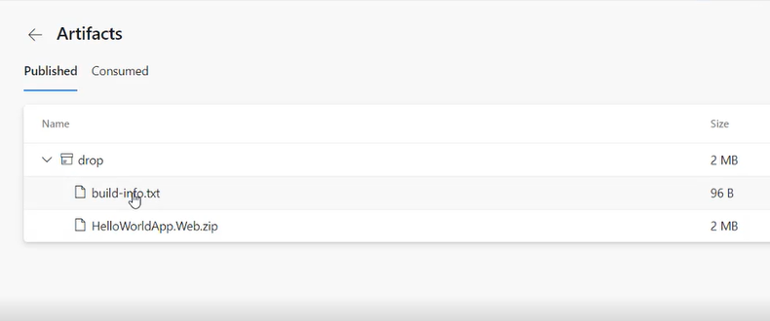

we have used default values for the tasks, now if we want to do with empty pipeline as our project is .net core, and do require value changes as shown in below screen shots with steps:

Go to pipelines and create "new pipeline" option use classic editor, choose "Empty template" and add the tasks manually we need to choose ".net core" task and rename them as 1. restore, 2. build, 3. publish

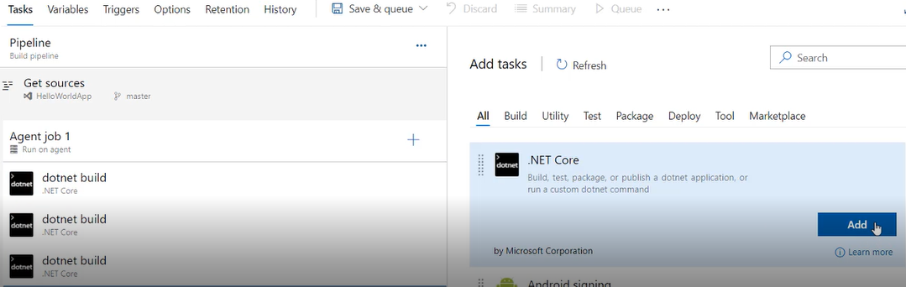

For restore, display name, command, path to project has to be changed and same way for remaining 2 options:

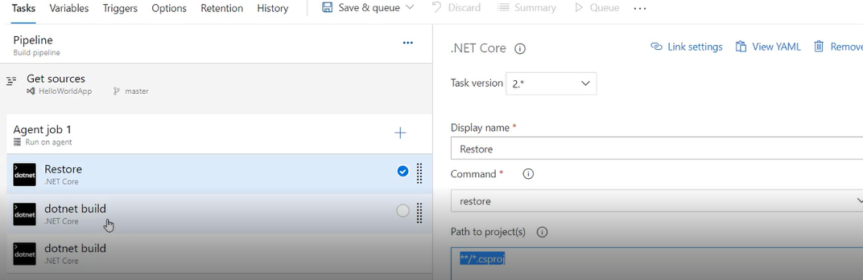

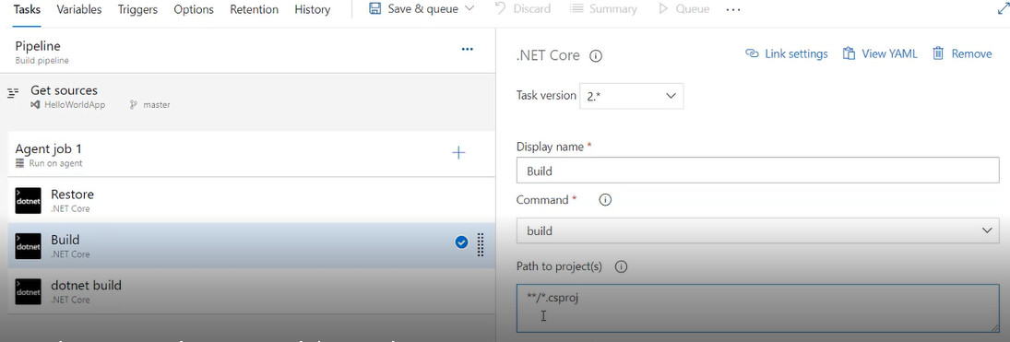

if you want to add build configuration, use below option -o (or) --output $(BuildConfiguration) as shown below and add the variable which will be under variables option as shown below:

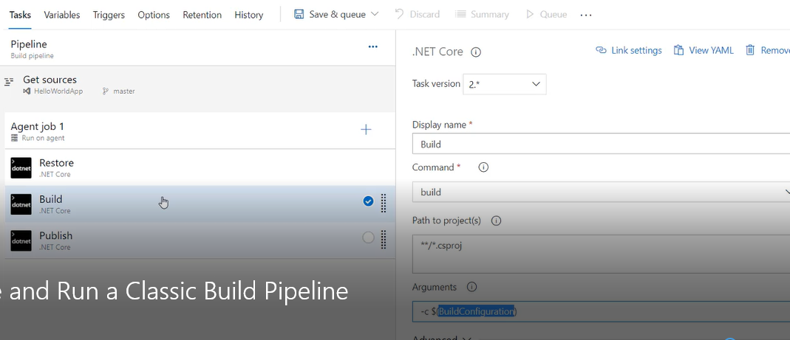

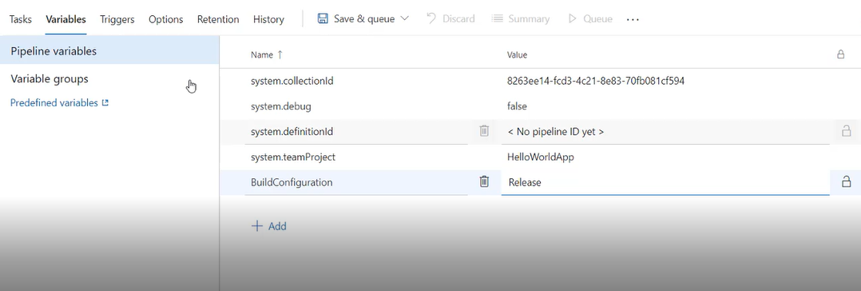

and for publish as below:

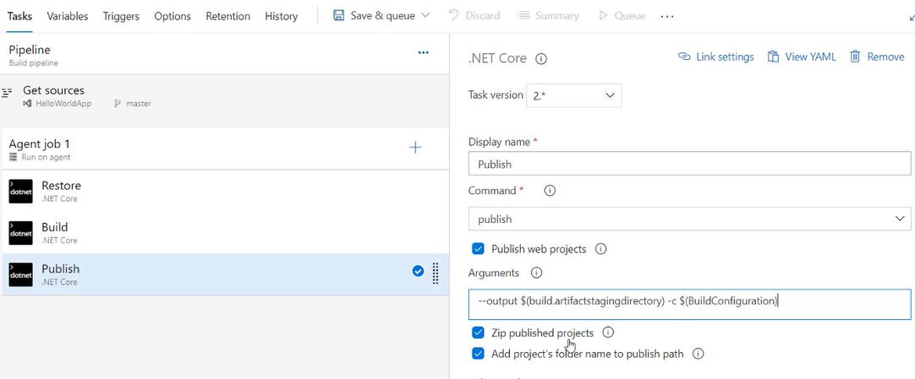

Now add one more task "Publish Build Artifact":

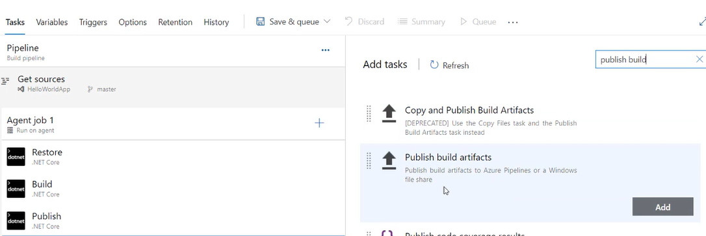

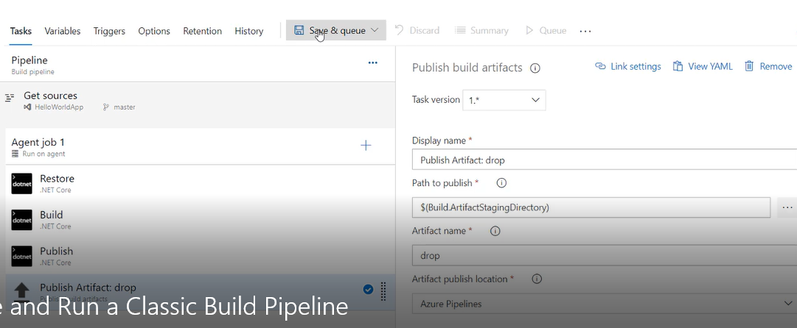

now do save & Queue, if you want to change agent click on pipeline and choose either Linux/windows. That's it your agent machine is done. you can see below from git it is checking out and finally publishing build artifacts.

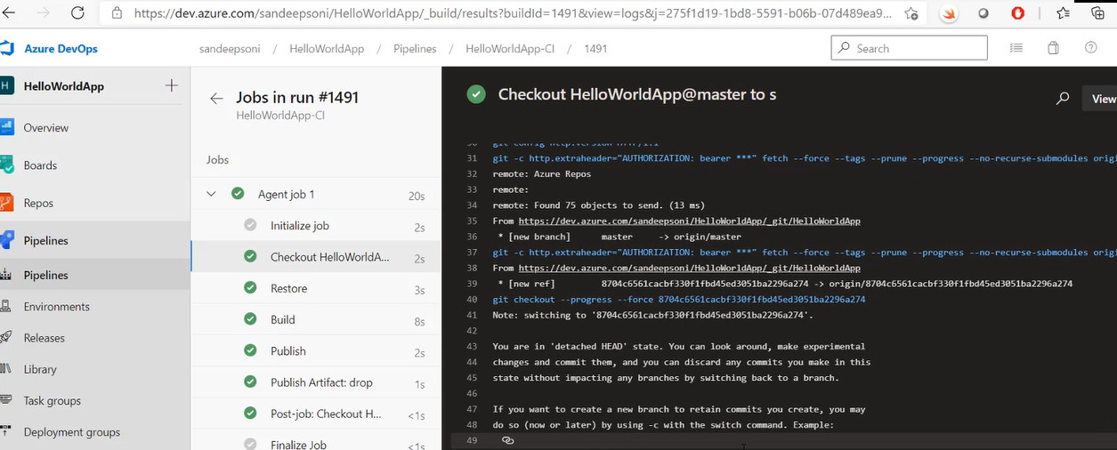

**28. Enable Continuous Integration for Build Pipeline**:

----------------------------------------------------------------------

Go to Triggers tab and click on "enable continuous integration" checkbox. once you check on this you will get some features appear as shown below 2 screens:

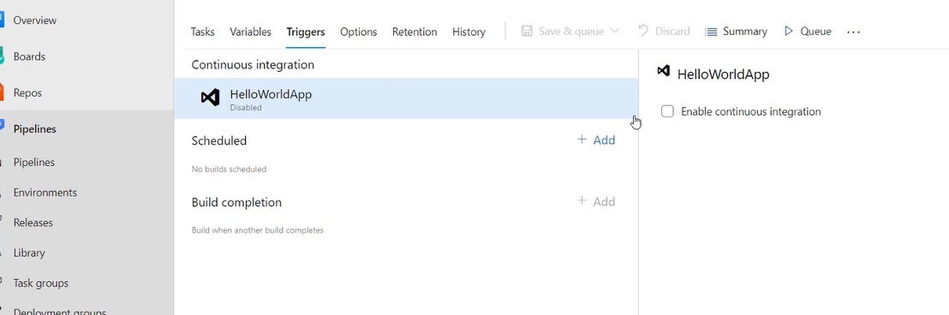

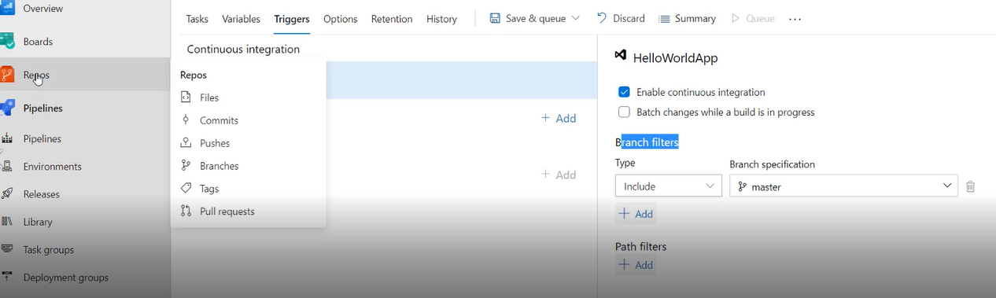

So, when this continuous integration should happen? whenever branch is master and some checkin happens it will do continuous integration same way you can add multiple filters.

similarly "path filters" are for including or excluding files to build on folder level/file level in the solution (continuous integration) like example under path filters we can choose exclude dropdown and in textbox we will specify please avoid build when changes are made to readme.txt.

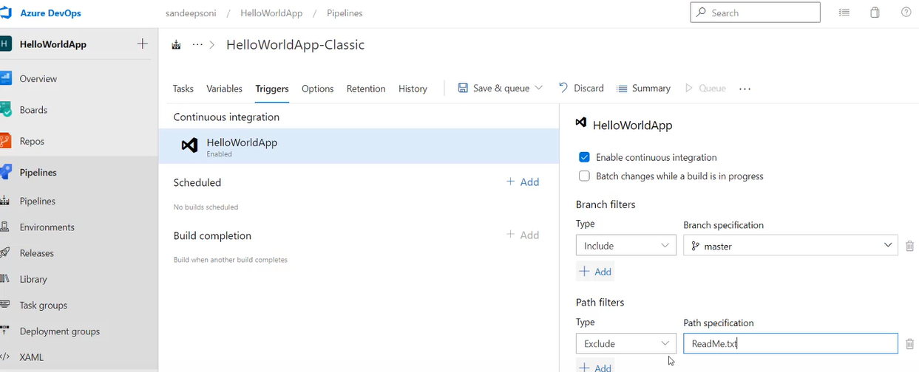

Under triggers we have one more options called "Scheduled" which is used for scheduling builds at a particular time like 12:00 a.m. (or) 3 pm. as shown below:

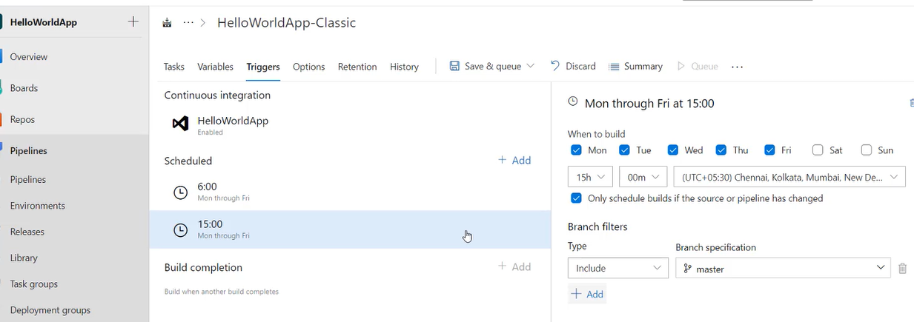

Now, one question may be asked support when a build takes place for 15 mins, then in between if someone check-in the code (example 2-time check-in) to Git then total 3 builds will happen. In order to not happen 3 separate builds, if you use the option "Batch changes while a build is in progress"(which is below "Enable continuous integration" check box) by clicking check box all the 3 builds will be done as a single build.

Note: - If you want to watch the status of the build, you can use dashboard which is under overview as shown below here you need to add widget "markdown":

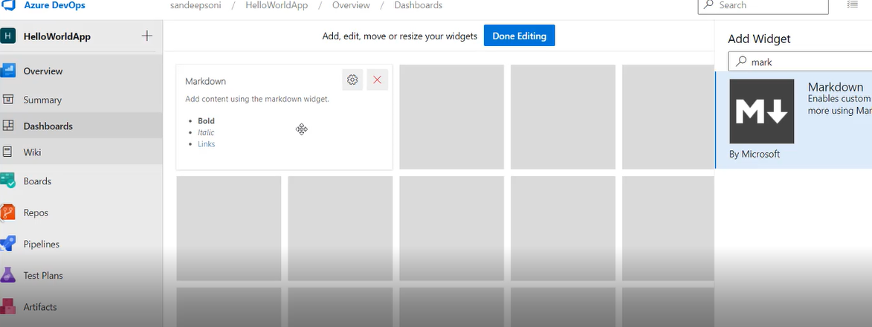

so, where do you get the text to Markdown? go to pipelines --> Edit --> under options --> under status badge --> copy URL of Markdown as below:

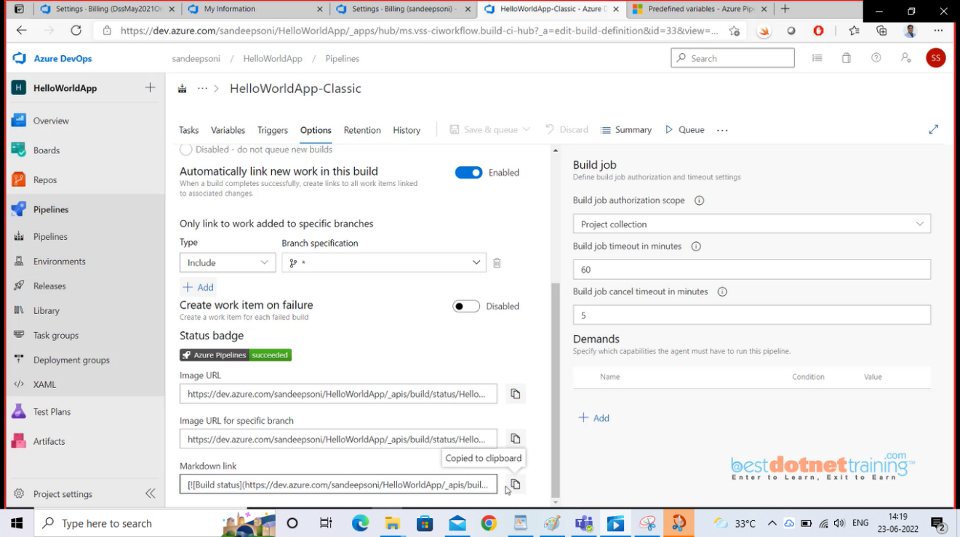

After copying go to settings select markdown and copy the URL into Custom markdown text area as shown below: then this build status will be shown up on dashboard itself.

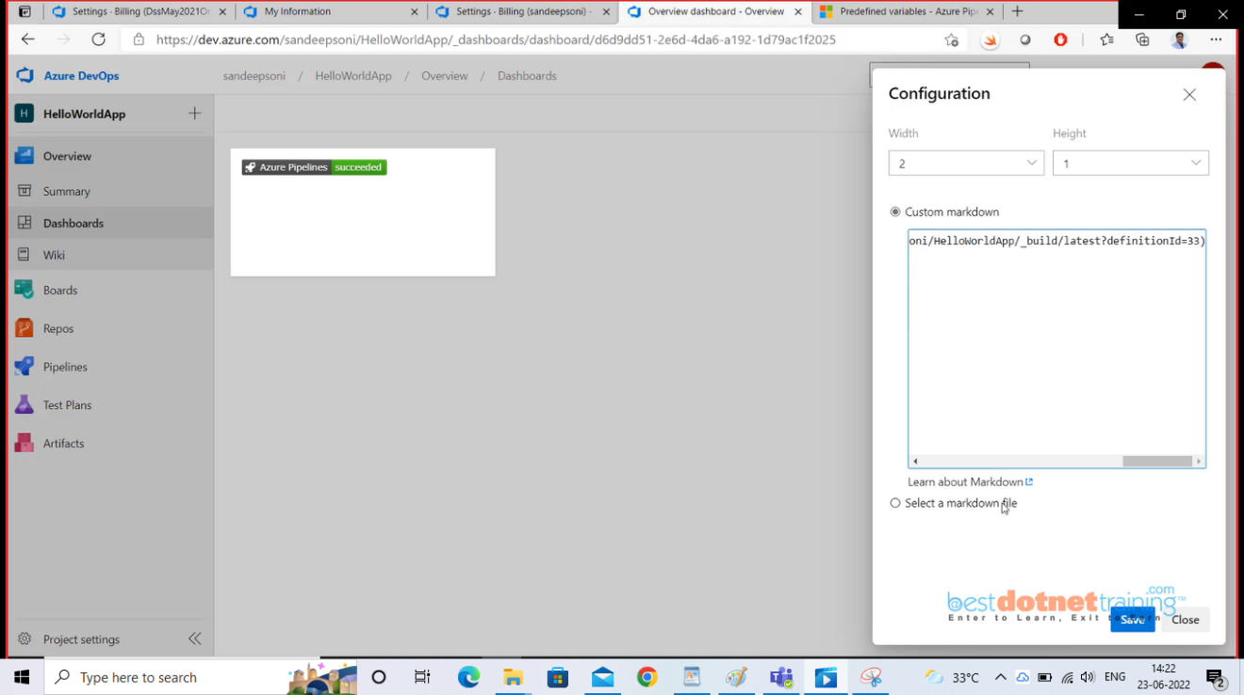

Note:- suppose if we make any error in a page and check-in the build starts and build will get failed.

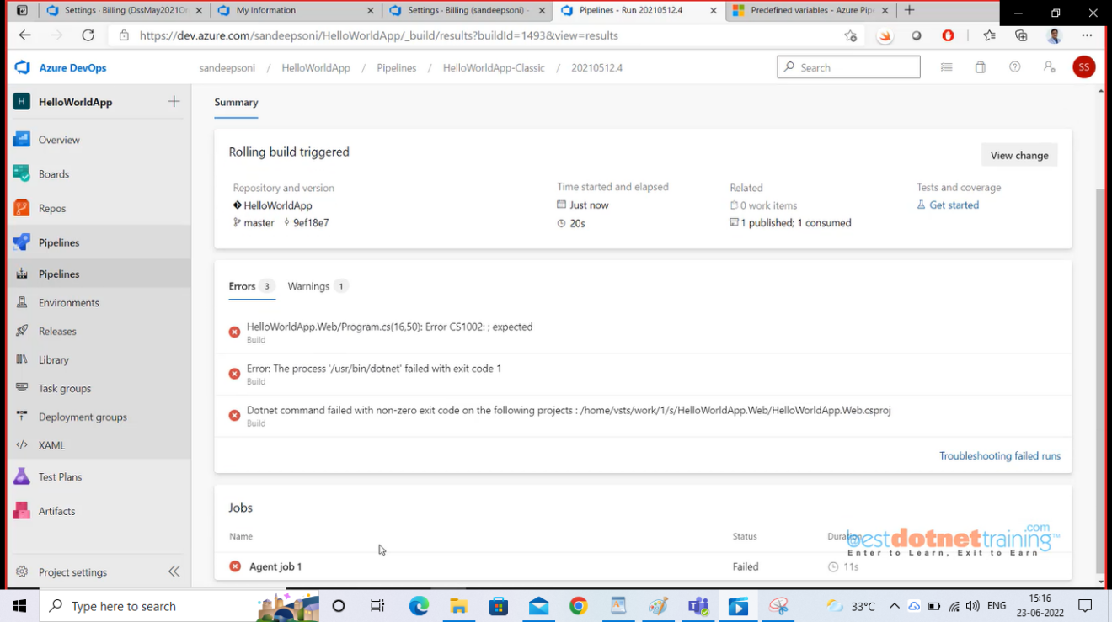

so, to trouble shoot the error, go to Agent job 1 under jobs as shown above:

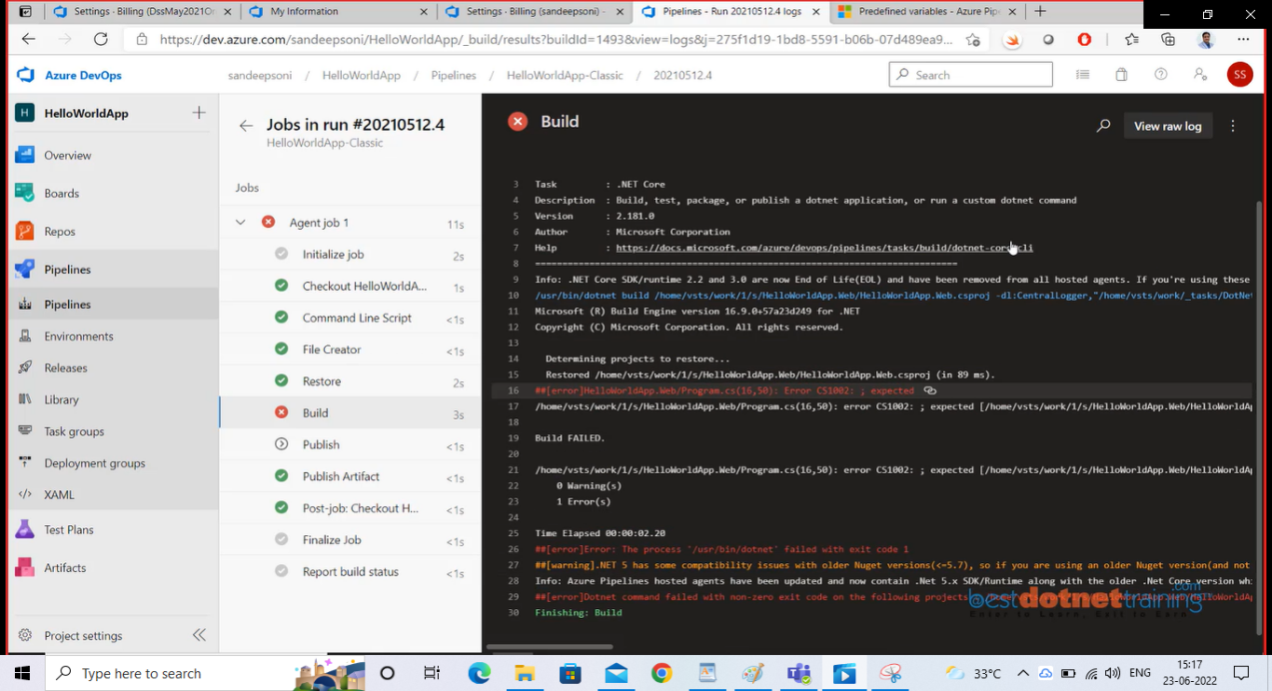

clearly here Build is showing error when you click you can read the errors, you can click on "view raw" log on right top to see in plain text and the error will be there.

Here above screen shot even though Build got failed, how did "Publish Artifact" has executed? for this there is an option as shown below: "Run this task" even a previous task has failed. even if the build was cancelled.

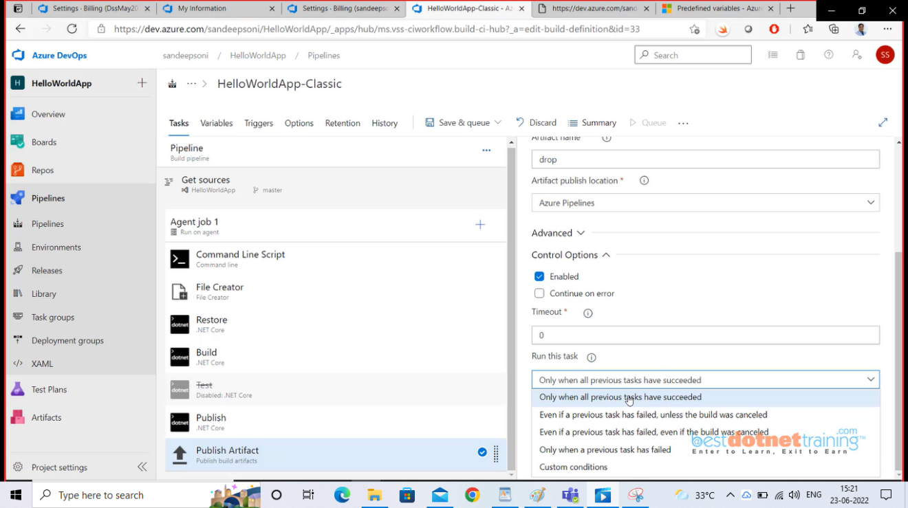

Note:- Under options tab, there is an option to disable the pipeline as shown below in order to stop the build automation(Also Paused option --> which will not run the build):

Also "Build number format" which manually we can set if we do not want default format.

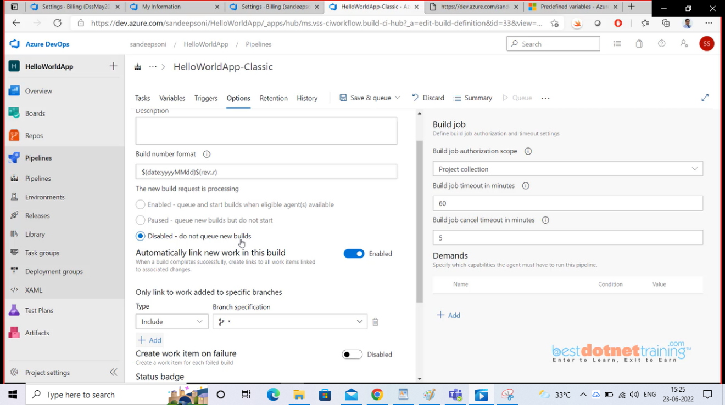

29. Working with Task Group in Classic Build Pipeline:

-----------------------------------------------------------------

"Task Group" is nothing but grouping the individual tasks for example: Restore & build task can be grouped and to do that we should unlink any linked properties like here "**/*.csproj" which is linked to main pipeline and when we change this property value it will reflect in main pipeline also so we need to unlink on both restore & build (path to project(s) click on link symbol which will unlock). Now chose both the tasks (restore & build) and select create task group option:

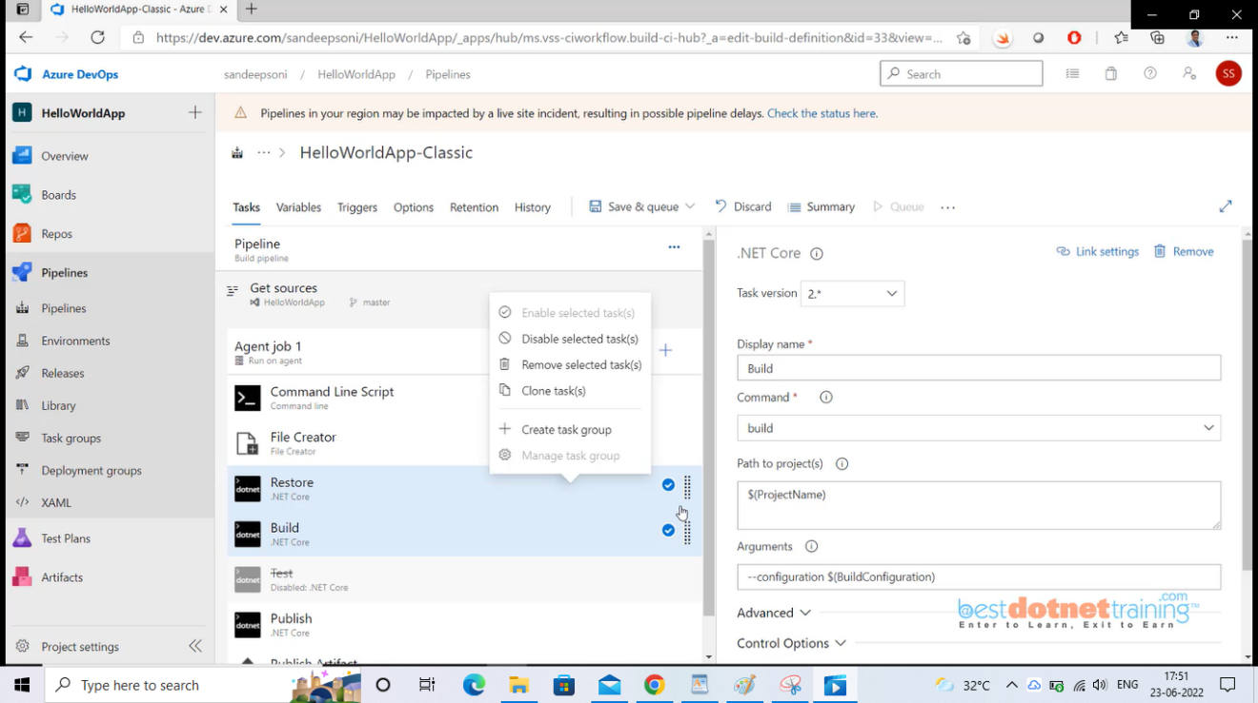

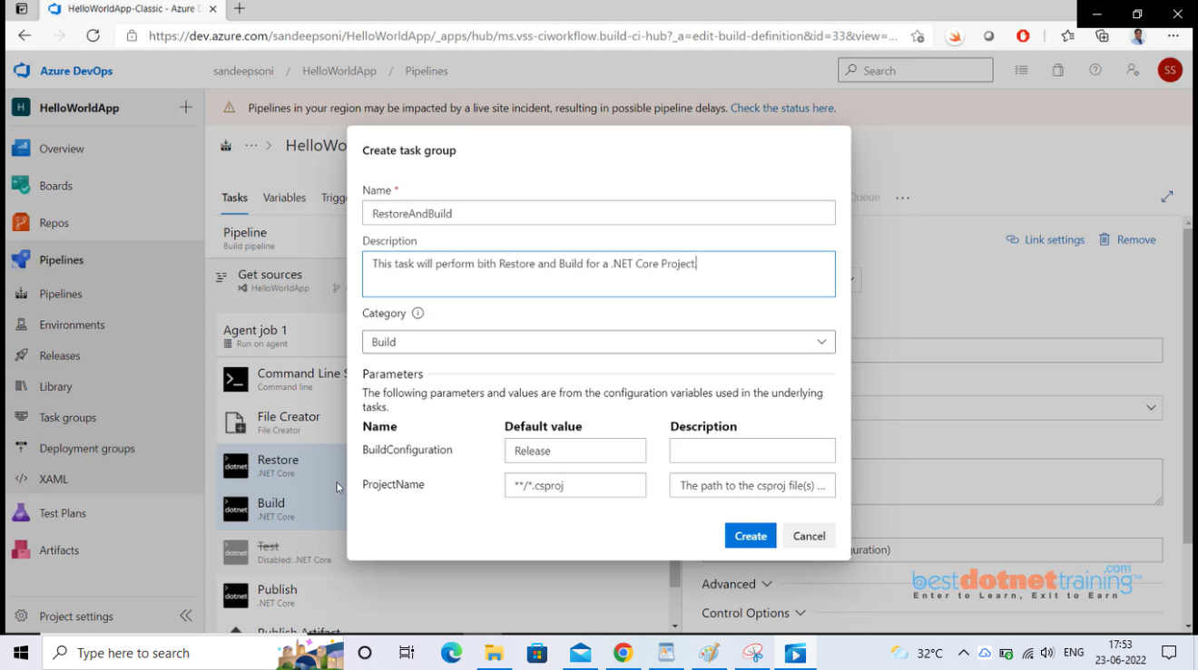

Now we can see task group is showing up instead of restore & build as below:

Also, we can see them independently under task group navigation. you can also export this task group which will be in json format and use in other projects. to do this, click on task group and click on import option and chose the exported json file that's it.

Note: - The way we provide input to the task group is through parameters and how these parameters are created are based on the original task variables they are automatically populated under task group's parameter section.

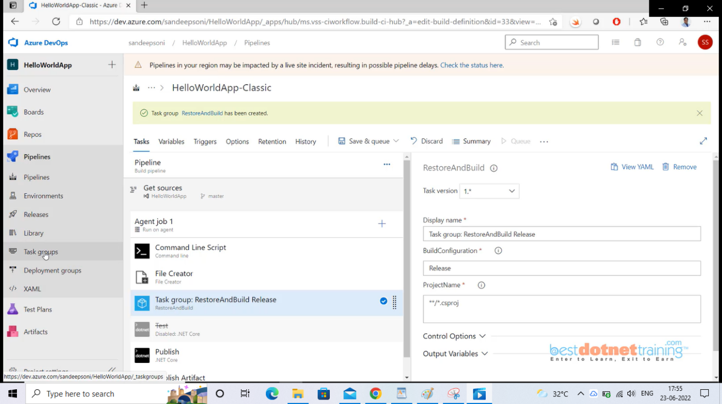

**Folder 5: Continuous Integration using YAML Pipeline:**

=========================================================

1. **How to Create and Run a Basic YAML Pipeline:**

-------------------------------------------------------------------

YAML (Yet Another Markup Language)

YAML is supporting below 4 type of source controls only as of now and doesn’t support SVN & Other Git: Actually, YAML is replacement for JSon. YAML is space-based syntax.

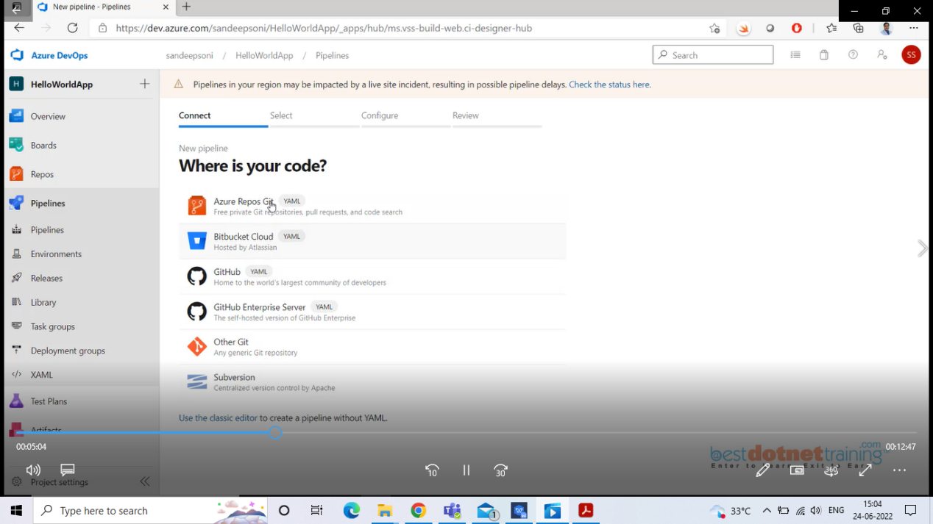

Choose repository ( using Azure Repos Git):

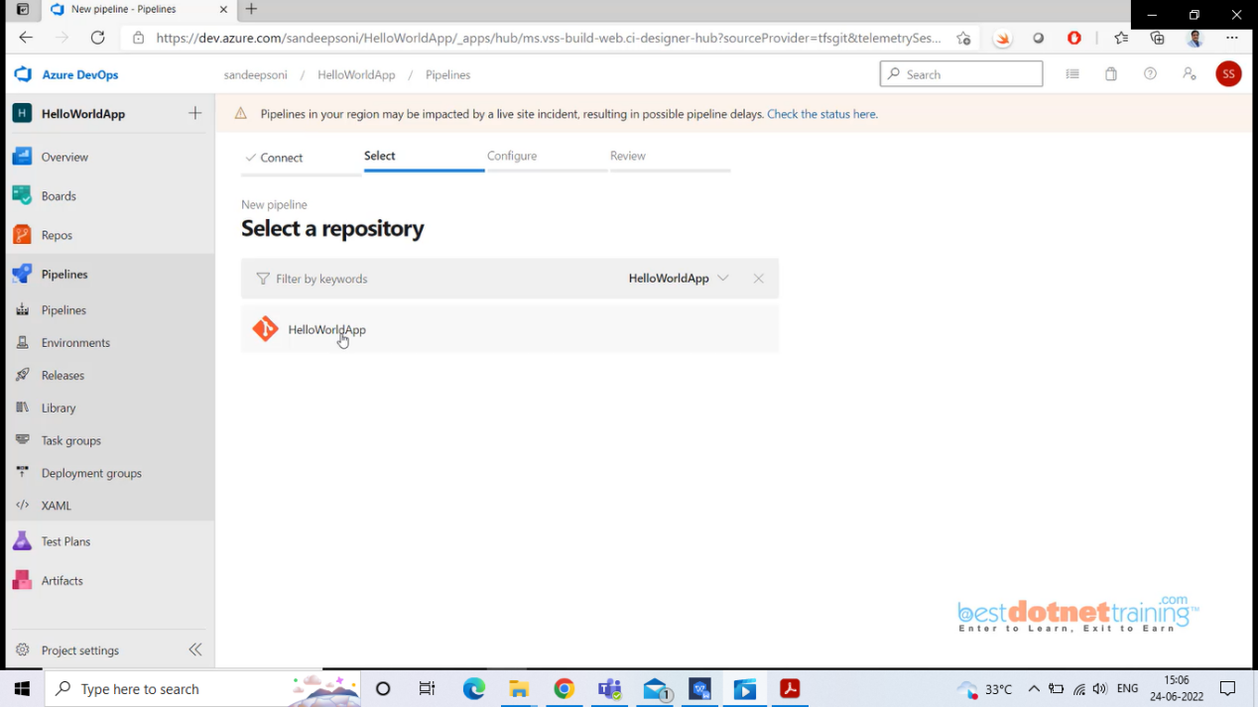

Choose your pipeline type: here choosing APS.NET Core(.NET Core).

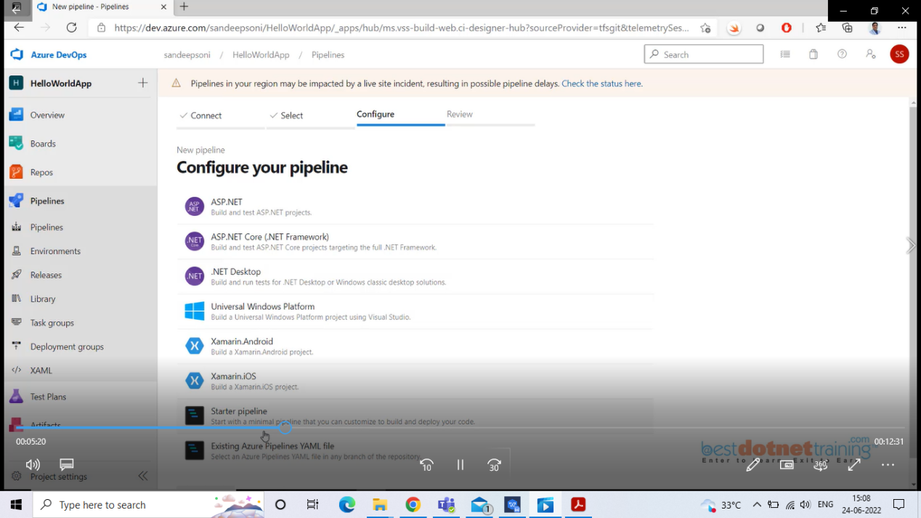

Below is default generated YAML pipeline code:

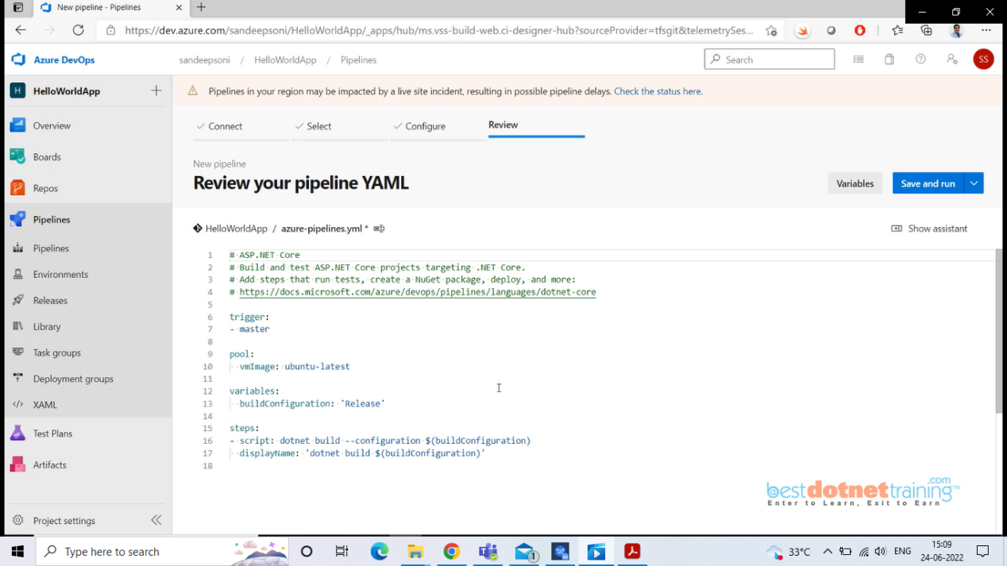

Here we will delete commands under steps and use intellisense “Show assistant” which will allow us to select task, and which will generate YAML code.

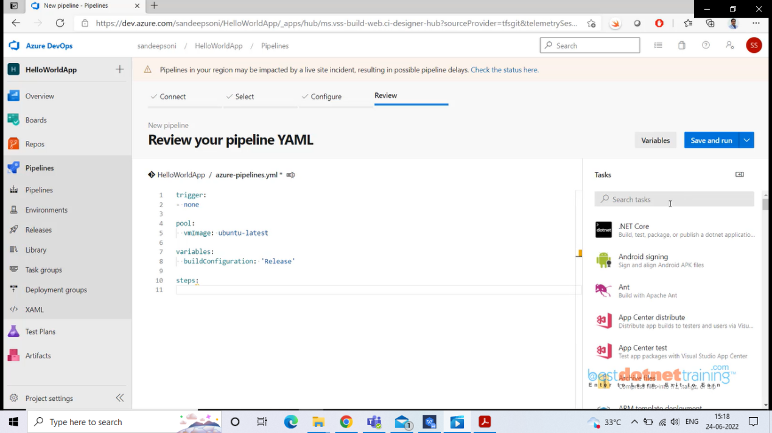

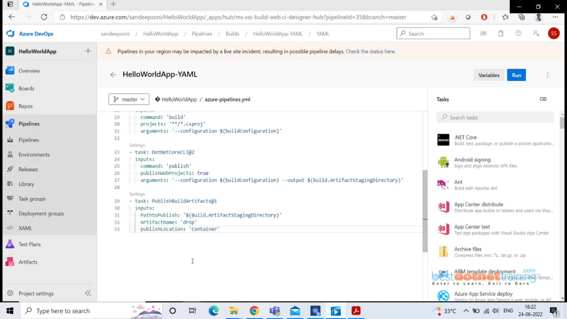

Once you are done click on Save & run and agent will start run. From here all the steps remain same as in Classic editor. And one more thing is this YAML code will by default created with file name azure-pipelines.yml which will be along with project code in repository. So, from the above screen shot we will get only Artifacts nothing beyond that.

1. Enable Continuous Integration in YAML Pipeline:

You can control which branches get CI triggers with a simple syntax:

trigger:

- none (means automatically CI pipeline will not trigger)

- master (when changes happen to master branch CI will trigger)

- releases/* (same as above under releases folder any changes CI triggers)

# specific branch build with batching

trigger:

batch: true (These are include exclude filters along with path)

branches:

include:

- master

# Specific branch build

trigger:

branches:

include:

- master

- releases/*

exclude:

- releases/old*

paths:

include:

- docs/*

exclude:

- docs/README.md

In addition to specifying branch names in the branches lists, you can also configure triggers based on tags by using the following format:

trigger:

branches:

include:

refs/tags/{tagname} (When we create PR at that time, we can create tags)

exclude:

refs/tags/{othertagname}

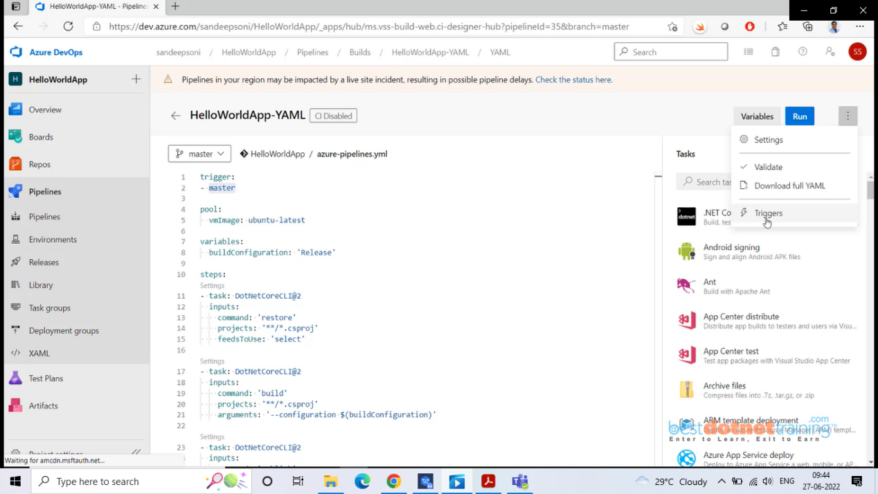

From above, even though we have set trigger as “master”, it will not trigger if we override it as below:

**Override YAML triggers**

PR(only for Git hub & Git Lab not for Azure repo) and CI triggers that are configured in YAML pipelines can be overridden in the pipeline settings, and by default, new pipelines automatically override YAML PR triggers. To configure this setting, select **Triggers** from the settings menu while editing your YAML pipeline as below: (Disable continuous Integration)

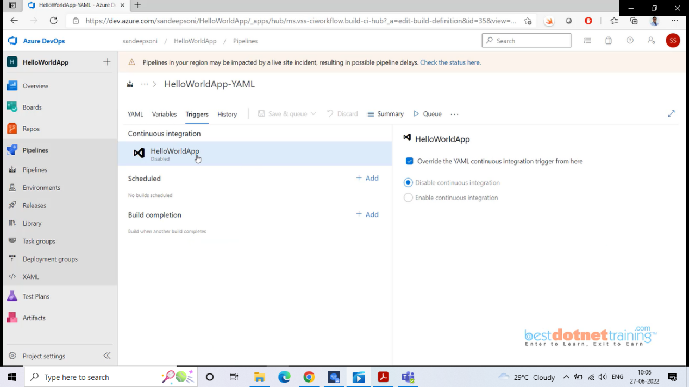

1. Using Templates in YAML file to build multiple configurations:

Now, we will use templates to build multiple configurations. We created task groups in classic pipelines. Of course, task groups in classic pipeline cannot be used in YAML. In YAML instead we must create and use templates. Now we will create a template file and re use in any other projects with different values for the parameters.

So, first we will create a folder under our repository’s root directory, and we will create all templates in that folder as below:

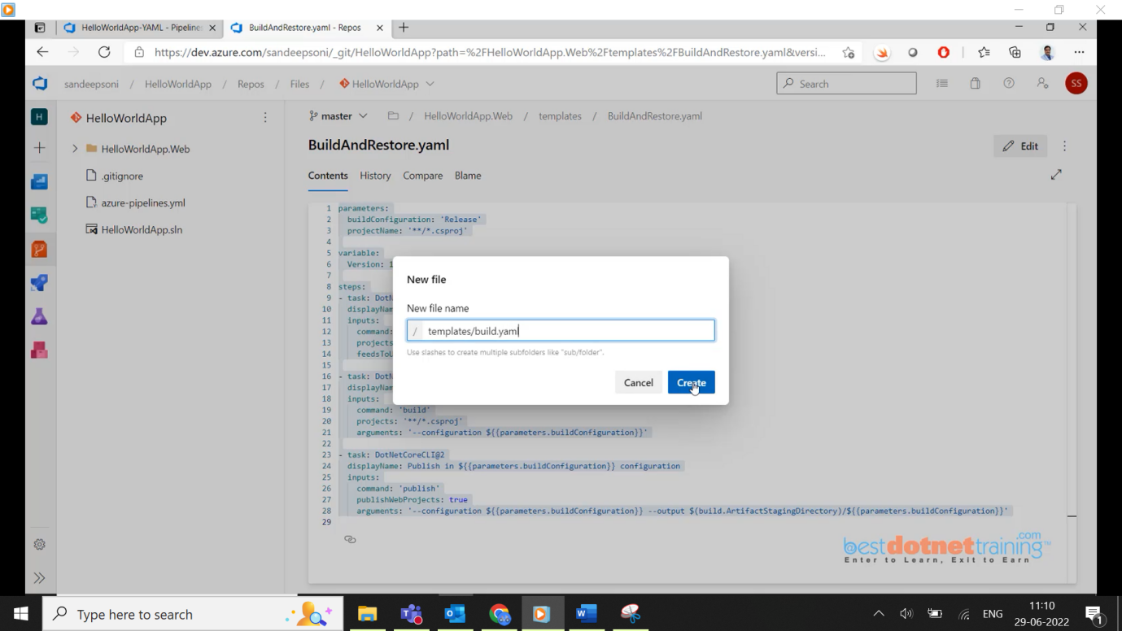

Now go to YAML pipeline and copy the ‘restore’ and ‘build’ steps into our build.yaml file and copy them under steps name. In YAML pipeline we will call variables as variables only but in templates we need to declare them as parameters.

When you are using parameter, they should be in double flower brace as below:

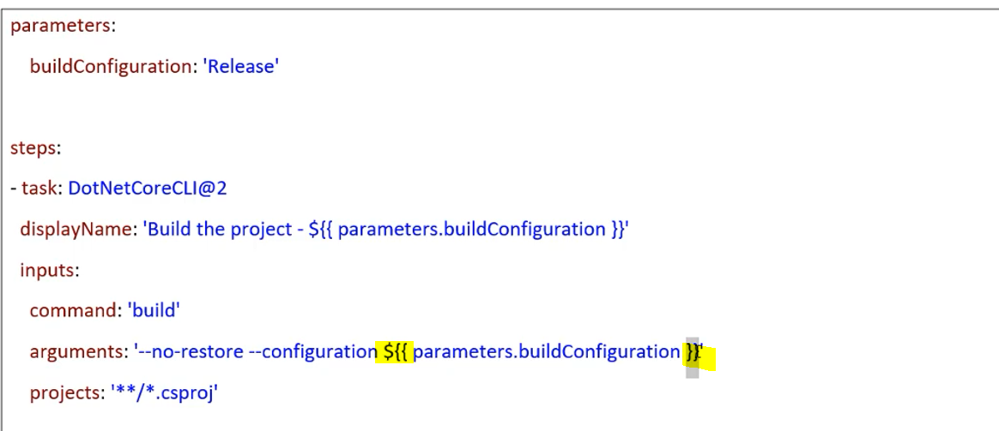

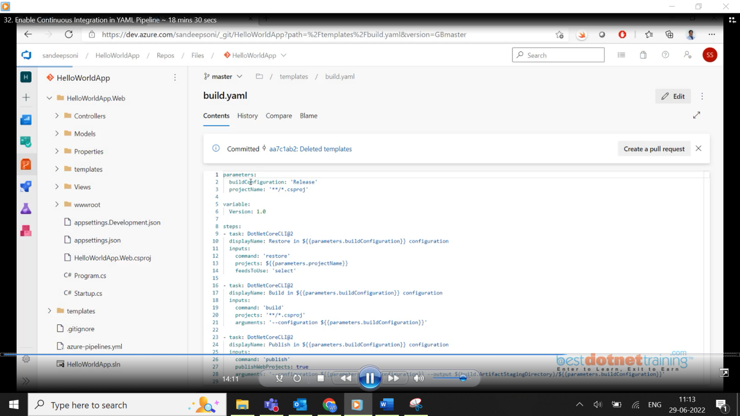

Now I would like to use the created template in YAML pipeline by commenting the ‘restore’, ’build’ and ‘publish’ steps. We need to be careful when using publish steps because for example, in we need to run the script 2 times by given 2 different input like first time buildConfiguration: ‘Release’ and second time buildConfiguration: ‘Debug’. When we run 2nd time second time output (artifacts) will be replaced by first time output. In order to avoid that better create release and debug folders under artifacts folder separately as shown below:

arguments: '--no-build --configuration ${{ parameters.buildConfiguration }} -- output $(Build.ArtifactStagingDirectory)/${{ parameters.BuildConfiguration }}'

**Note the two differences: summary of above steps:**

• In a template file, you use the parameters section instead of variables to define inputs.

• In a template file, you use ${{ }} syntax instead of $() to read a parameter's value. When you read a parameter's value, you include the parameters section in its name. For example, ${{parameters.buildConfiguration }}.

3. Call the template from the pipeline

4. Place the below two task just above the last task in **azure-pipelines.yml**

- template: templates/build.yml

parameters:

buildConfiguration: 'Debug'

- template: templates/build.yml

parameters:

buildConfiguration: 'Release'

5. You see that the pipeline produces a *.zip* file for both the **Debug** configuration and the **Release** configuration.

Calling template from azure-pipelines.yml:

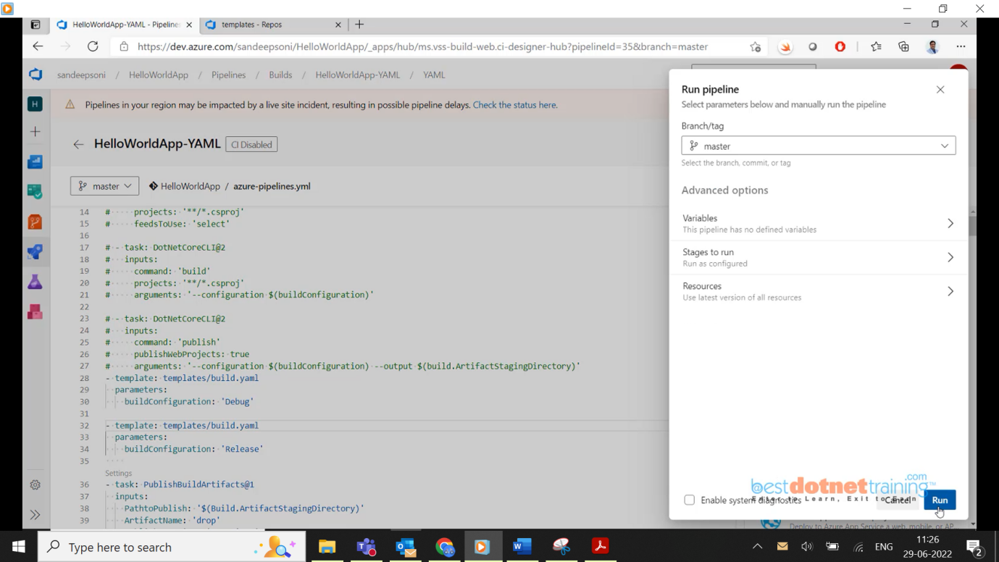

In YAML templates are used a lot to do easy maintenance.

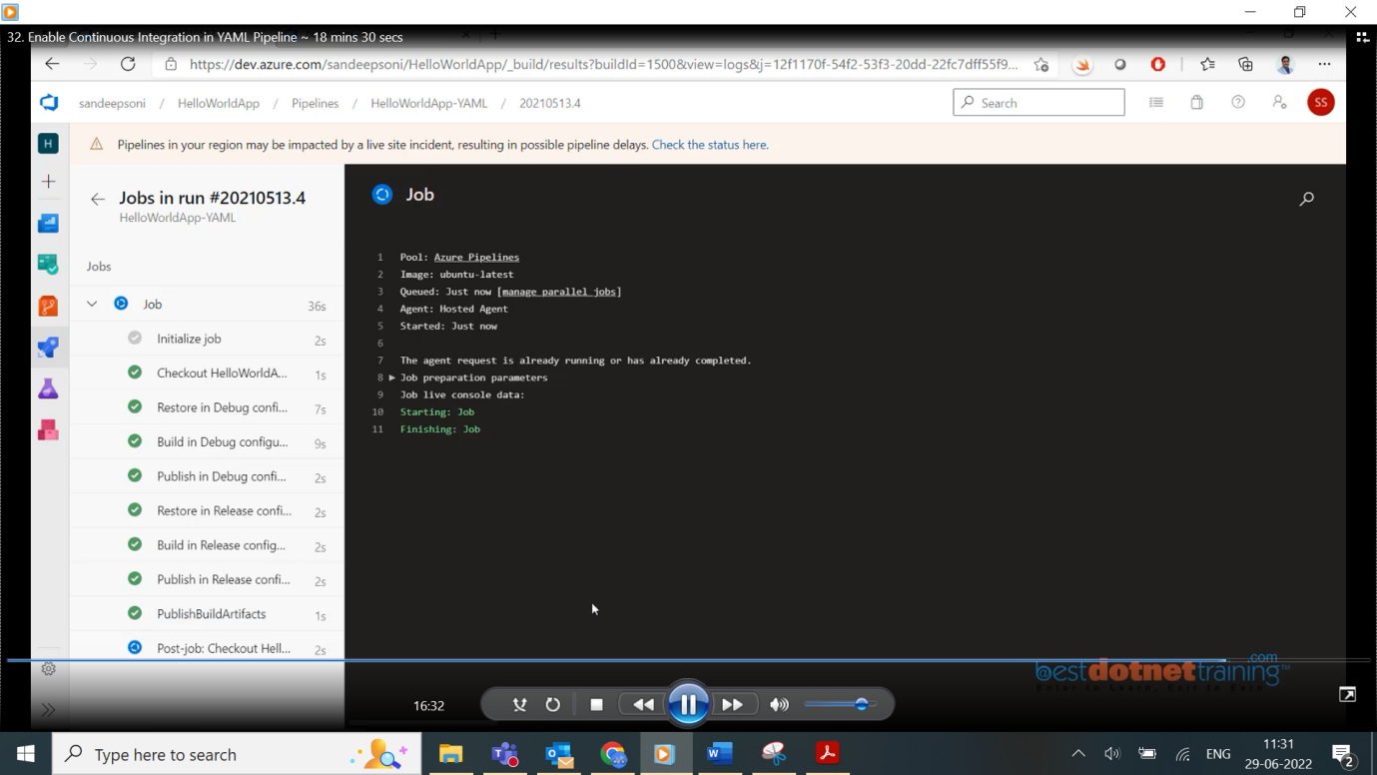

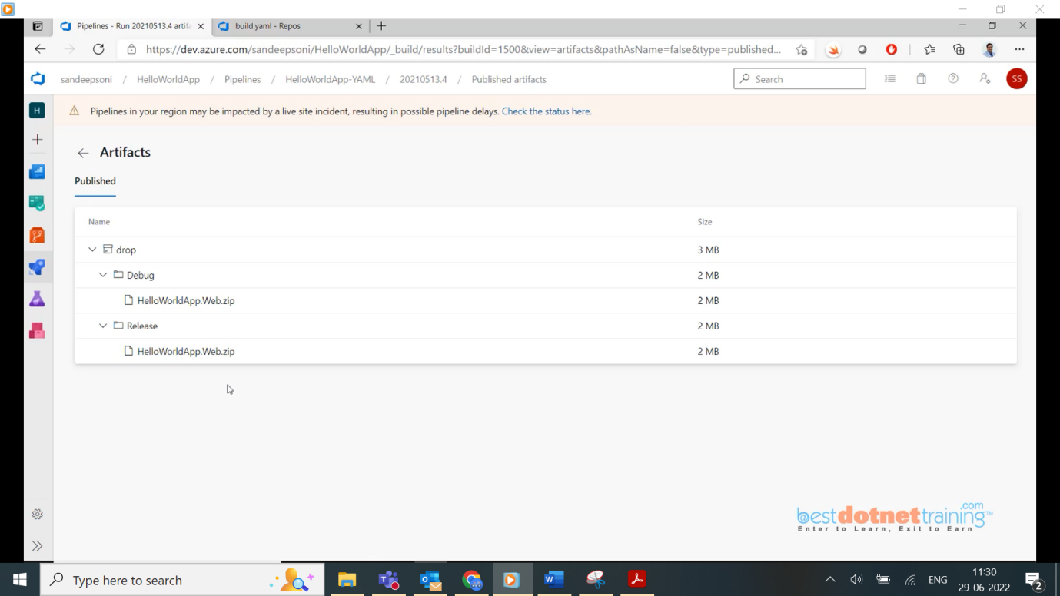

So, we have seen with template we can have multiple configurations done easily.

6. Continuous Deployment using Release Pipeline:

33.Introduction to Continuous Delivery:

Till now we have seen CI classic & YAML way of building artifacts now in CD we will use this build artifacts and publish to different environments. So, we can deploy this web output into different things like App service/virtual machine (VM)/it can be some serverless compute like azure function/ it can be orchestration service like Kubernetes, different type of environment we would like to deploy our application, and this is what called as **Continuous Deployment/Continuous Delivery**.

**Continuous Delivery** is a software development discipline where you build software in such a way that the software can be released to production at any time.

**CD** by itself is a set of processes, tools, and techniques that enable **rapid, reliable, and continuous delivery** of software. So, **CD** isn't only about setting up a pipeline, although that part is important.

**Companies need to become**

* **Better**: Quality needs to be high. Applications need to be secure. Code needs to be maintainable
* **Faster**: Customers demand features. They want it fast, otherwise they go to the competitor
* **Cheaper**: Competition is fierce, and we are competing with the neighbour next door

**The Eight Principles of Continuous Delivery:**

1. We have a reliable and repeatable process for releasing and deploying software.
2. We automate as much as possible.
3. We don't put off doing something that's difficult or painful. Instead, we do it more often so that we figure out how to make it routine.
4. We keep everything in source control.
5. We all agree that *done* means *released*.
6. We build quality into the process. Quality is never an afterthought.
7. We're all responsible for the release process. We no longer work in silos.
8. We always try to improve.

**Azure Compute Options: (where we can deploy our applications)**

* **Azure App Service - PaaS** (App Service is a PaaS service, you do not have to create VM’s there, no framework installations, no runtime installations, no worry about webserver, backup with click of a button, the app service does all these for us in background. Even scaling if needed we have to multiple instances, we just need to give no. of instance from panel/power shell script it will add that means you don’t need to take care of load balancer, no need to add & remove instances to the load balancer.
* **Virtual machines & VM Scalesets - IaaS** (This is Infrastructure as a service we will be provided with raw virtual machine with OS and remaining all s/w we need to install including s/w’s, webservers, security patches, upgrade patches we need to do it. Of course, VMScalesets will be used in dealing with auto scaling and adding to load balancers.)
* **Serverless computing** – **Azure functions**: you can build azure functions locally and when you find everything is ready you can deploy that azure function into “Azure function app” of course, it is managed by **Azure App Service** only.
* **Containers**: You also have ability to create docker containers basically first you create docker image, put the image into docker registry and then create a docker container. In azure we have container instance which can be created for pulling the code from docker registry and deploying into it. Of course, app services also have the same ability we can also always install a docker image as a container in VM etc. Etc...

**Supported build source repositories:**



In below diagram, approvals are nothing but ‘button click’ by approver(lead).



34. Setup App Services and Service Connection to Azure Subscription:

Now the Azure Release Pipeline (CD pipeline) should be built which will take input ‘build artifacts’ from CI pipeline’s output. Here the CD pipeline will have Dev Stage/ITG(QA) Stage/Staging Slot/Prod Slot which should publish the content to azure portal’s “App Service/VM/Docker” Dev/QA/Stage/Prod environments (<https://portal.azure.com>).

Now, how the connection happens between *devops portal* and *azure portal*? (Through service connection)

Login to azure portal and create 3 separate environments’ (here you need to have active subscription which can be azure pass/ free trial that is a pre-requisite). Once login search for App Services which will be as below:

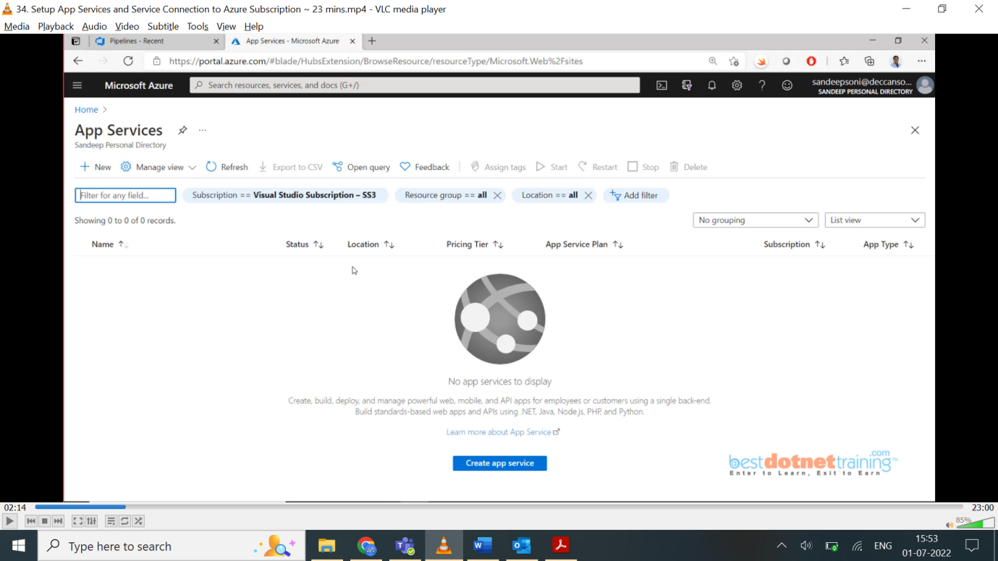

Now we will create 3 app services.

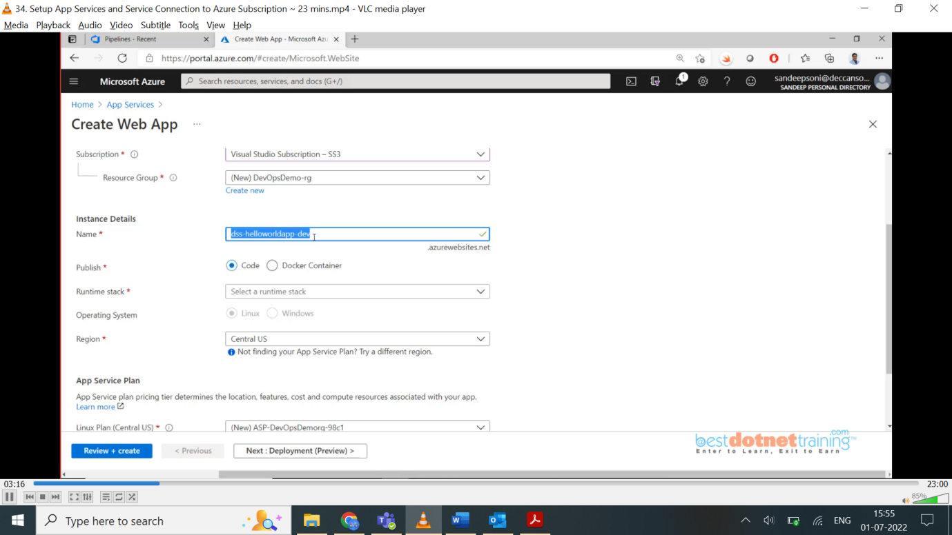

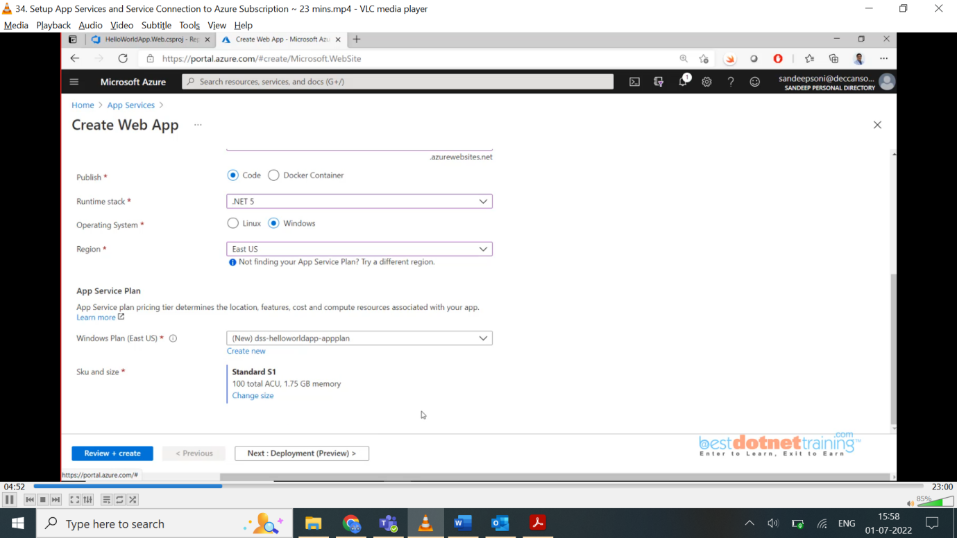

Very important our App Service should use “App Service Plan” which is pricing plan. Here we created “dss-helloworldapp-appplan” this plans we will use for all 3 environments (and we may need to go for different plan on production environment).

Continue Deployment from CD Deployment tab (from ADO (Azure DevOps)):

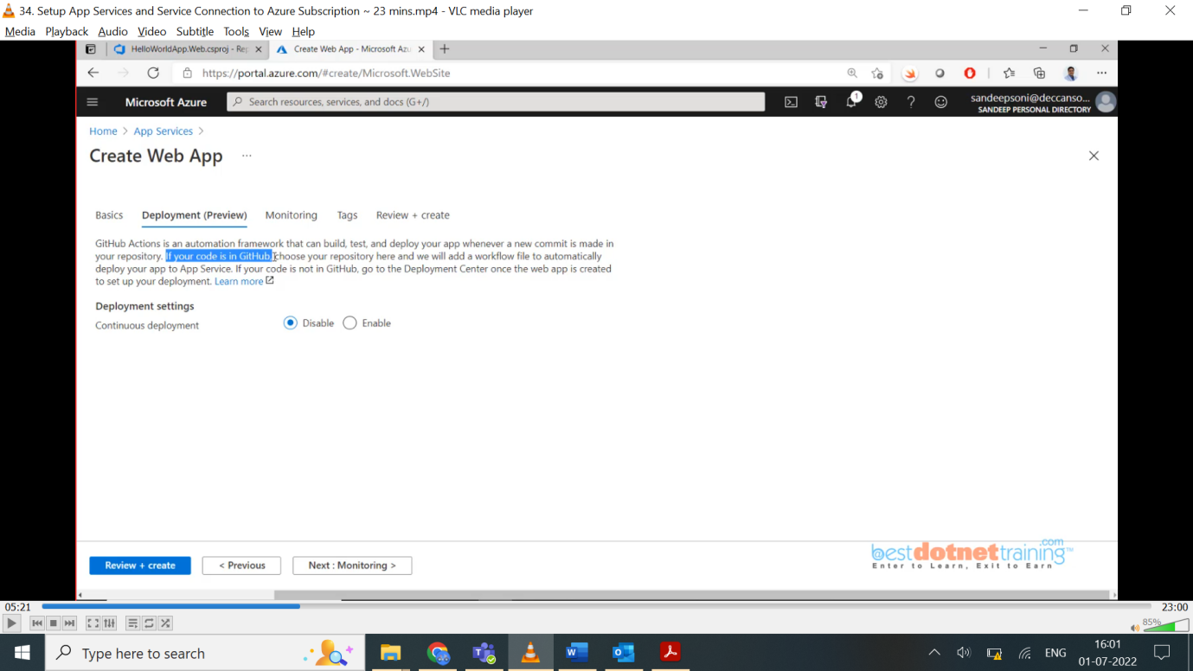

If we enable “Application Insights” from Monitoring tab, it will be useful for developers to get telemetry information(metrics) about the application when it is deployed in Devops. To monitor the performance of app/ where the bottle necks in app/bottle necks on db/errors in javascript/ajax calls/how traffic in website/how many sessions created/who are creating sessions/website is always running/when it is down all these information it will give us.

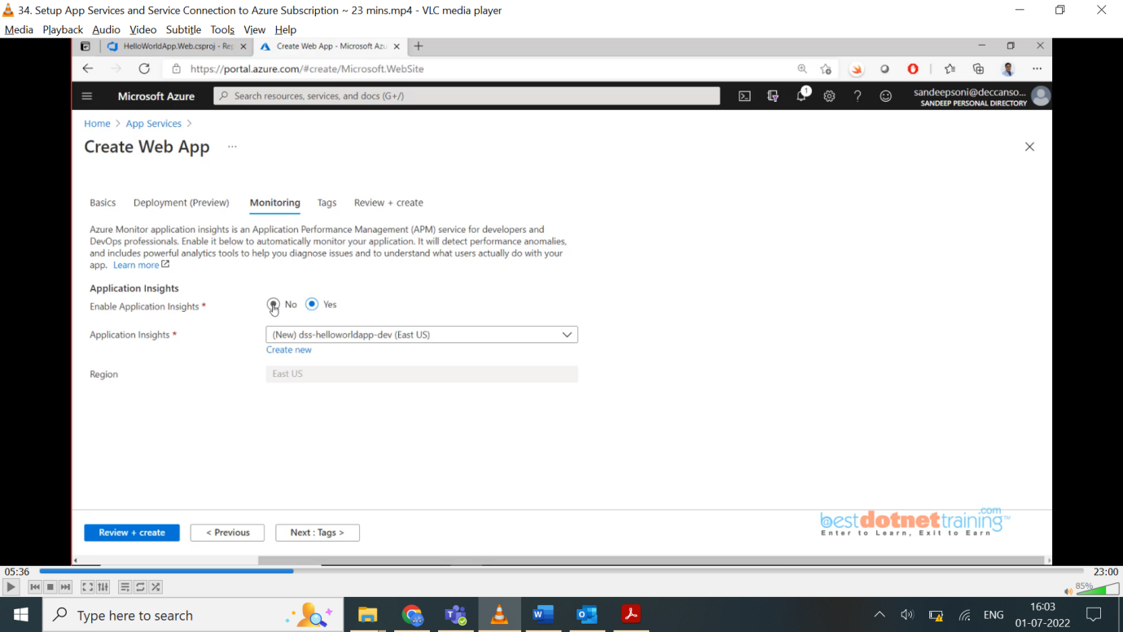

Hit “Review+create” button which will create our app service and also it generates ARM template. We are going to use this ARM template in devops and even app service creation also we can do thru devops (Iac) we call it. Which means infrastructure itself we create thru app service, and, in that environment, we are going to deploy our application. which are dynamic thru ARM templates/using terraform.

In this way we create QA App Service & Prod App Service. Once Prod App service is created, we will create a slot for prod app service which is staging slot (which will be used to avoid downtime i.e., we will push our code to prod-staging and once deployment done, we will swap it with prod). We can see all the three environments created in below screenshot:

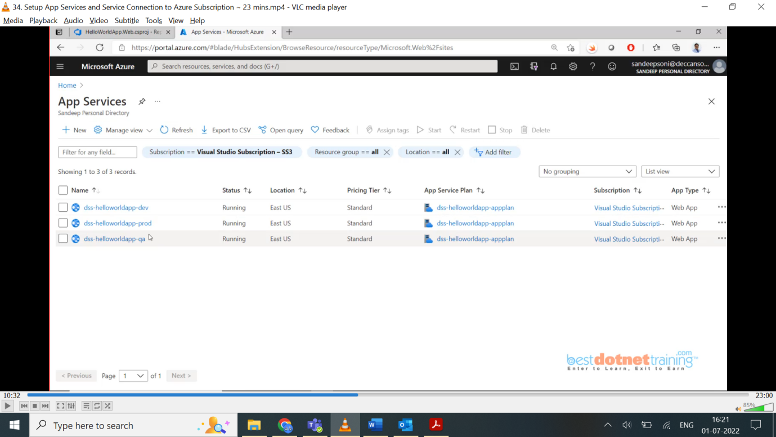

To create prod slot: Go to production app service and there you will find Deployment slots. To create deployment slot, you should have at least “standard pricing tear”/premium (for basic app service plan we cannot create deployment slot).

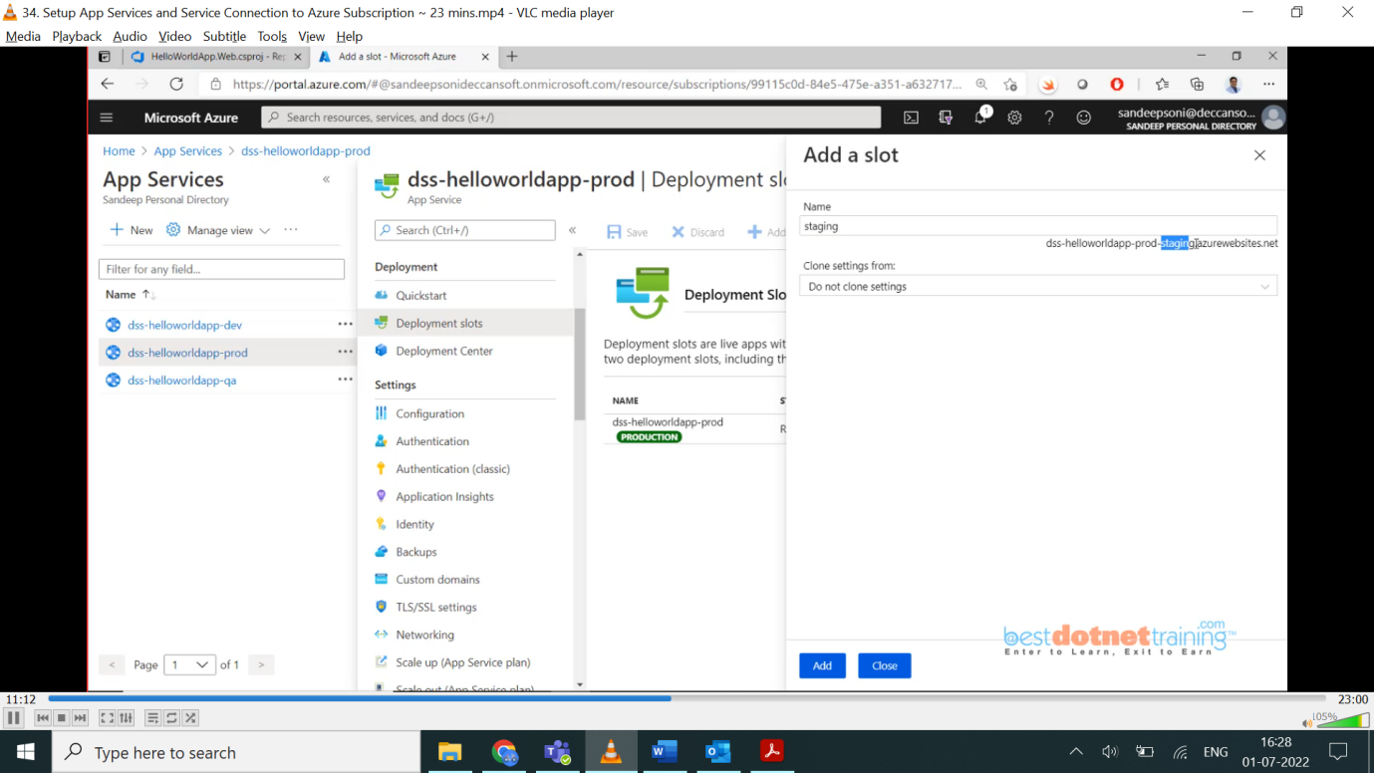

If production has any kind of configuration settings, we got option to clone them.

We just completed setting in azure portal. Now that we have environment ready. Next task how to do connection between devops and this app service? 2 ways: 1. goto project settings and click on service connection as below:

It can connect to any cloud like azure/aws/gcp/docker/cluster of Kubernetes etc.

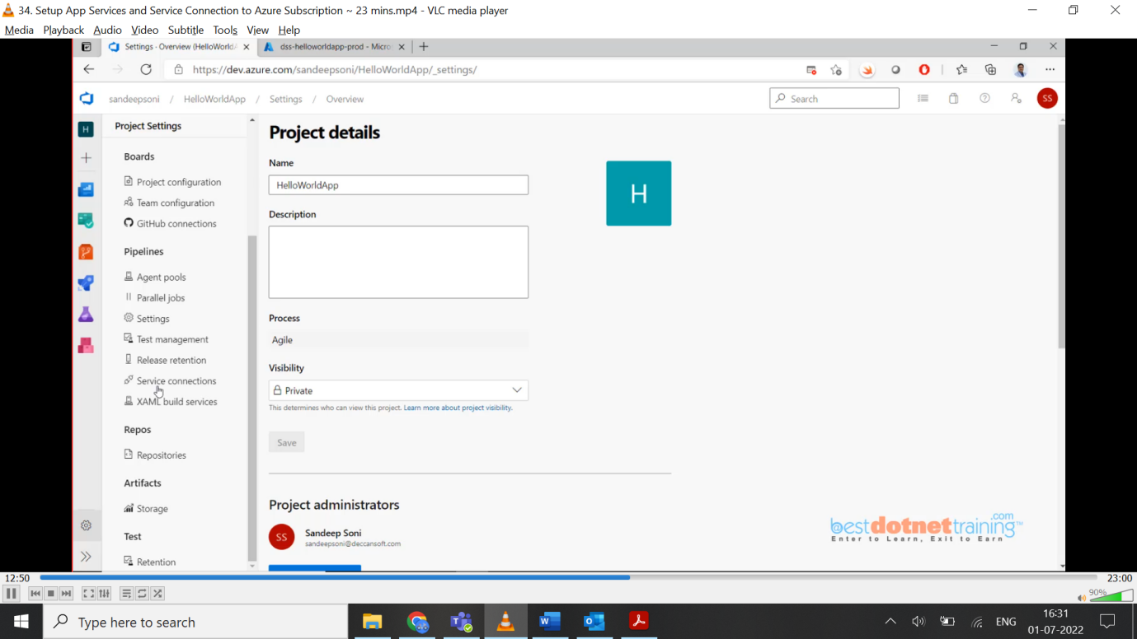

If you don’t find your service connection, say AWS, you go to marketplace gallery and add to list.

For our case, we need to choose “Azure Resource Manager”

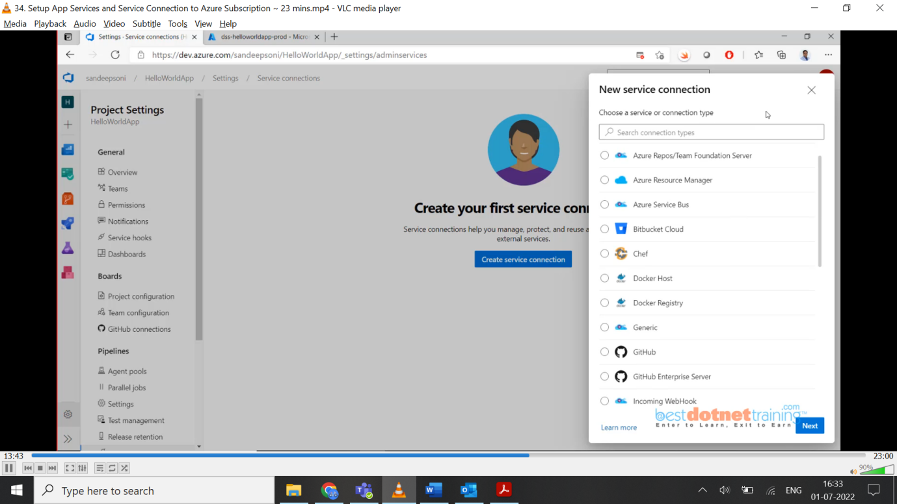

Once you select ARM option you will find 4 sub options as shown below:

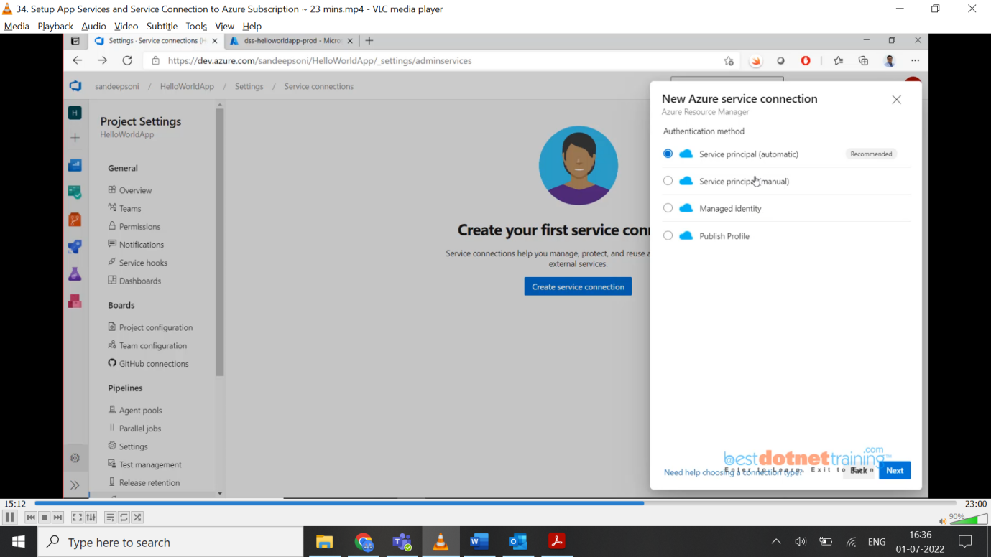

NOTE: - You will be able to create service connection provided you have admin rights on azure portal in AD (Azure Directory). If you goto app registrations 🡪 app applications, you will find the connection you just created which will be in screen shot 2nd below:

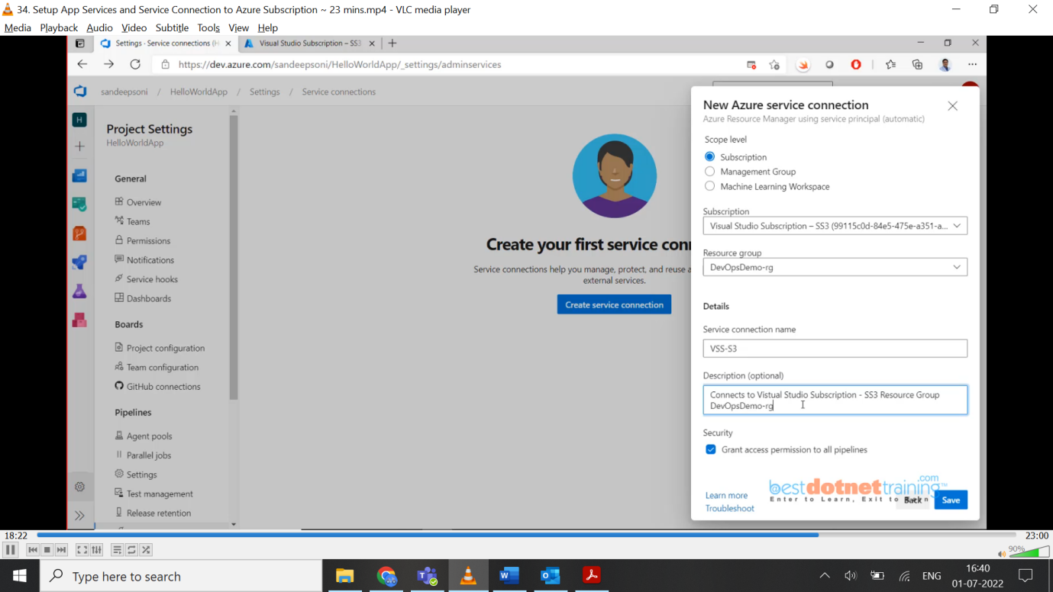

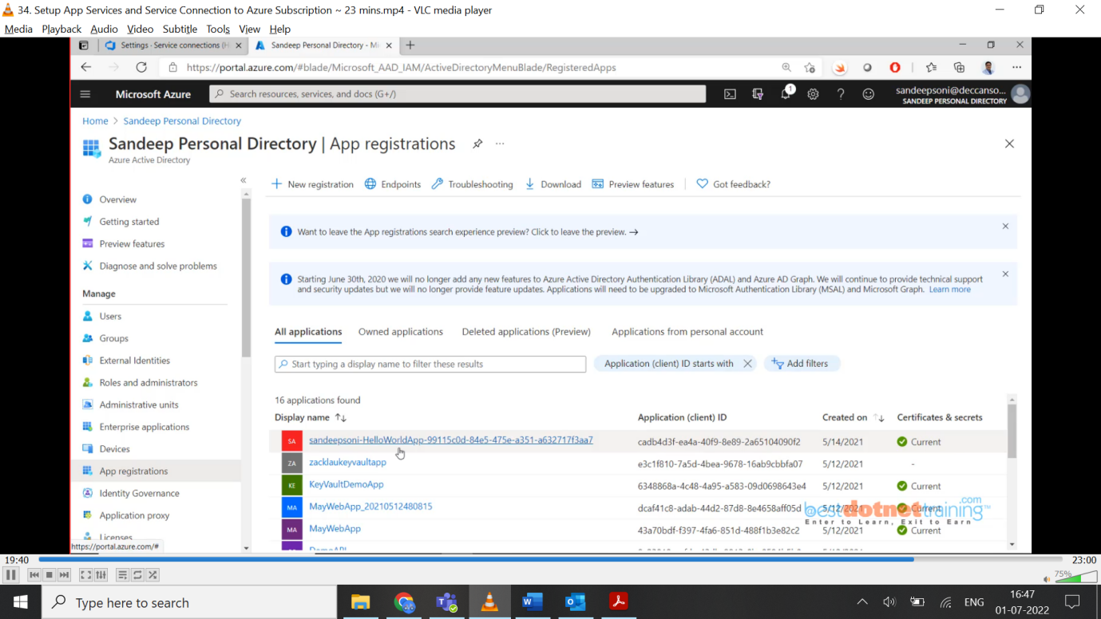

This “Sandeepsoni-HelloWorldApp” in above screen shot we created, is called service principal. This particular service principal is given permission on subscription. To check go to 🡪 Visual Studio Subscription 🡪 Access Control (IAM) 🡪 Role assignments, I didn’t find it here because I scoped it to a resource group. So, this subscription will have permissions granted at resource group level. So go to Resource Groups 🡪 Access Control (IAM) 🡪 under Role assignments you will find that as shown in below screen shot:

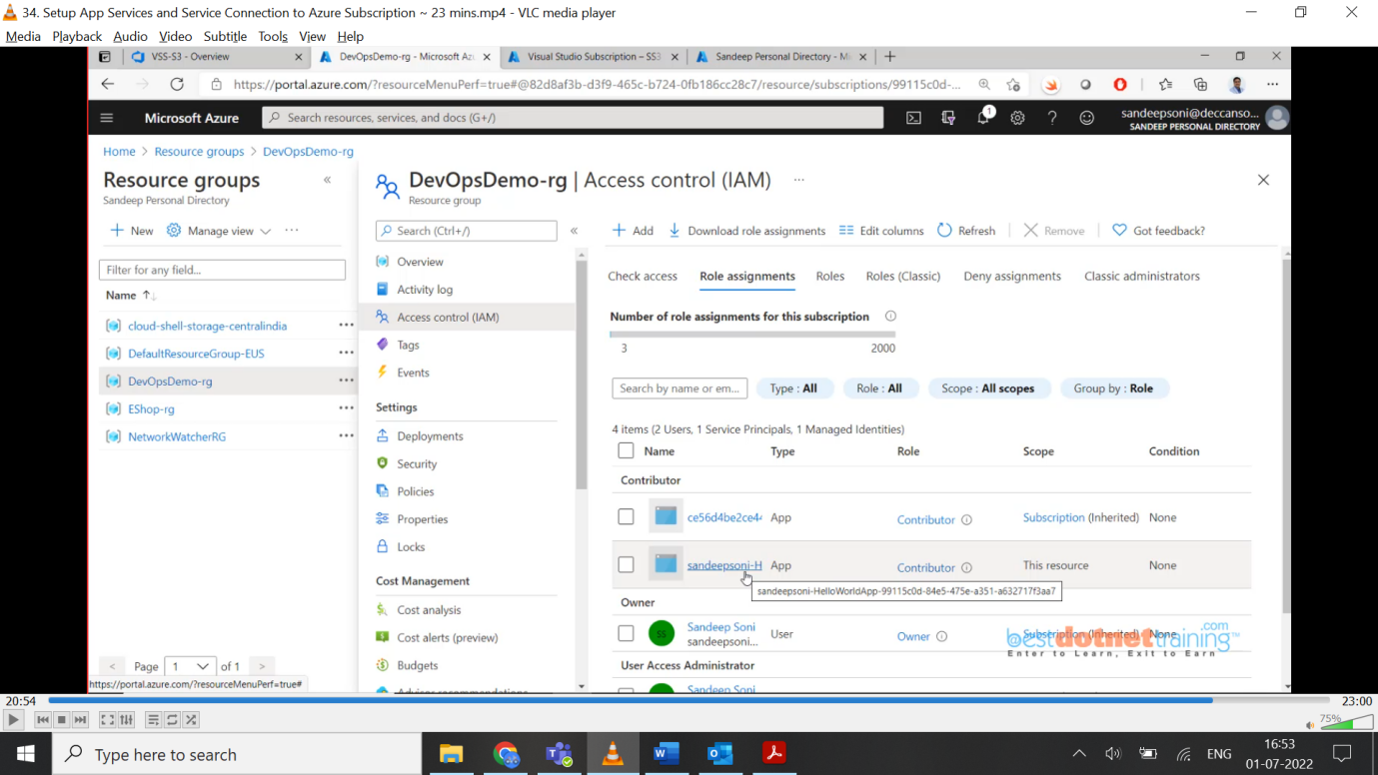

The automatic option is working because the same identity we used in both devops and azure portal. What if, devops identity is different with azure portal, then Service Principal (automatic) will not work. We need to go for Service Principal (manual).

So now, we have our dev env/qa env/prod env with slot ready/also service connection ready using this we will publish.

**35. Create and Run a Release Pipeline:**

Till now we have seen Build pipeline, from devops portal need to select **pipelines** and create Build pipeline. But now we need to select **Releases** option to create release pipeline (CD Pipeline). Now we have again 2 options to create release pipeline as we had in CI like classic & YAML way.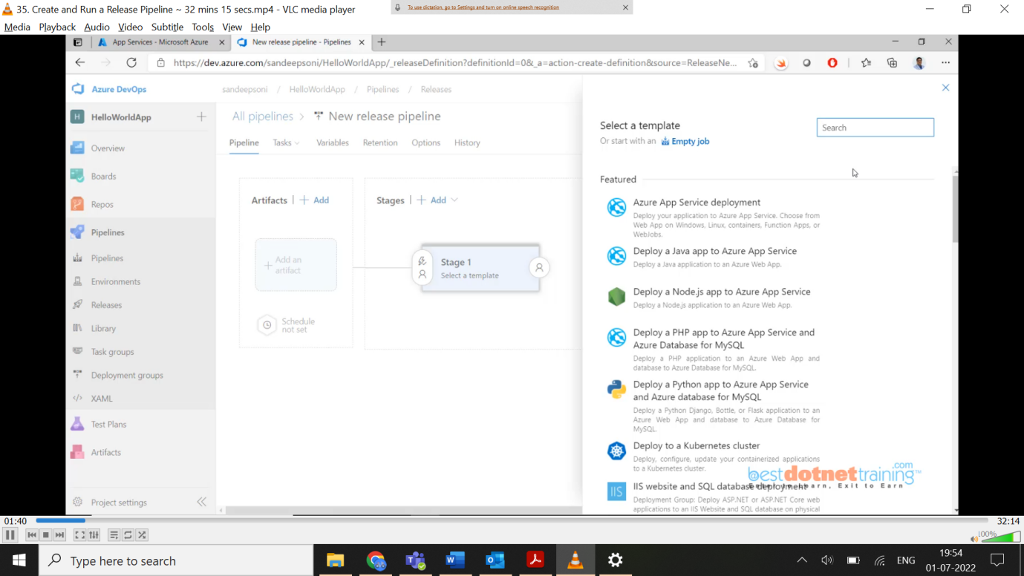

When click on new pipeline, you see above screen there we need to choose appropriate template for deployment. for our case “Azure app service deployment” once you select you see below screen highlighted with stage1.

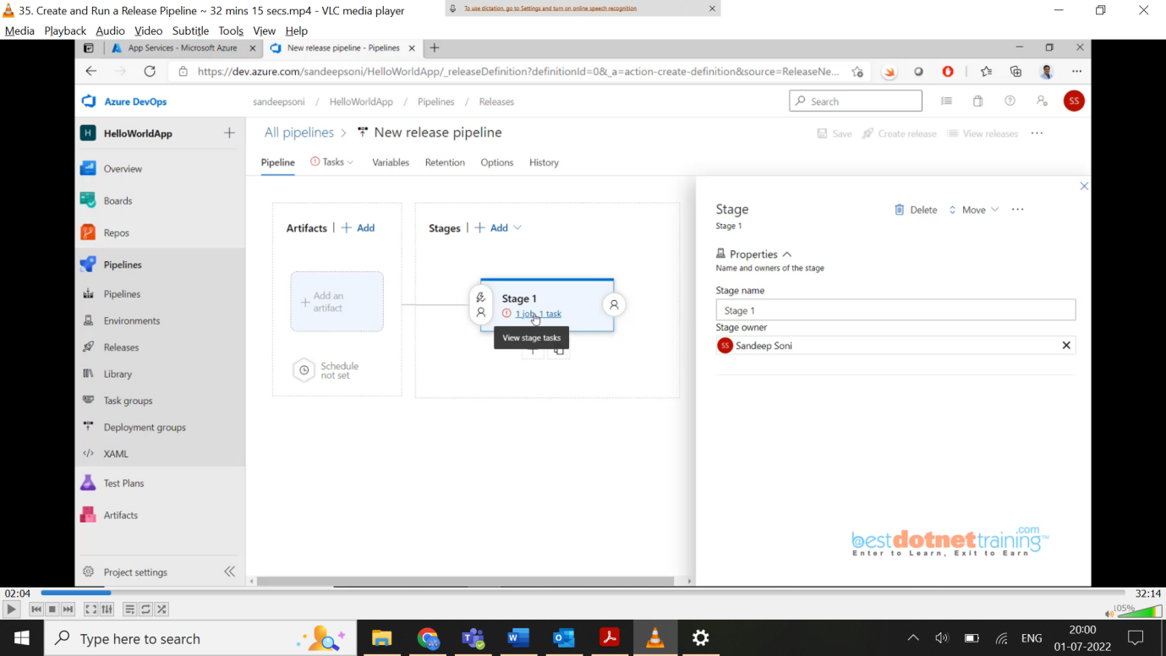

Once you click on the stage1 link, it will display below screen where you need to choose the service connection created in previous video section for azure subscription as below (VSS-S3):

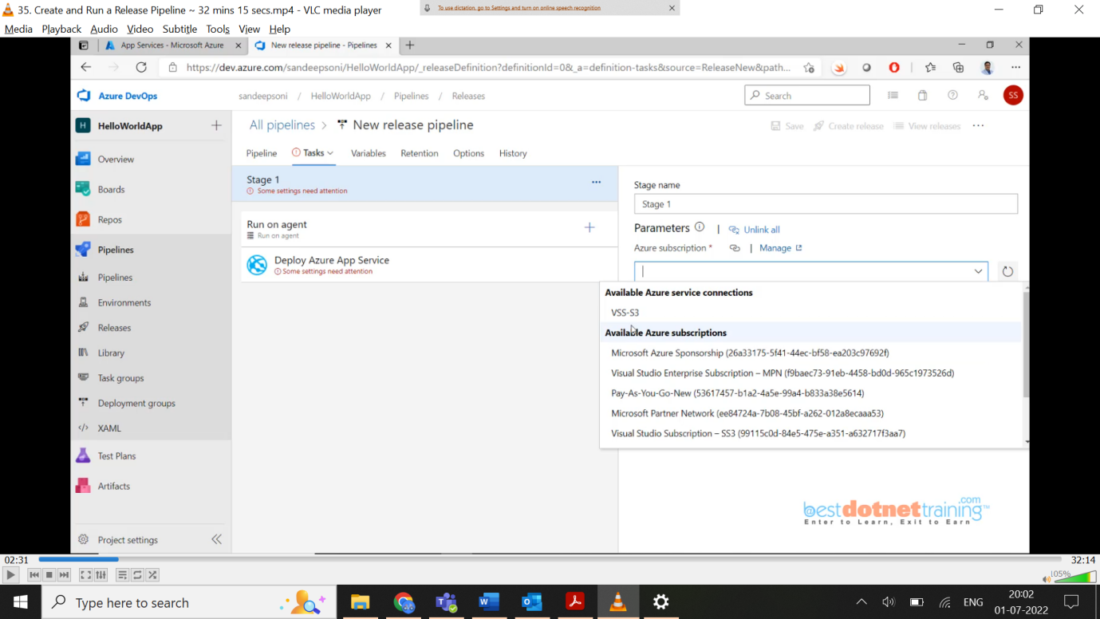

As we are deploying to windows server need to select below option and for “App service name” we need to choose “dss-helloworldapp-dev”.

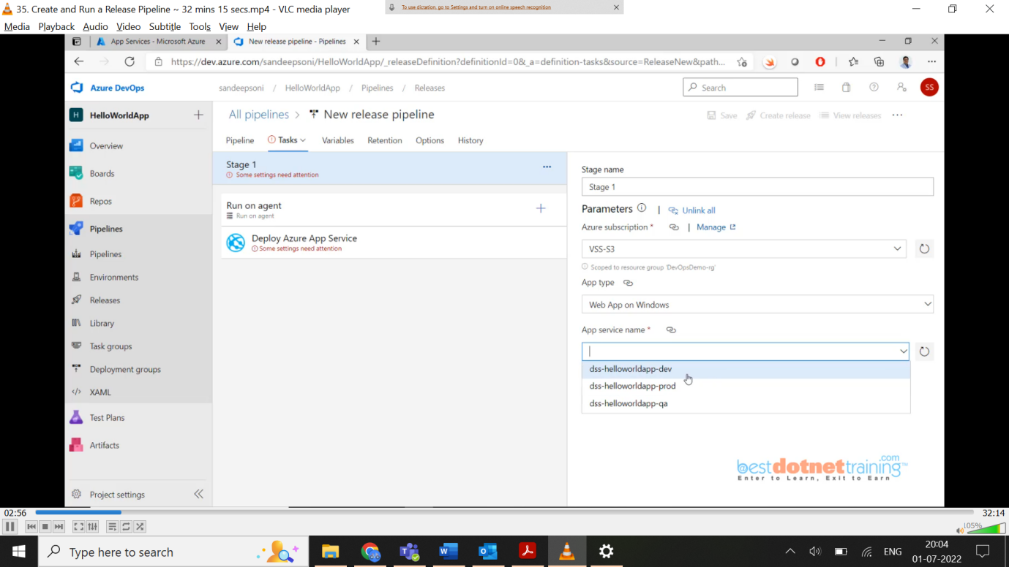

So, what do you want to deploy on Stage1, we want to deploy our build artifacts generated by CI:

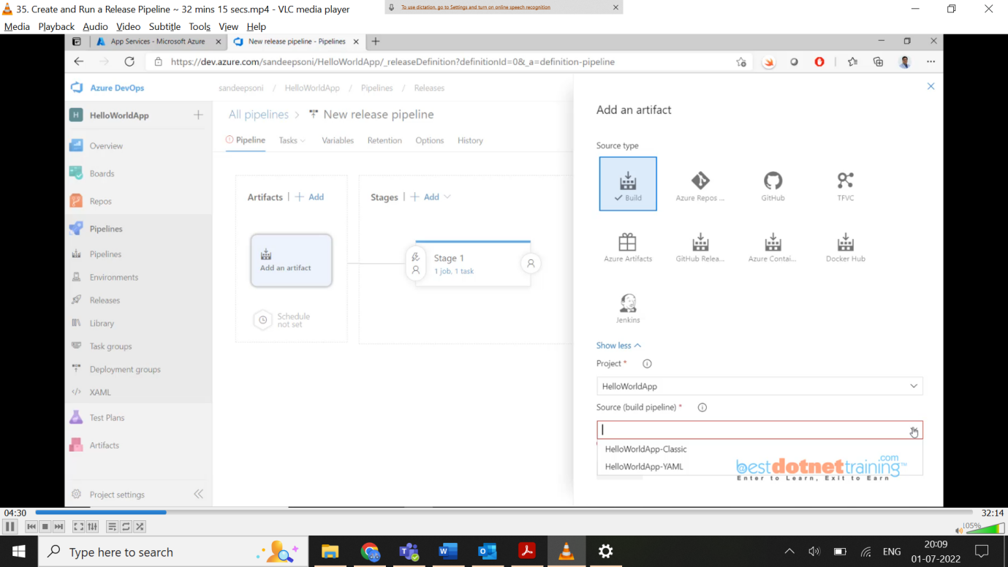

Now we have artifacts in release pipeline with stage1 which is to dev environment connecting using service connection. We can now add one more stage (or) just simply clones and change settings as below: rename stage1 to Development and Copy of stage1 to QA. Click on QA and change task properties “App service name”: dss-helloworldapp-qa.

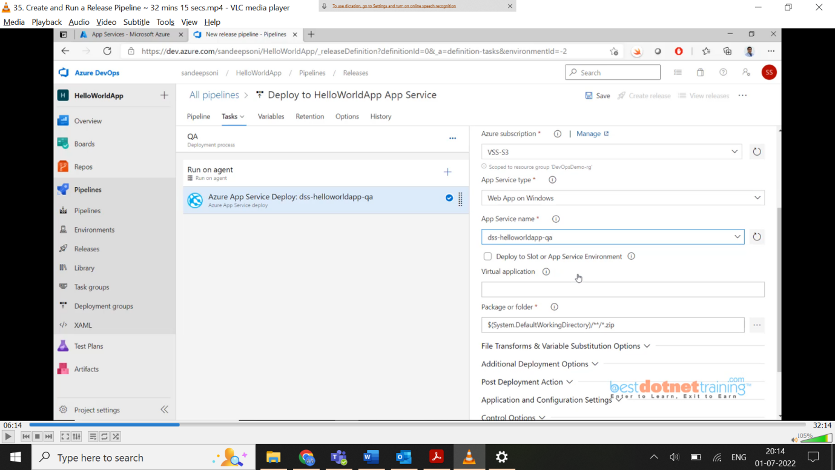

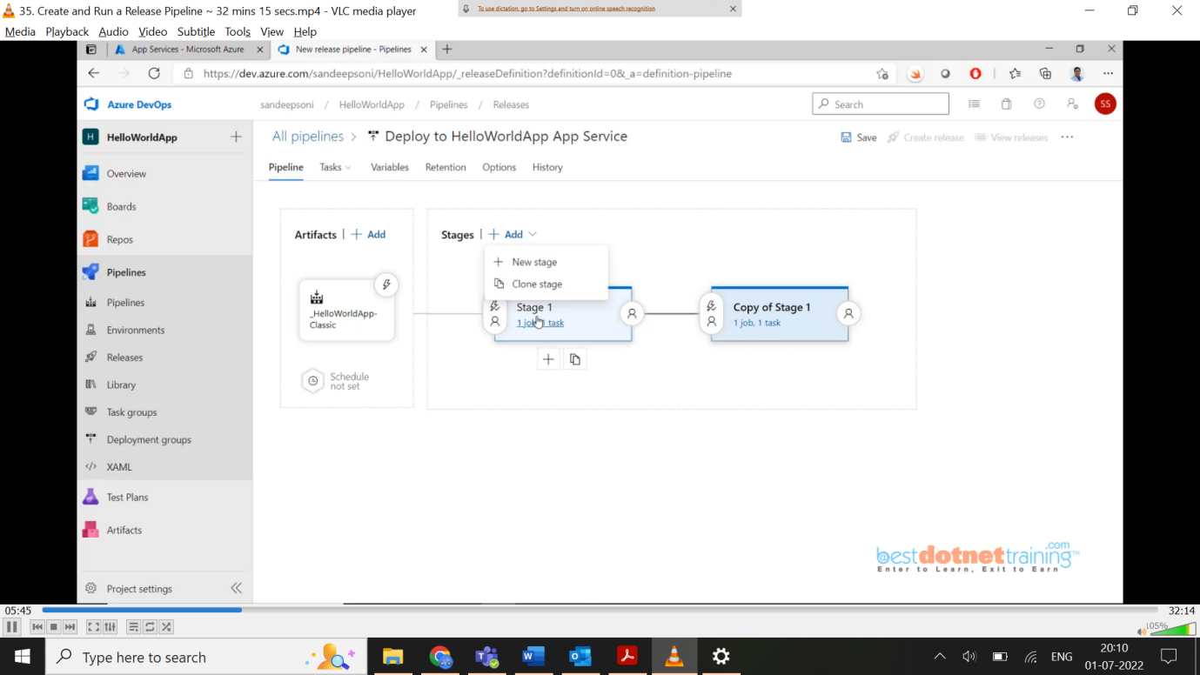

Same thing you need to do for production. But you need to select check box “Deploy to slot or App Service Environment” and then for “slot” option: you need to select “*staging*”

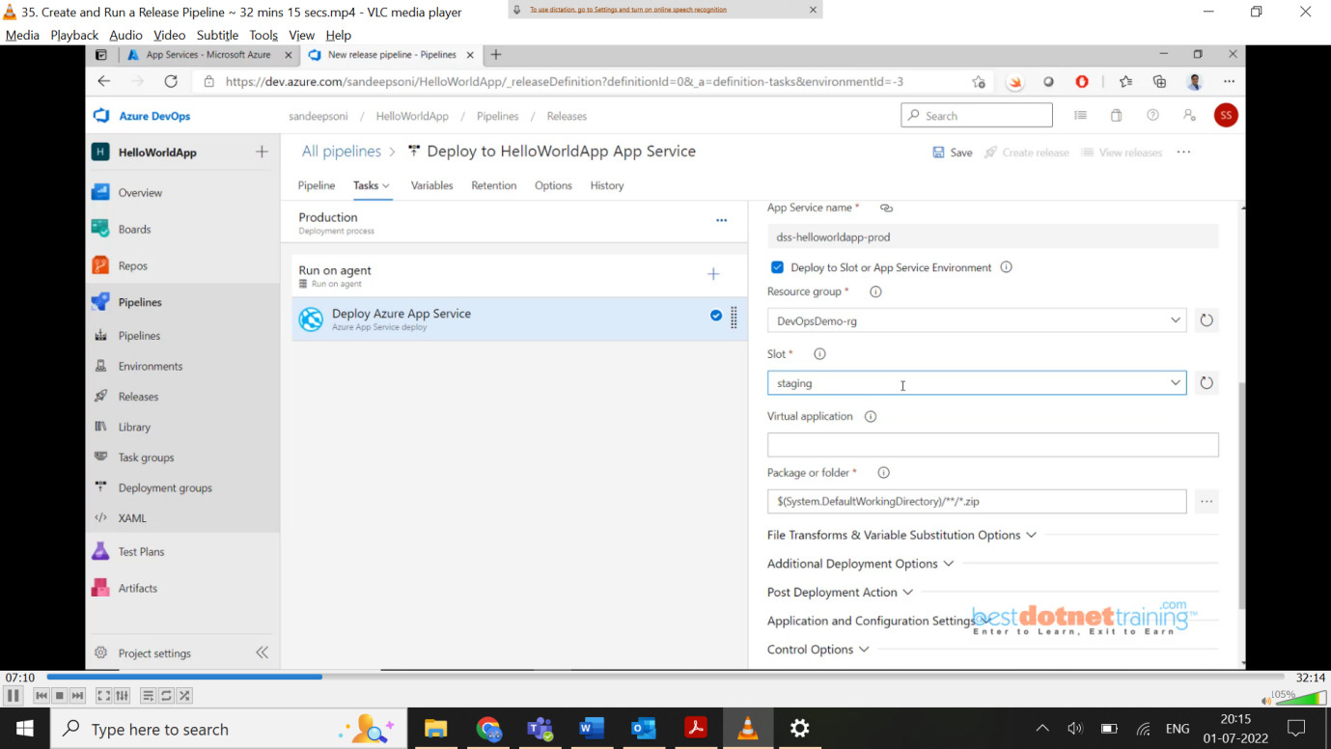

So, still we need to manage prod environment by selecting option “Azure App Service Manage” as shown below:

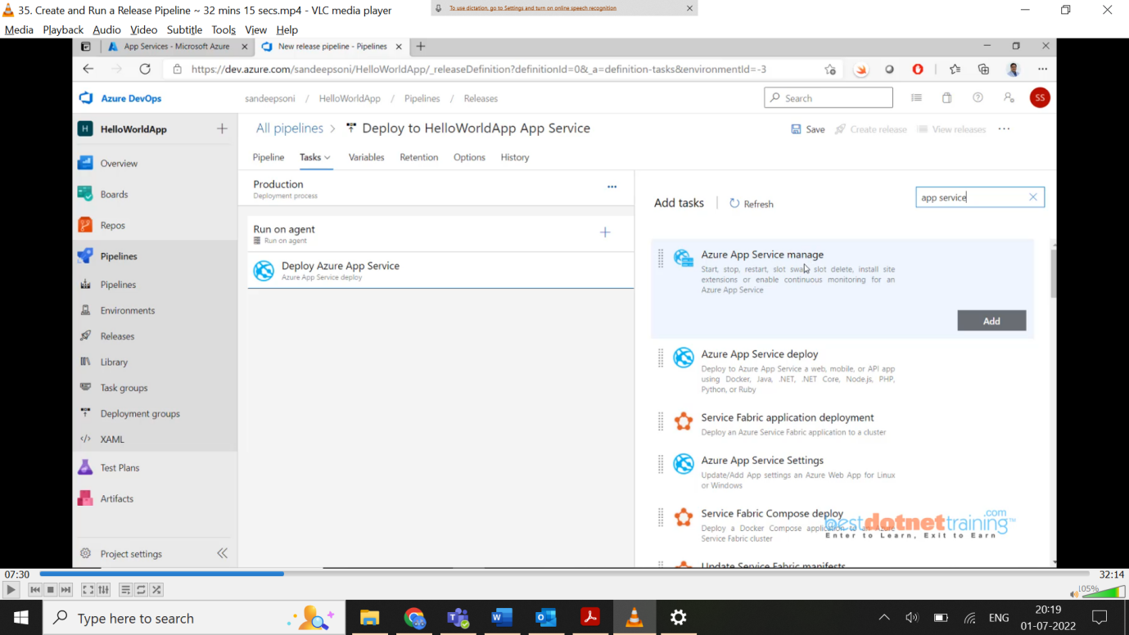

This task has all the features like start, stop, restart, slow swap etc. as shown in above image. Display name: “Swap Slots:”, Action: “Swap Slots”, App service name: “dss-helloworldapp-prod”, source slot: “staging” and check the checkbox – Swap with production as below:

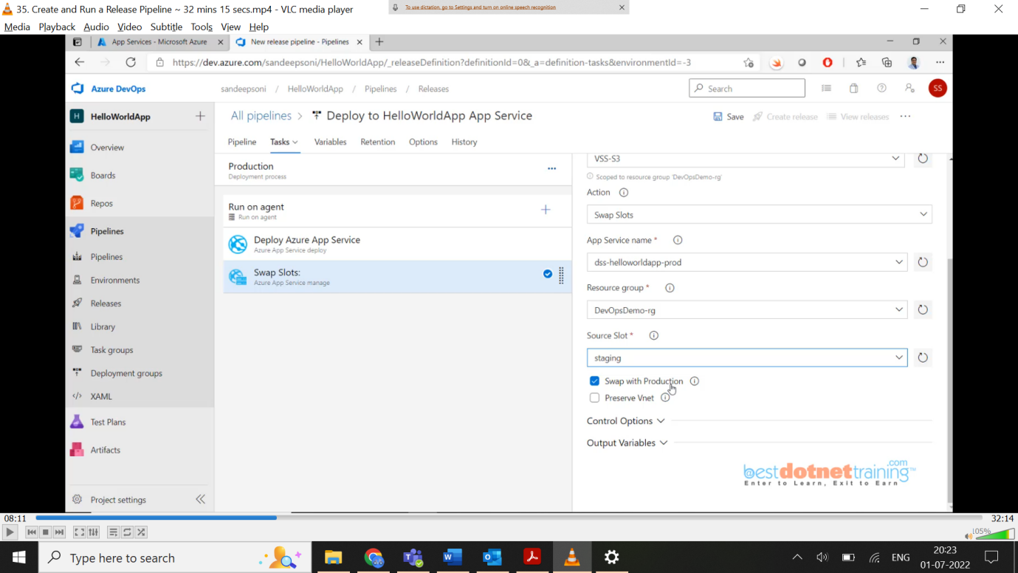

Final pipeline looks as below: for production you can see 2 tasks as we did in above steps.

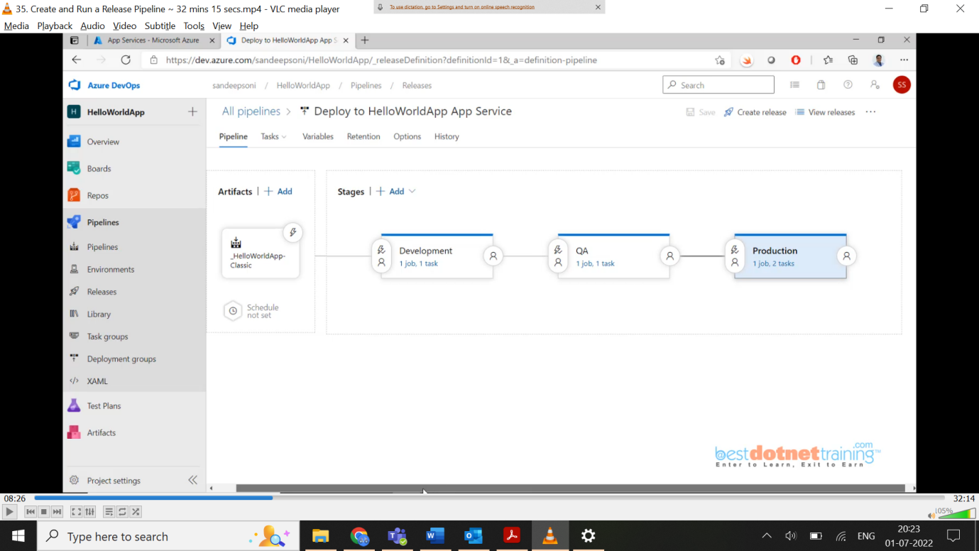

We can have post deployment conditions like approvals etc. as shown below:

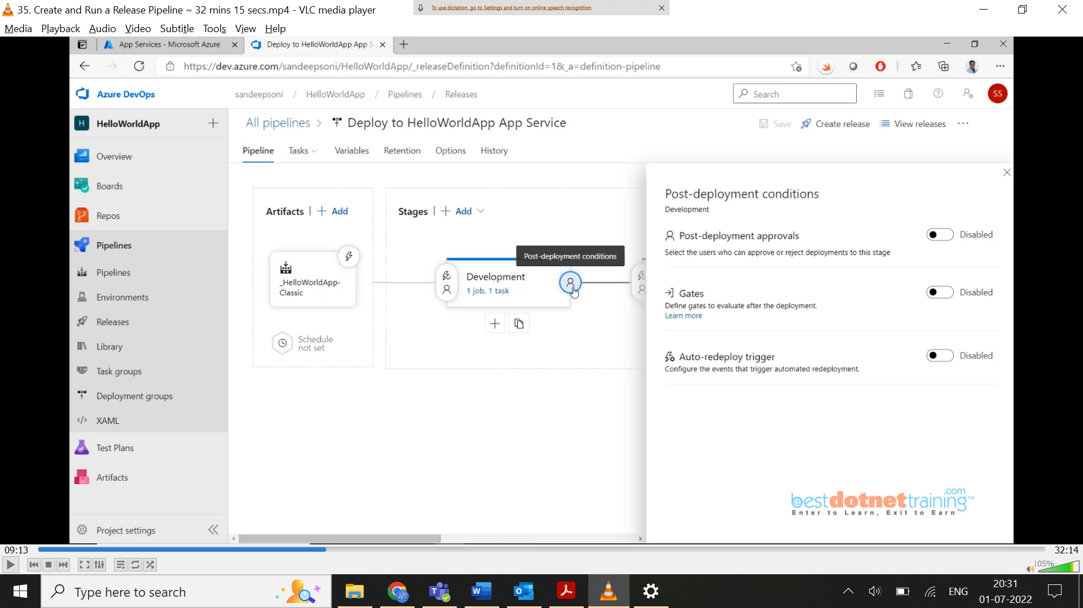

We can enable post-deployment approvals by giving some lead/manager email-id which need approval before publishing to QA environment as below:



So for above 2 cases of dev & qa we have given post deployment approvals now for production environment we will give pre-deployment approvals as below:

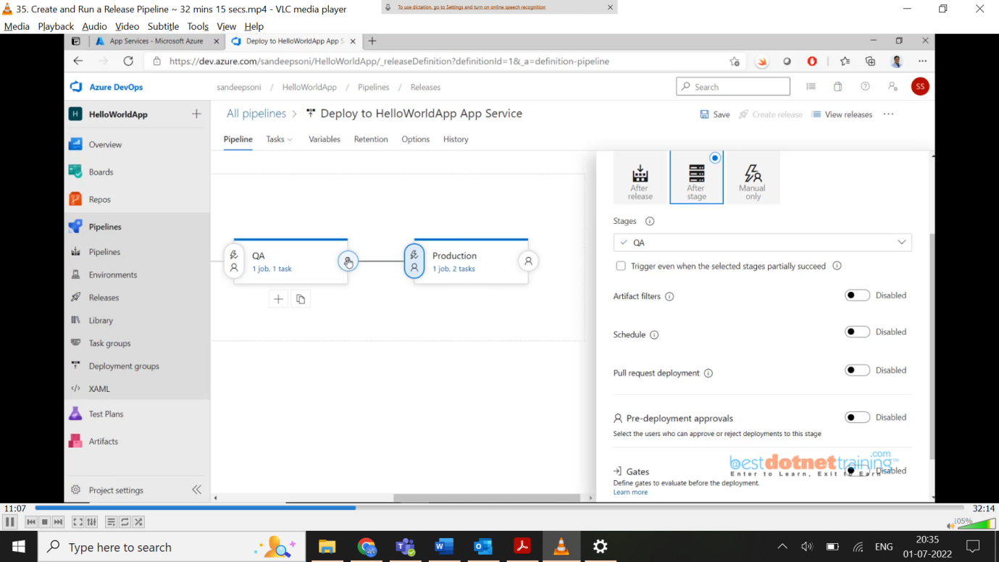

That’s all. Pipeline is properly configured from dev to production with approvals now time to run the pipeline. Now as we know our deployment process give in sequence like once dev completes with post approval it will go to qa and same for production. We have option to run these in parallel also we will see later. As everything is packed, we need to create a new release as below:

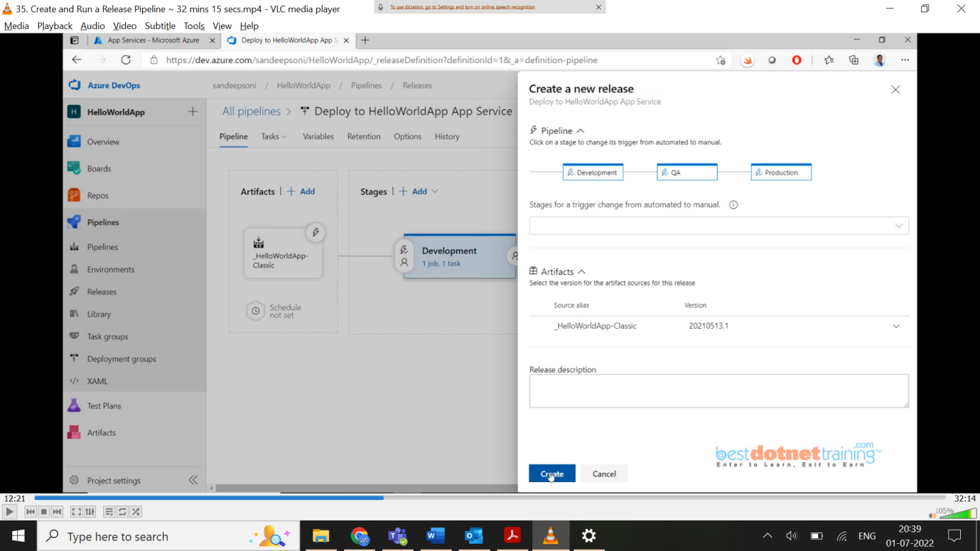

Simply click on create. You will see “Release-1” has been created. When you click the link, you will see the progress as below: you can see we manually triggered the create release option and currently dev is queued. When you click on logs button, you will see the progress.

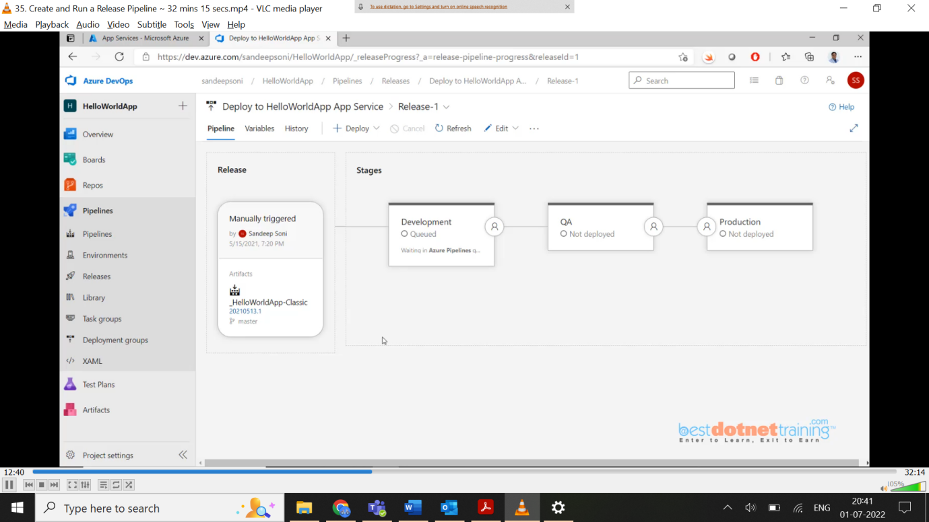

You can see below once dev environment published you will get approve option to the person whose email id given:

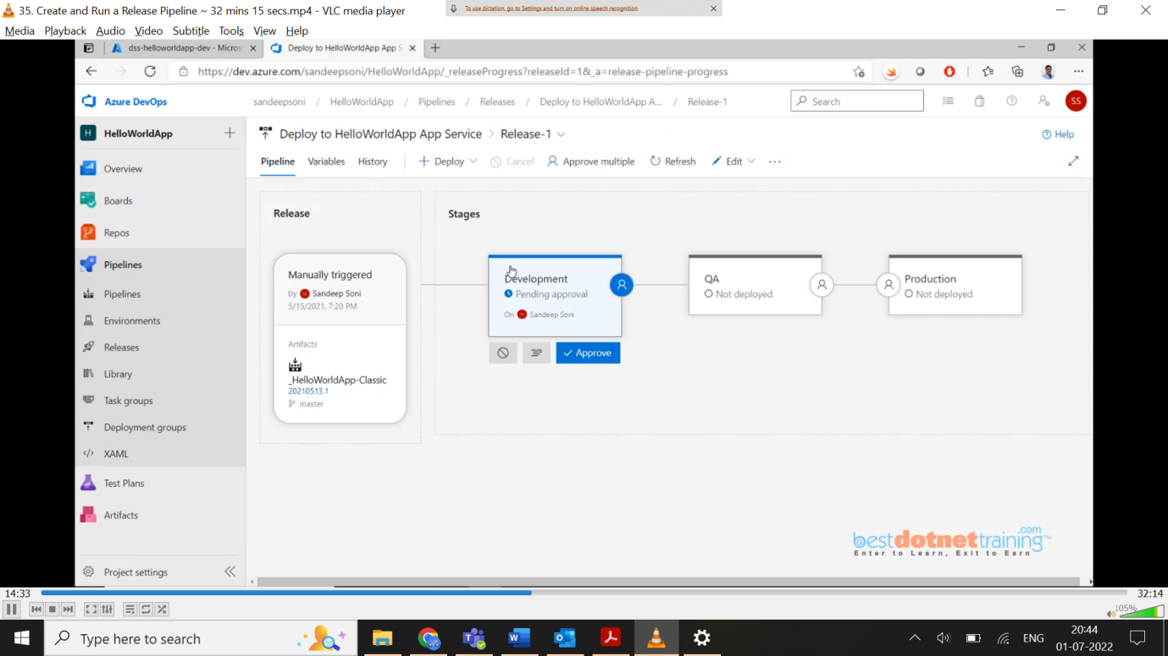

You can verify your dev app service by clicking on overview and clicking on the URL as below: you can see hosted website “hello world”. As qa is still waiting for approval when you check the URL of qa service, you will get default page of app service. Once we approve again we will see “hello world” page. For production case, first staging URL will get updated with “hello world” and our production URL will be with old content, once prod server gets “hello world” the staging URL will show old content because swap happens here.

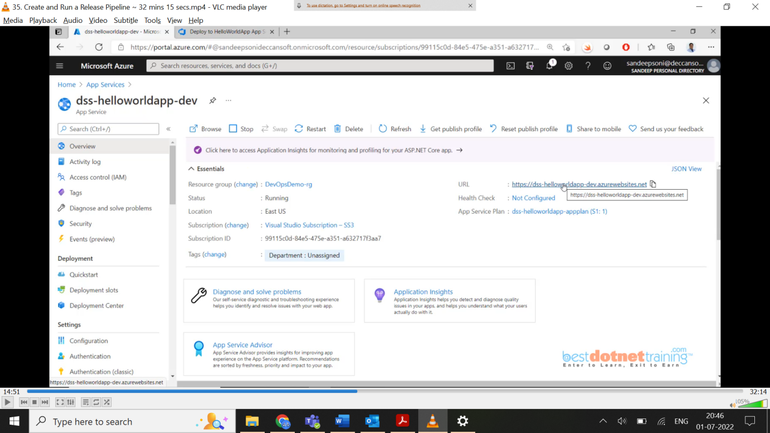

Check prod & staging URLs below:

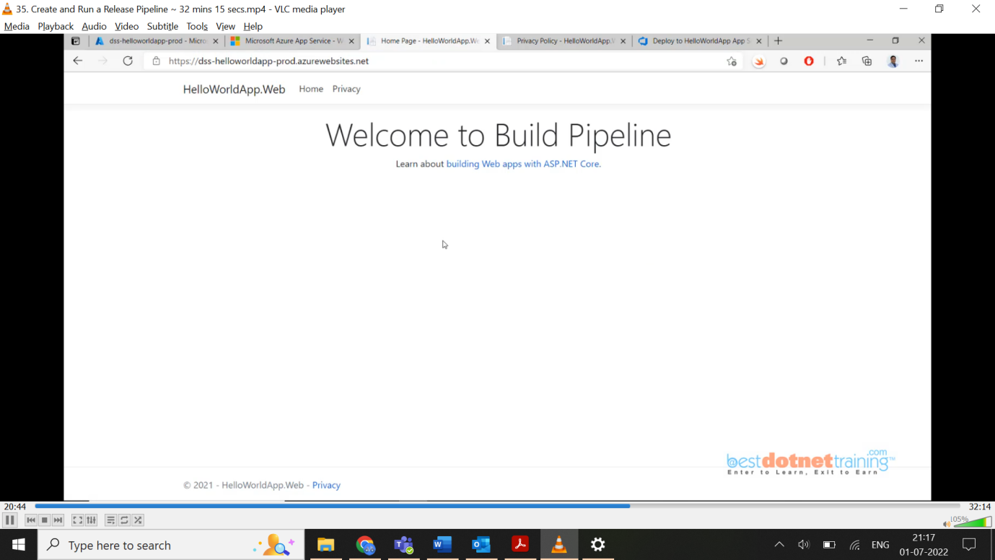

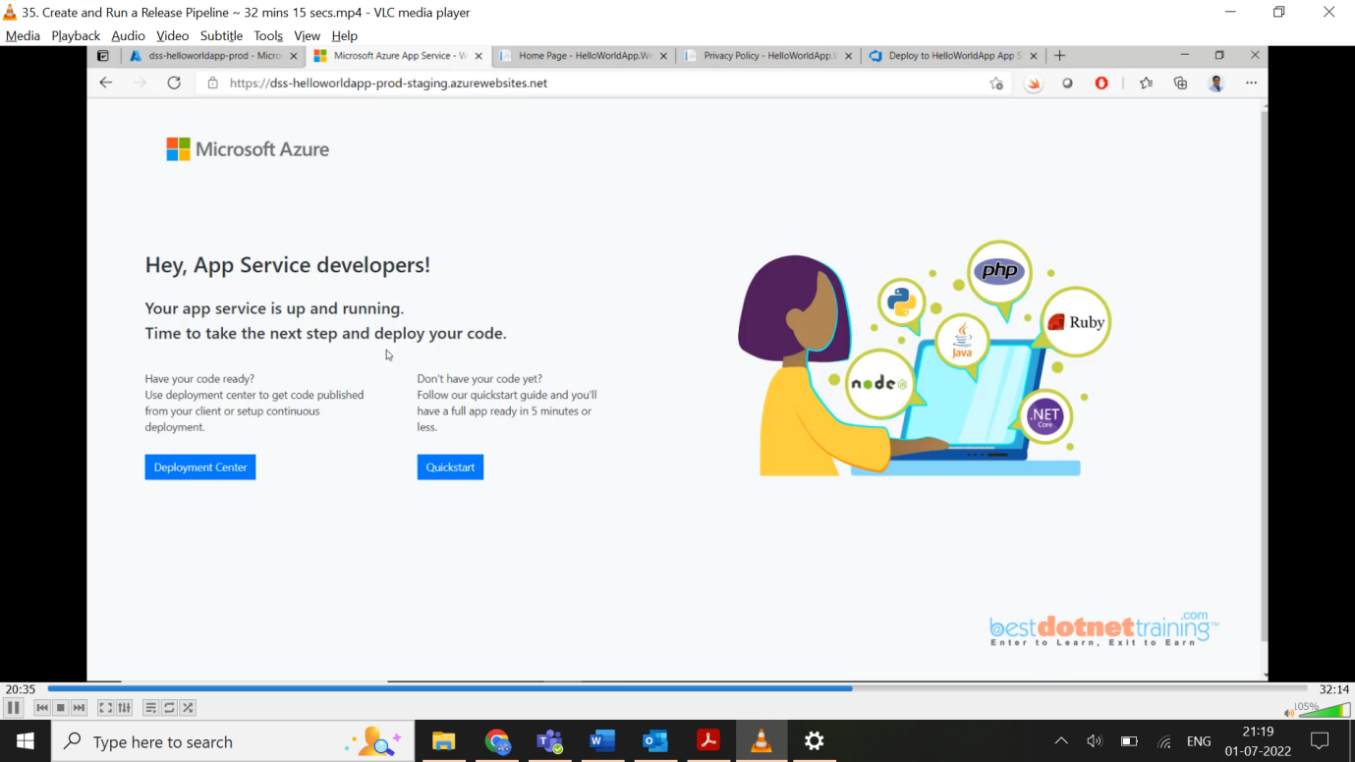

If you see something messy you can always go back to portal and swap staging and production manually as below: (see swap option)

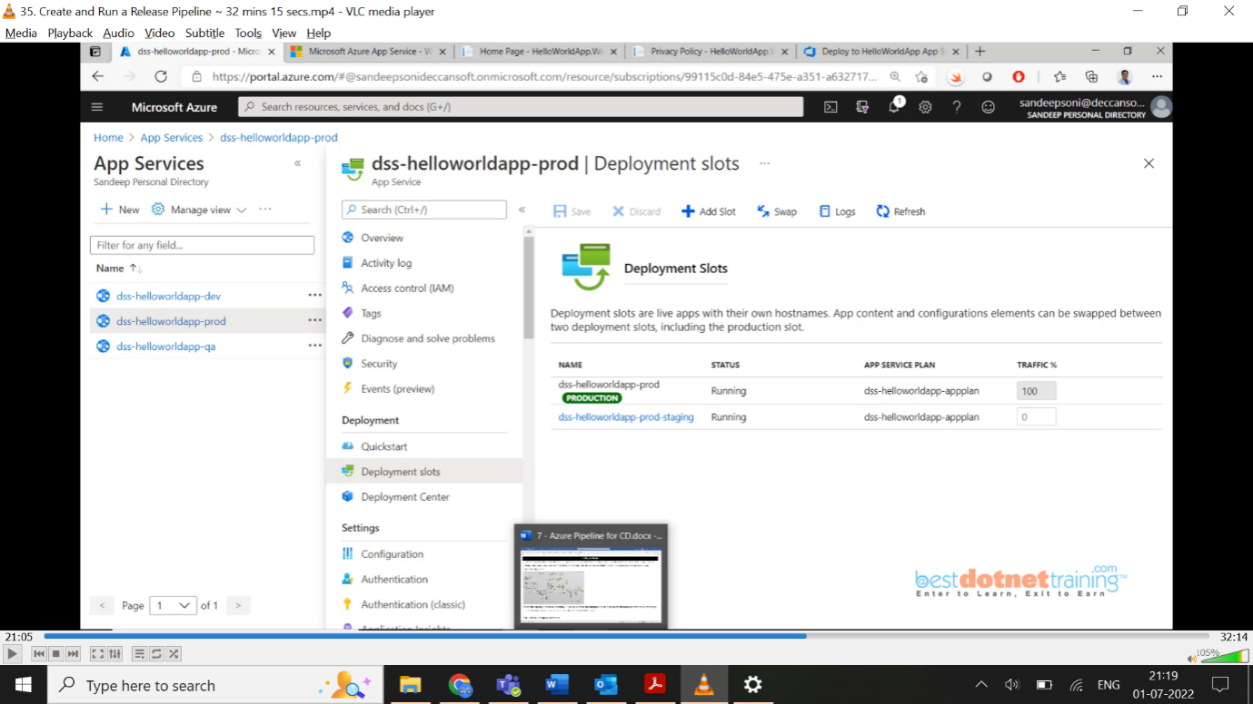  
Now as everything is successful, you can go back to releases and there you will find below screen shot with Release-1 successful with date and timestamp.

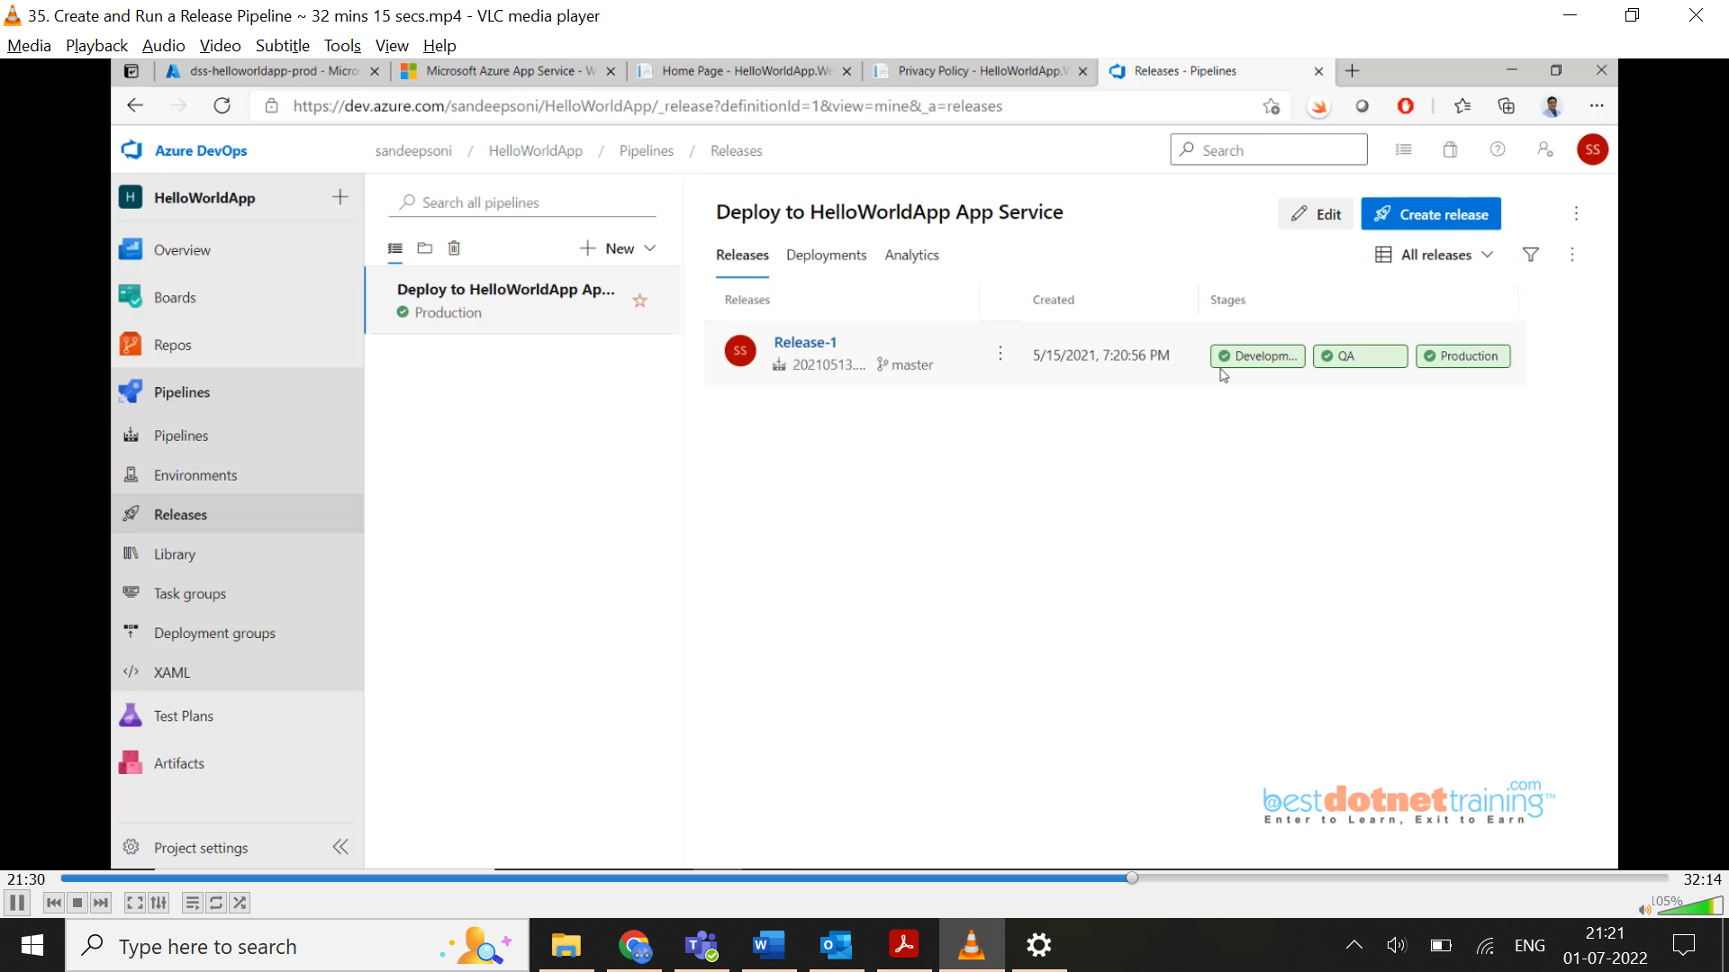

If production server crashes, easy way we can go to Release-1 and click on production there you will see redeploy button option which immediately publishes to prod with ease. This is the beauty of the pipeline concept.



Now we will see how Continuous Deployment happen in Release pipeline as we saw in build pipeline.

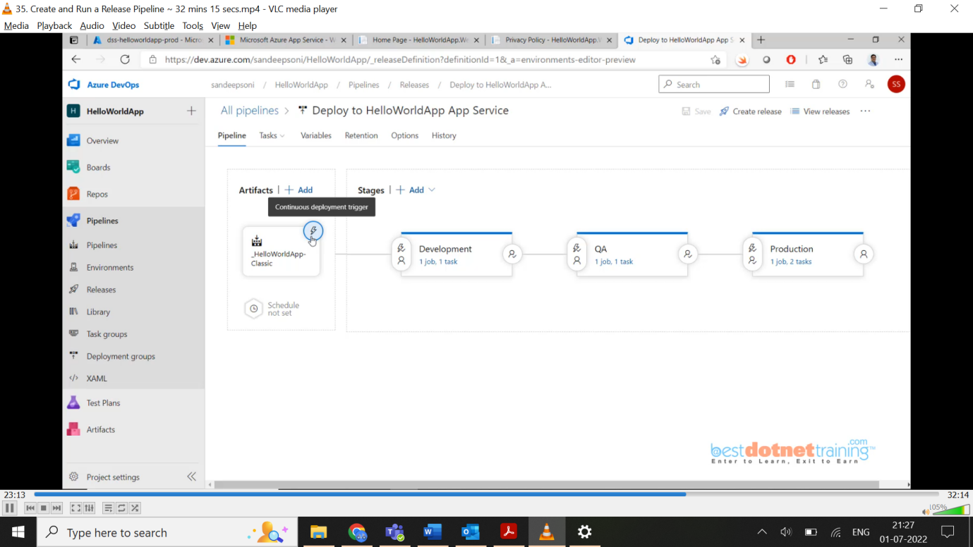

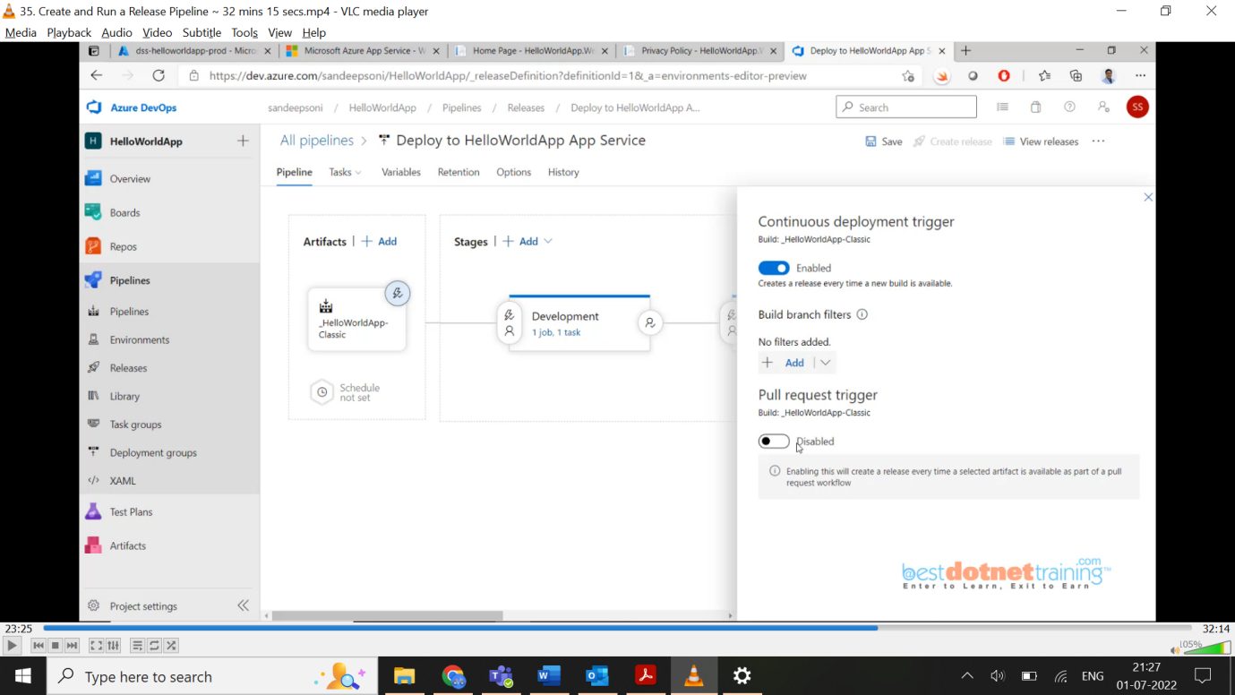

Now, everything is done end-end. To test, you can do some change to the code and push it to git. Automatically CI and CD will be done and post development deployment, you will need to either approve (or) reject. If you reject, the deployment will fail.

One final thing parallel deployment example as below: if we want QA2 to be deployed for another team, we need to add one more task and choose “after stage” option where we will give development. That’s it.

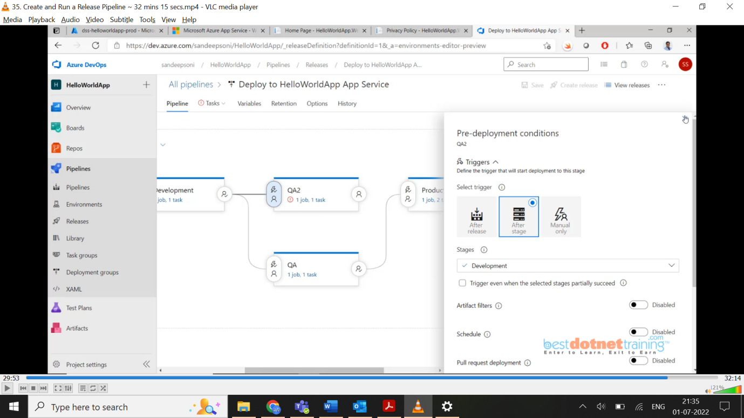

36. Deploying Application to **Virtual Machine** using **Release Pipeline**:

Up to now we have seen deployment on App Service, now we will start deploying into VM. Go to portal and search for Virtual Machine and create new as below. Because we are deploying a web server on VM, we will allow port 80 and RDP port 3389 to connect remotely. On next tabs give default values. Click on review + create.

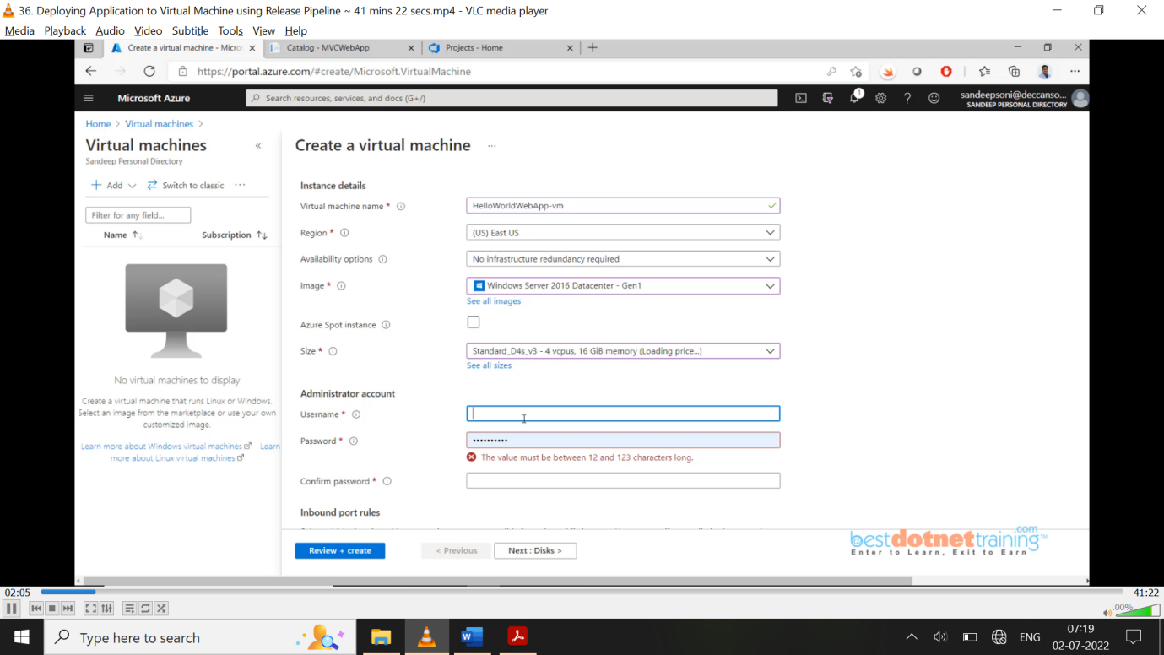

Once VM created, we need to install IIS and .NET core bundle. Connect the VM using RDP option available from azure portal as below:

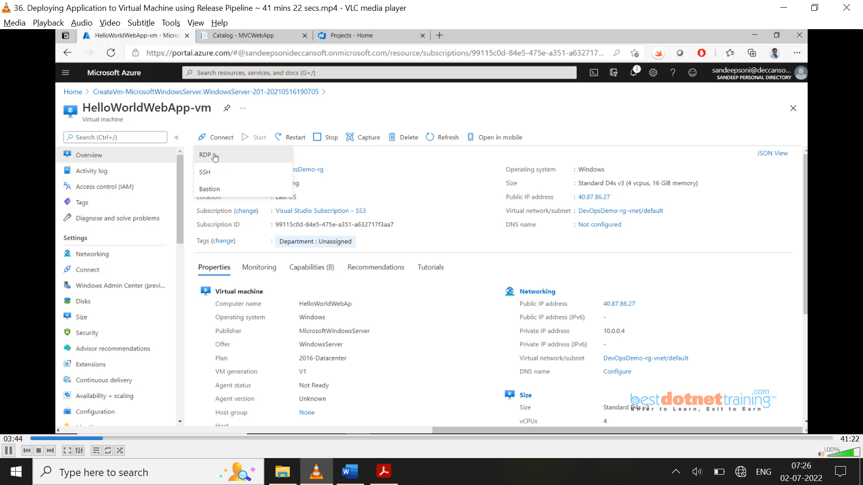

Download RDP file and we will connect using public ip option, to connect use the credentials we have created during VM creation (admin username & password). Once server manager loads as below:



Click on add roles & features 🡪 next 🡪 default value role based (radio button) 🡪 select a server from the server pool (radio button)🡪next 🡪 chose web server (IIS) as below: click on next and done.

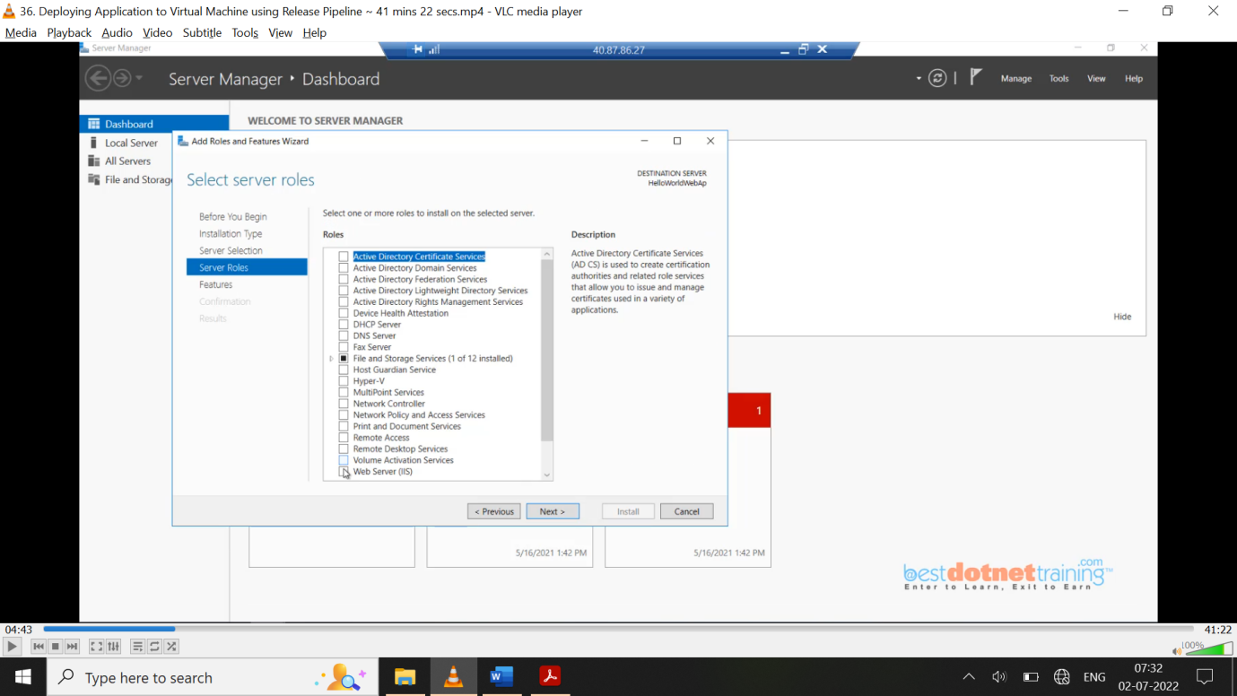

To install dotnet core, we need to download the s/w for that we need to disable security configuration on the server as shown below: search in browser asp.net core installation and download req. version in our case .net 5 and download “windows hosting bundle” from Microsoft website. When we click hosting bundle, we will get **click to *download option*** and also ***direct link*** option which will have full URL path.

Why hosting bundle? It will take care of installing all the required s/w required running for our application.

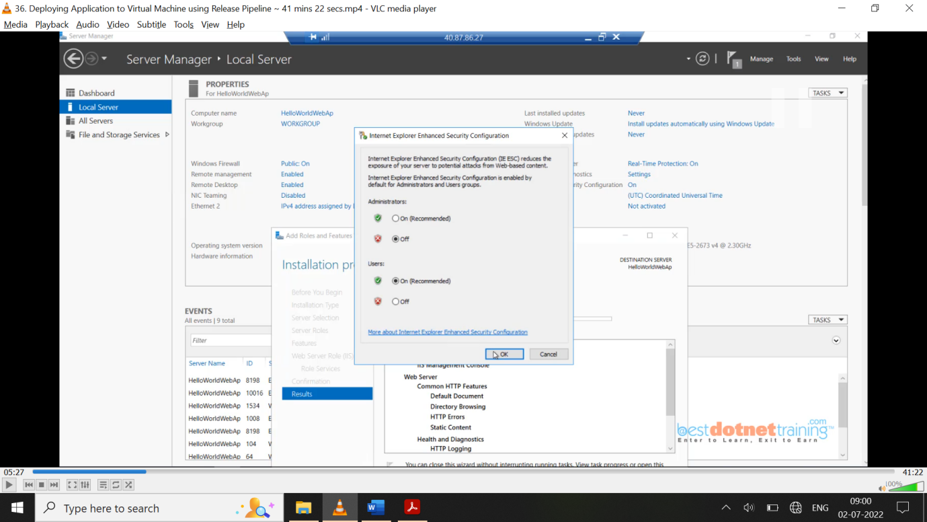

**Another way of doing it is using PowerShell command:**

On your VM, open an **Administrator: Windows PowerShell** console. Install IIS and the required .NET features:

1.Install IIS:

Install-WindowsFeature Web-Server, Web-Asp-Net45, NET-Framework-Features

2.Install the .NET Core Windows Server Hosting bundle:

Invoke-WebRequest https://download.visualstudio.microsoft.com/download/pr/24847c36-9f3a-40c1-8e3f-4389d954086d/0e8ae4f4a8e604a6575702819334d703/dotnet-hosting-5.0.6-win.exe -outfile $env:temp\DotNetCore.WindowsHosting.exe

Start-Process $env:temp\DotNetCore.WindowsHosting.exe -ArgumentList '/quiet' -Wait

The above 2 commands can be used in IaC (ARM templates) to automate the installation of webserver and .net core in pipeline itself.

Once installation is done, you can go to c:\inetput\wwwroot to check installation is successful. Once the application is published to this VM you will **see the files** in this wwwroot folder.

In order to automate publishing of our project we need to install ‘***agent s/w***’ on that vm and through that ***agent* s/w** we want to register that machine into azure devops.

To do all these things we have to create a deployment group. Go to azure devops project under pipelines 🡪 deployment groups 🡪 Add a deployment group 🡪 HelloWorldWebApp

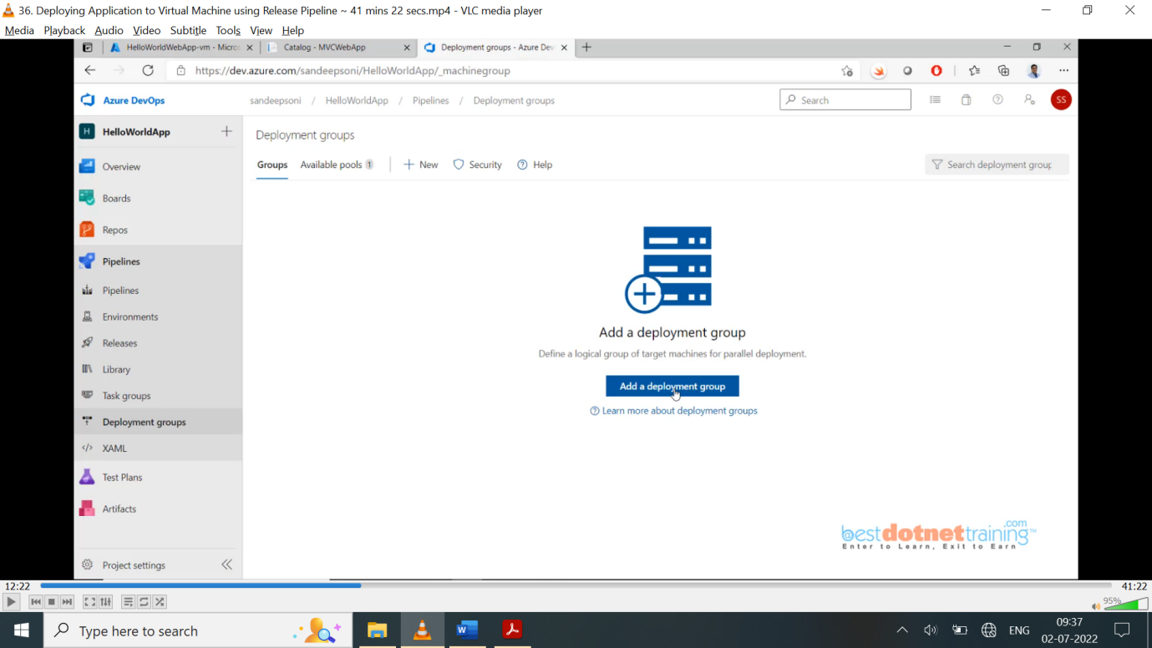

Once you open the deployment group ‘helloworldwebapp’ you will find **target** tab(**empty**) and default script which you need to execute on VM as shown in below screen shot. In this deployment group we will have VM registered (target tab will show up) when script executed on VM, Also, you will find check box “use a personal access token in the script for authentication”.

Copy the script and go to VM open “windows power shell” in admin mode and paste your script run that’s it.

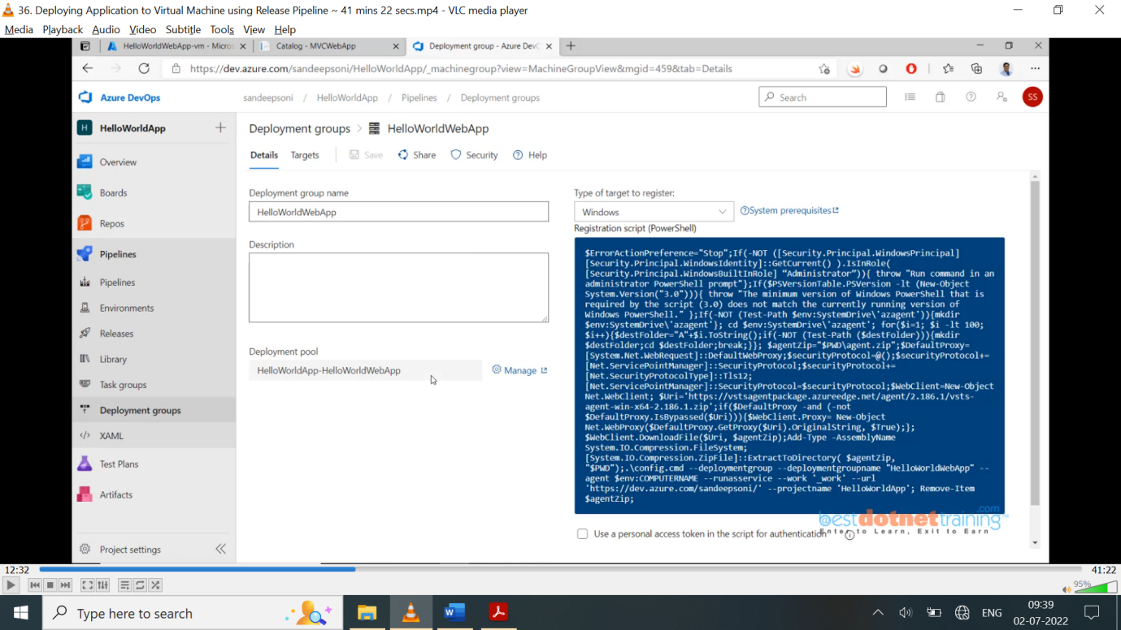

So, what is there on the script? It will download agent s/w on that machine and installs it as below: also, you will see it is connecting to server (devops server). Now in the deployment group we can have multiple VMs can be added with some tag probably not unique.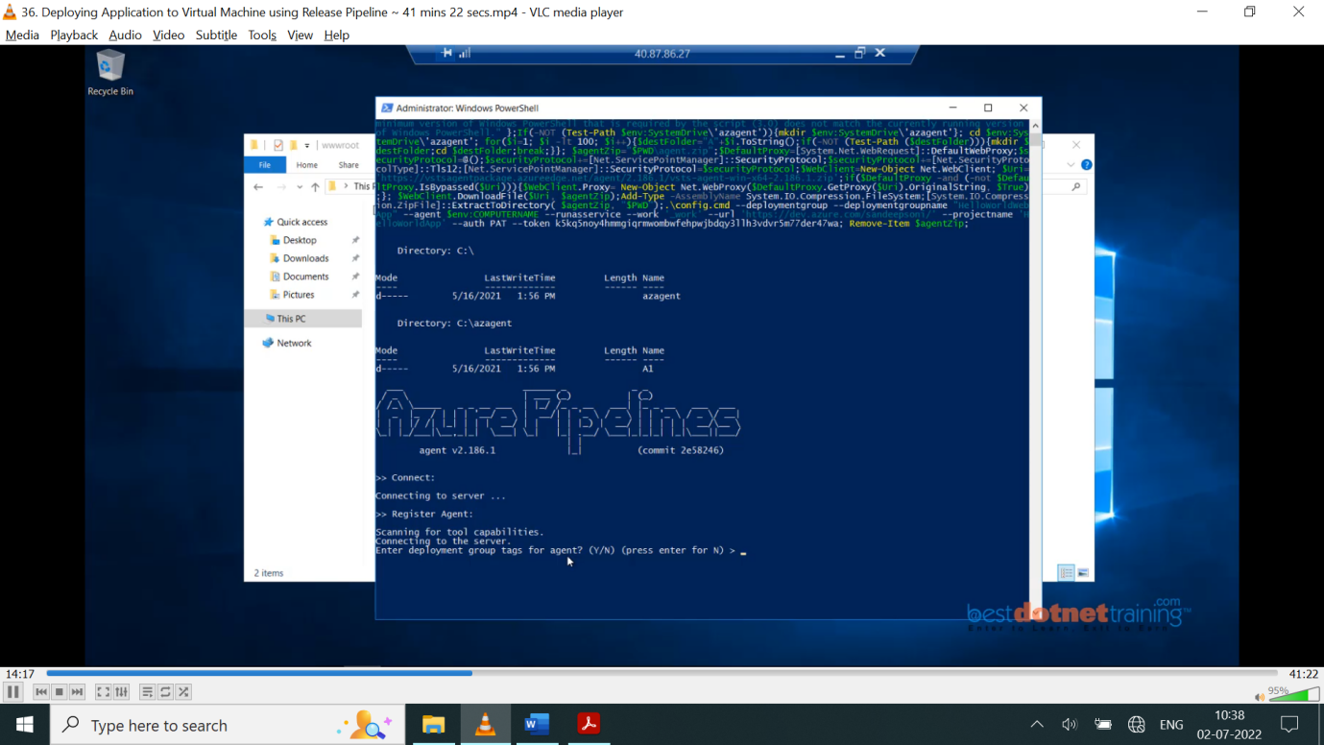

Devops machine with pipeline will talk to VM **agent** so, which user agent you want to use as a service. You can leave it as default account which is system account as shown in below screenshot:

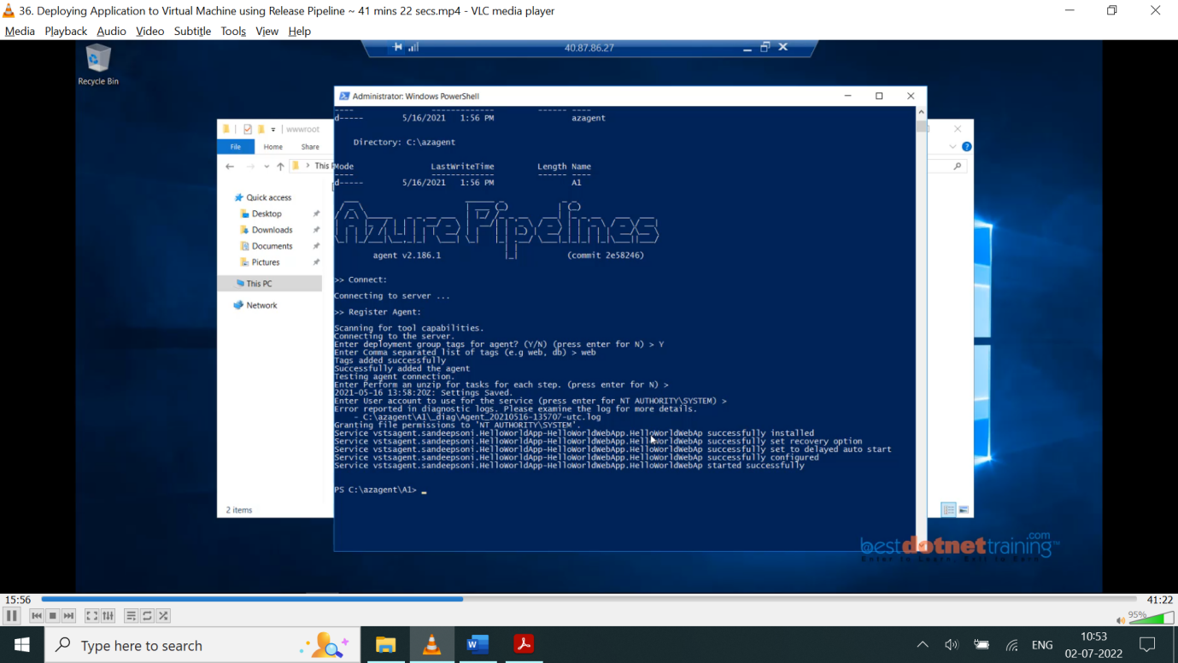

You can see in above screenshot that agent s/w installed in c:\azagent and with all file permissions. You can actually go to windows services (using task manager) and see that vstsagent also.

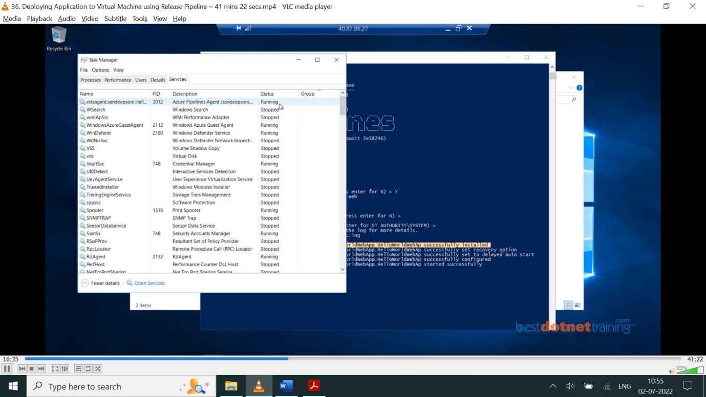

Also, now you can see the particular VM machine is registered in deployment groups under **targets** tab. Like this you can run the same script on other 2 VMs (qa, prod as in classic pipeline example) with same tag web and you will find them under targets tab. Deployment groups are a collection of V Machines on which we intend to install our s/w.

So now that the deployment group is ready and VMs are added to it now set the deployment group as the target to our *release pipeline*. Go to releases 🡪 click on new release pipeline 🡪 Search for IIS website deployment template – automatically required jobs are added as below: (IIS Web App Manage & IIS Web App Deploy).

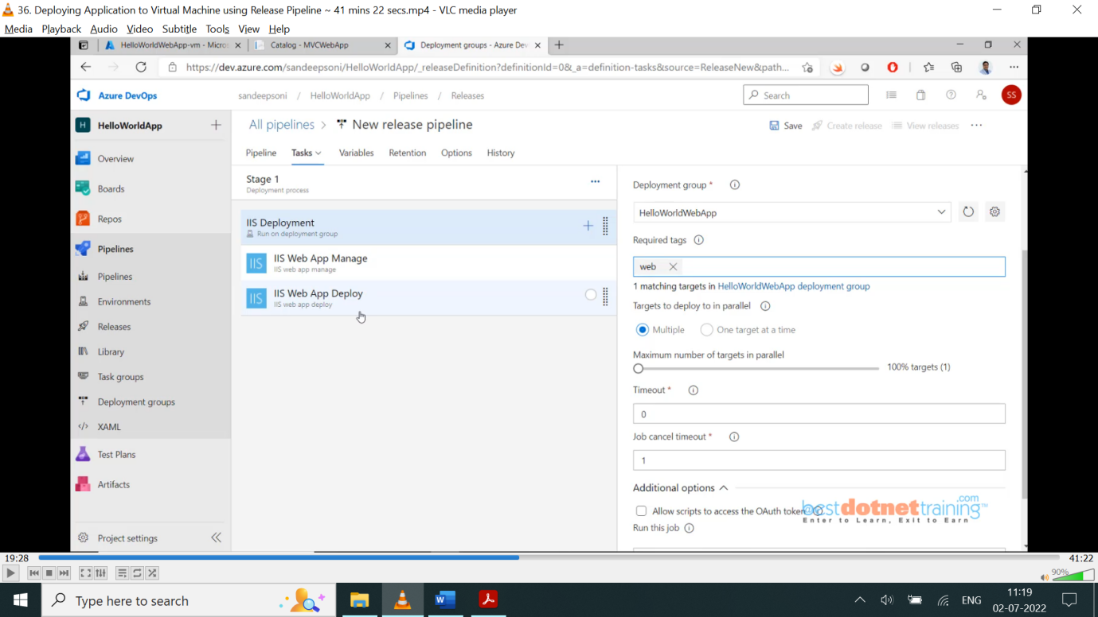

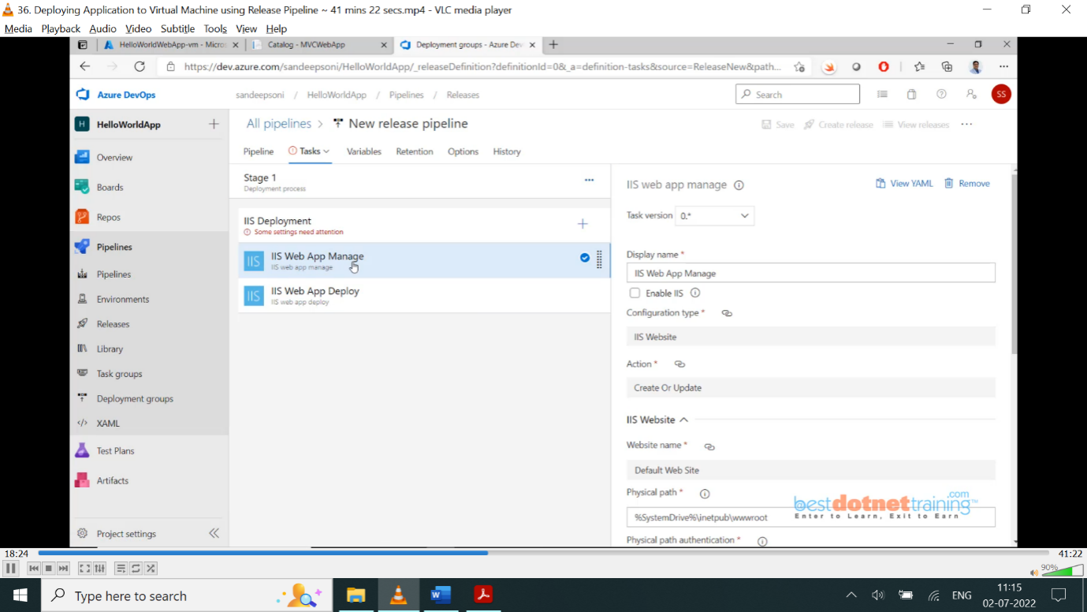  
Select IIS Deployment (deployment group name we just create in above steps) and leave default values. Also, for *IIS web app manage* and *IIS web app deploy* (Enable IIS check box installs IIS if not available) leave default values. If you use tag web, it further filters VM based on tag for deployment.

Now going back to *pipeline* tab, we need to add *artifact* which is input for CD Pipeline as we did in classic CD pipeline. The steps repeat like post deployment approvals etc.., as we did in ***app service*** deployment.

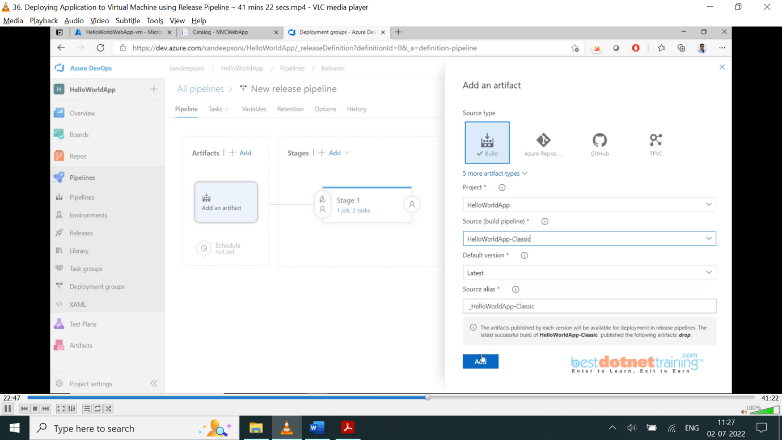

Now run the pipeline once job is finished to go VM and check wwwroot folder with project files published to confirm. Go to the VM and copy the public IP address and paste in browser our website will start working.

As we enabled port 80(while creating vm, rdp and http 80 enabled) it is working. If not done you can go to azure portal 🡪 networking tab 🡪 check http 80 port if not available, click on “add inbound security rule” and select http 80.

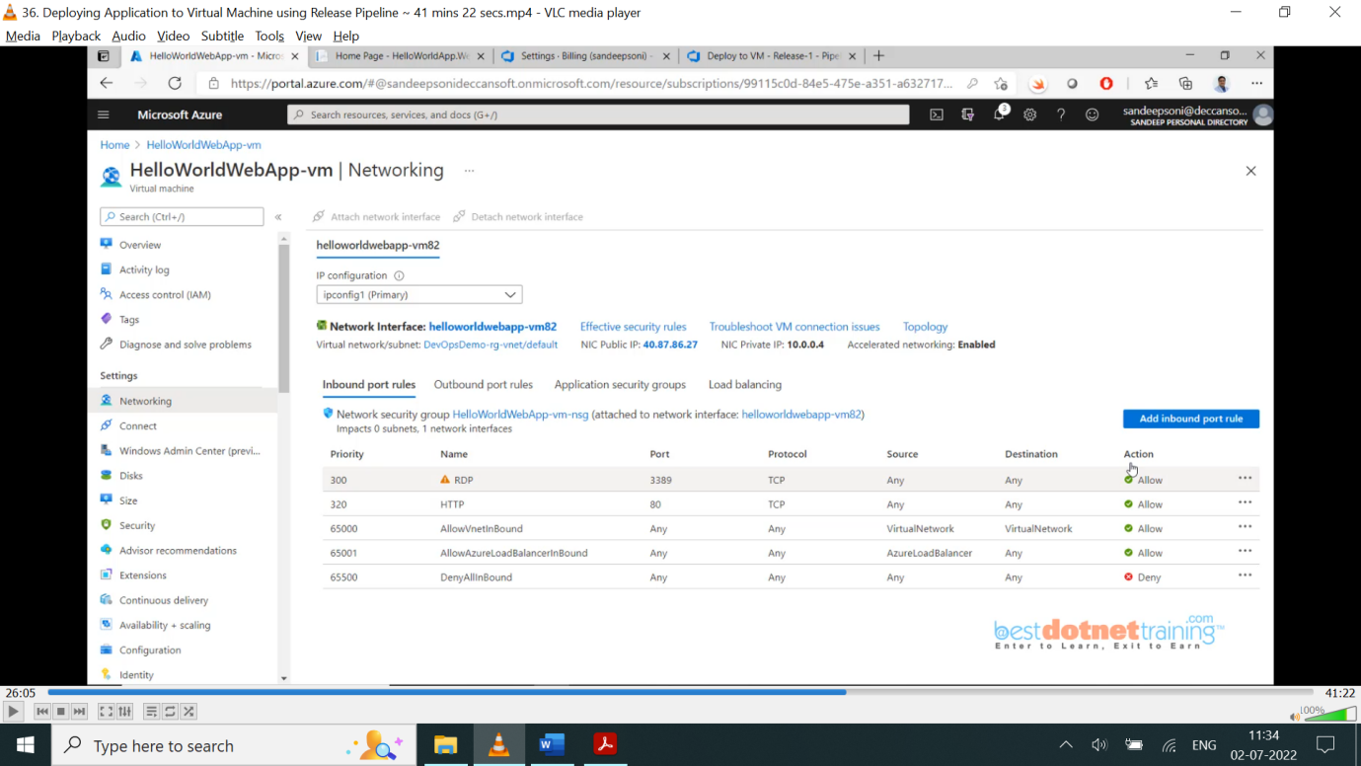

Note: - this agent s/w can be installed in 3 ways of which we saw using script installation.

You can install the agent in any one of these ways:

You can install the agent in any one of these ways:

1. Run the script that is generated automatically when you create a deployment group. (**We did this**)

2. Install the Azure Pipelines Agent Azure VM extension on each of the VMs. (For this option we also need PAT token which we get from azure devops and go to ***user setting*** on top right corner click on PAT and create)

3. Use the Azure Resource Group Deployment task in your release pipeline (ARM Templates): The same second option Extension is used in ARM Templates while creating VM.

Note: - This procedure remains same for all applications like windows/web services etc. except the tasks will change a/c to the application.

One more catch here there will be no agent on the azure devops it is just devops service which talks to agent on VM for “Add a deployment group job”. “Add an agentless job” (used to invoke like azure functions where we don’t need agent). Agent is required if something need to be configured/install/execute something), “Add an agent job” (which will be on self-hosted (or) Microsoft hosted in this case there is no VM concept). So, we have an agent running in the devops process/ on VM on either case.

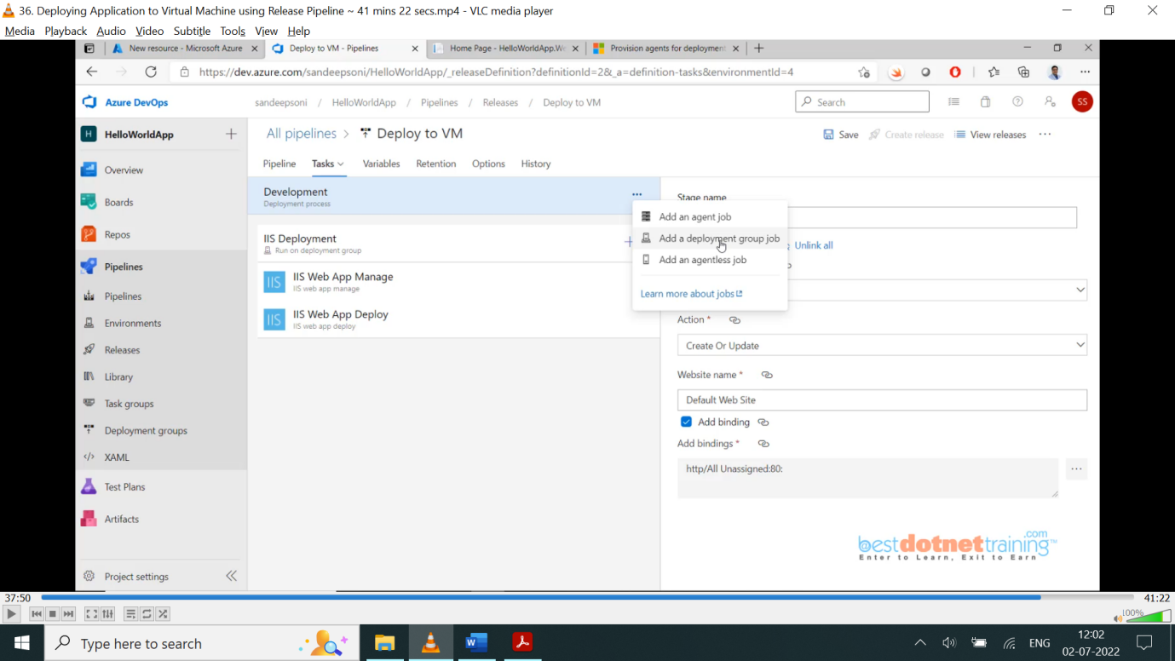

37. Creating a Service Connection to Azure Subscription Manually:

Now we will create a service connection manually we earlier saw Automatic. Automatic will work if you have same account in devops and azure with the subscription.

Now service principal (manual) option: - go to azure portal search for subscription and copy subscription Id & name. Also, we need *service principal Id*, *service principal key* and Tenant ID as shown below:

How we get these? Every subscription will have associated AD when we open that on azure portal, we go to “App registrations” and create new app registration like AzureDevopsServicePrinciple and leave all other remaining default values and create.

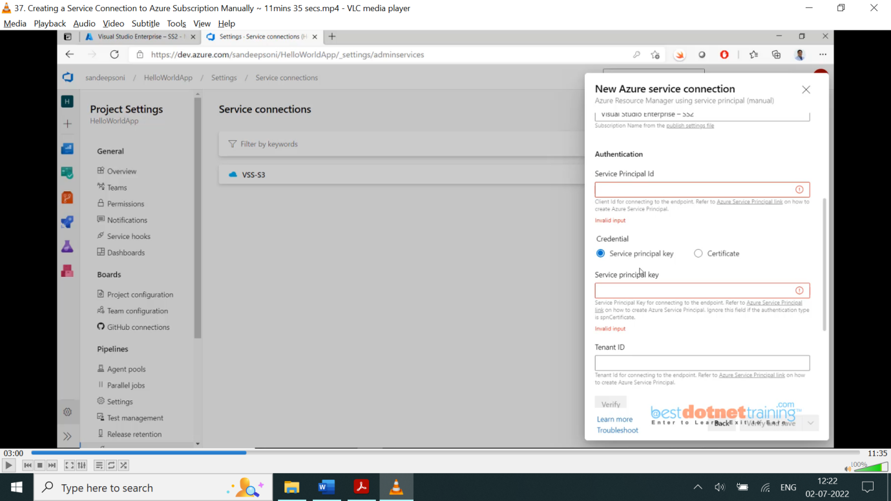

Once created app registration you will find client id (service principal id) and tenant id. To get key you click on certificates and secrets on left navigation you will have choice of upload certificate and create client secret.

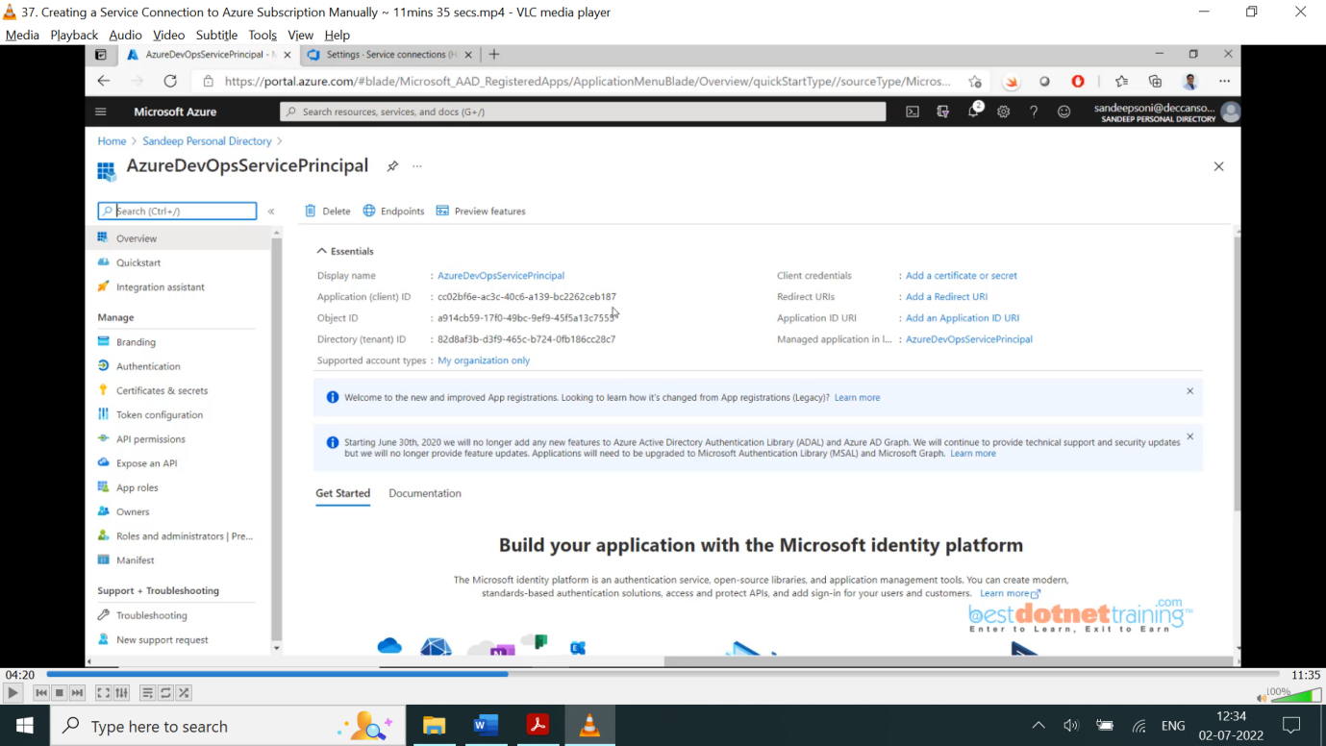

We will choose second option as show below 2nd screenshot:

Once you add all 3 fields and click on verify it will fail why because, the service principal is not given permission on this subscription.

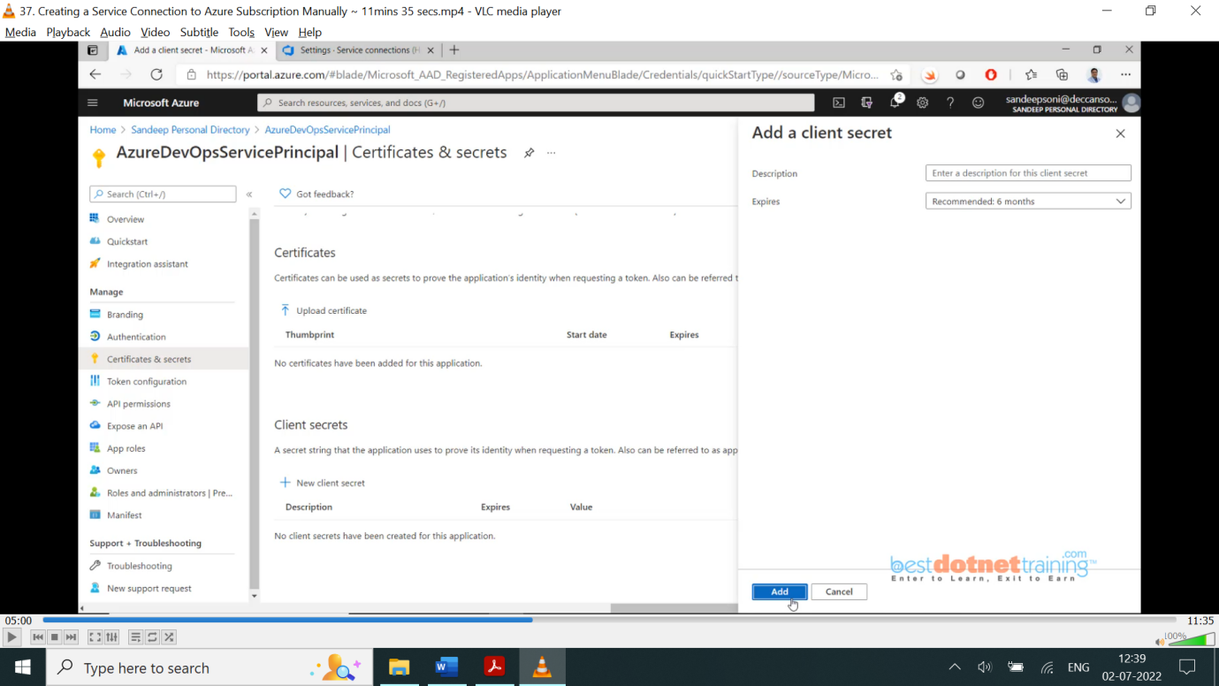

So, anything you want to perform on the subscription go to the subscription and click on the Access Control (IAM) 🡪 role assignments 🡪 most powerful role is “owner” which will not be given, and we will give contributor option as shown in 2nd screenshot below:

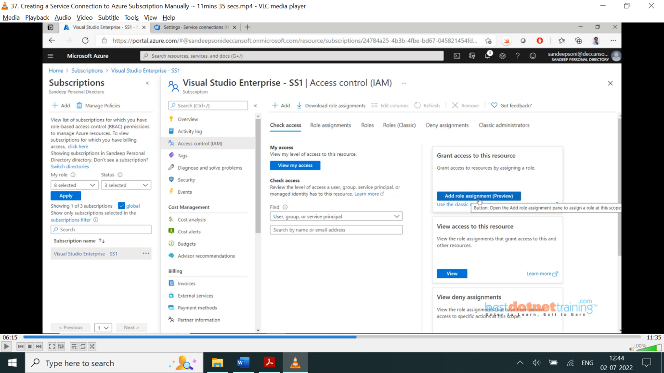

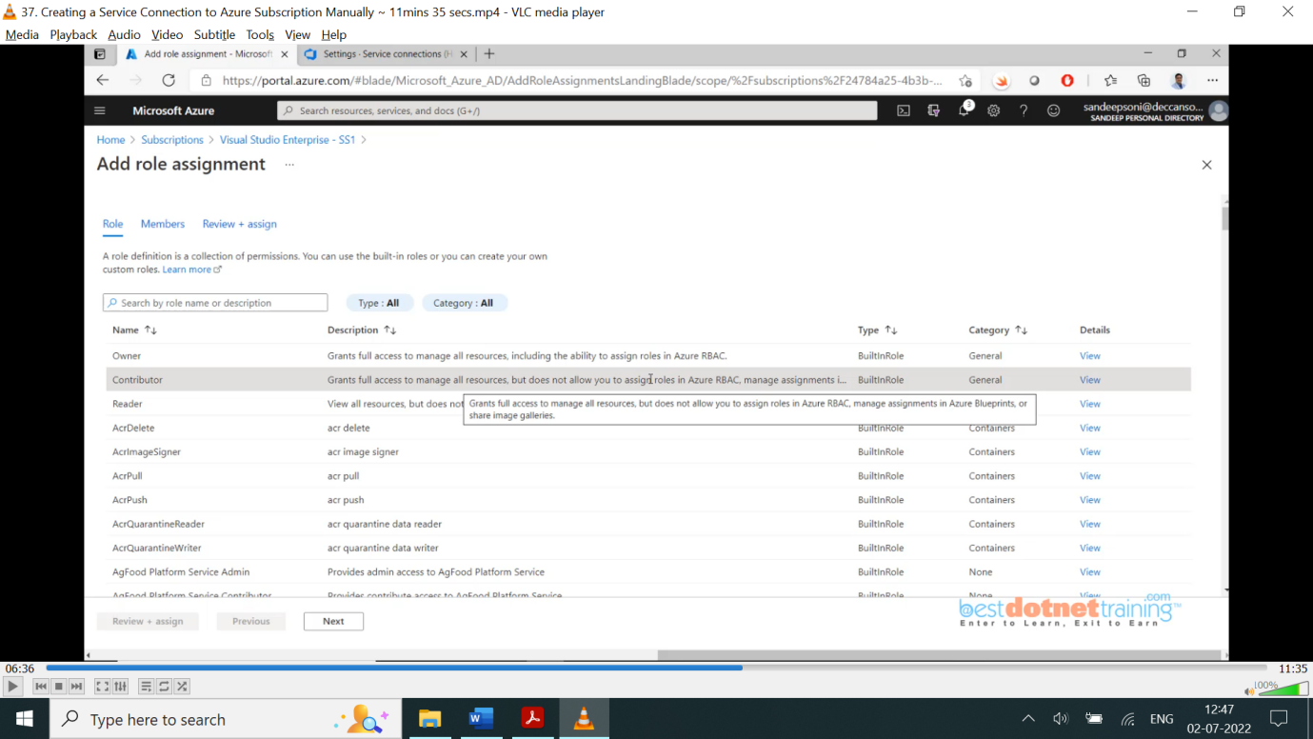

Select member option and choose our service principal.

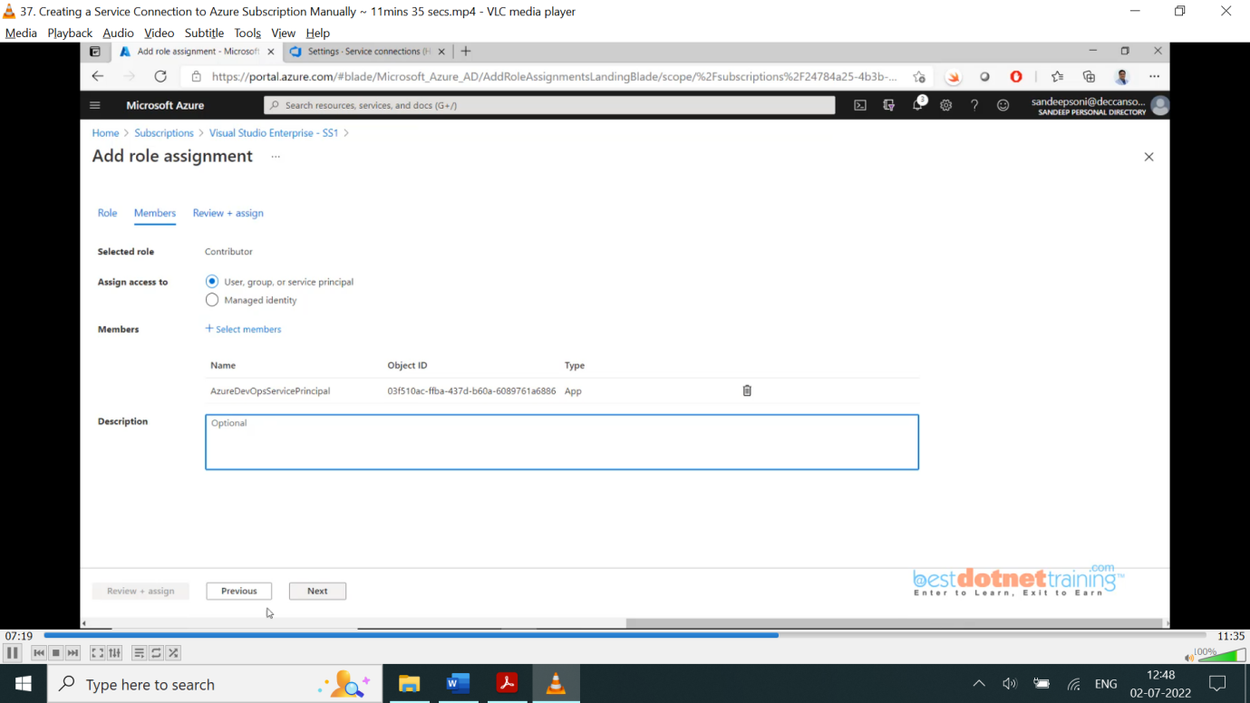

what we did? To a service principal we added a role called contributor over subscription. So automatically that particular role becomes contributor for a resource group under that subscription and now go back and click on verify. Once verification success gives some name to the service connection like “VSS-SS2”. Verify and save done. Now service connection is ready.

38. Working with Gates in Release Pipeline:

We have seen approvals already. Now we will go through Gates. Approvals need human interactions. But gates are automated tests which are going to be performed. Automated test which will ensure that the system is robust when the code is getting deployed into the environments. Where do we enable gates? Go to release pipeline 🡪 click on pre-deployment condition 🡪 there you will find gates 🡪 when enable gates you will see multiple options as below:

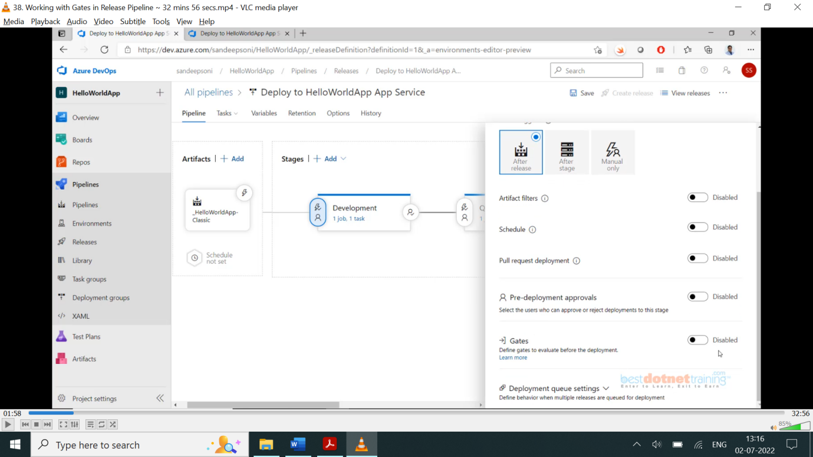

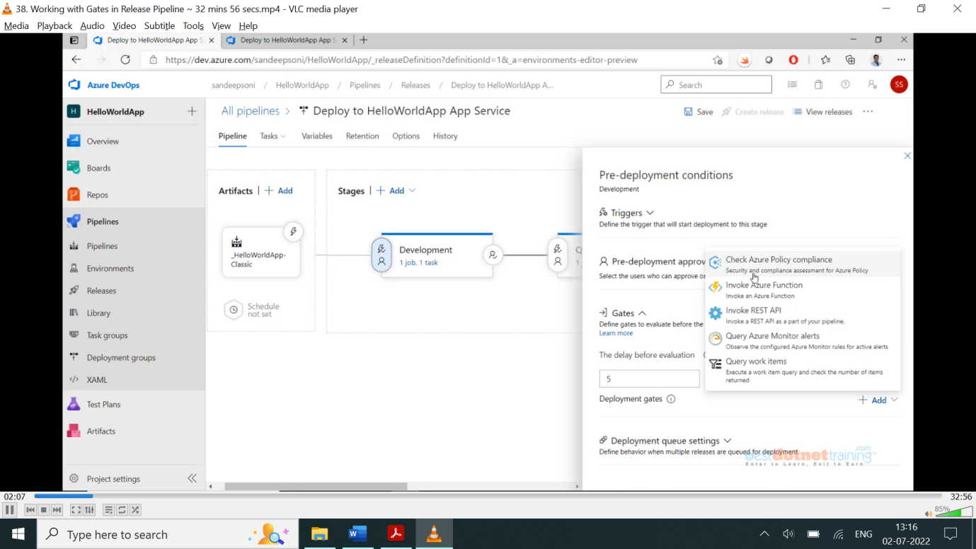

We will now go with “Query work items” option. When you select this item, we need a Query. Where is this query? You need to go to *Azure boards* and click on *work items* click on bug for testing purpose. Create new bug with “title is incorrect” state as “new”.

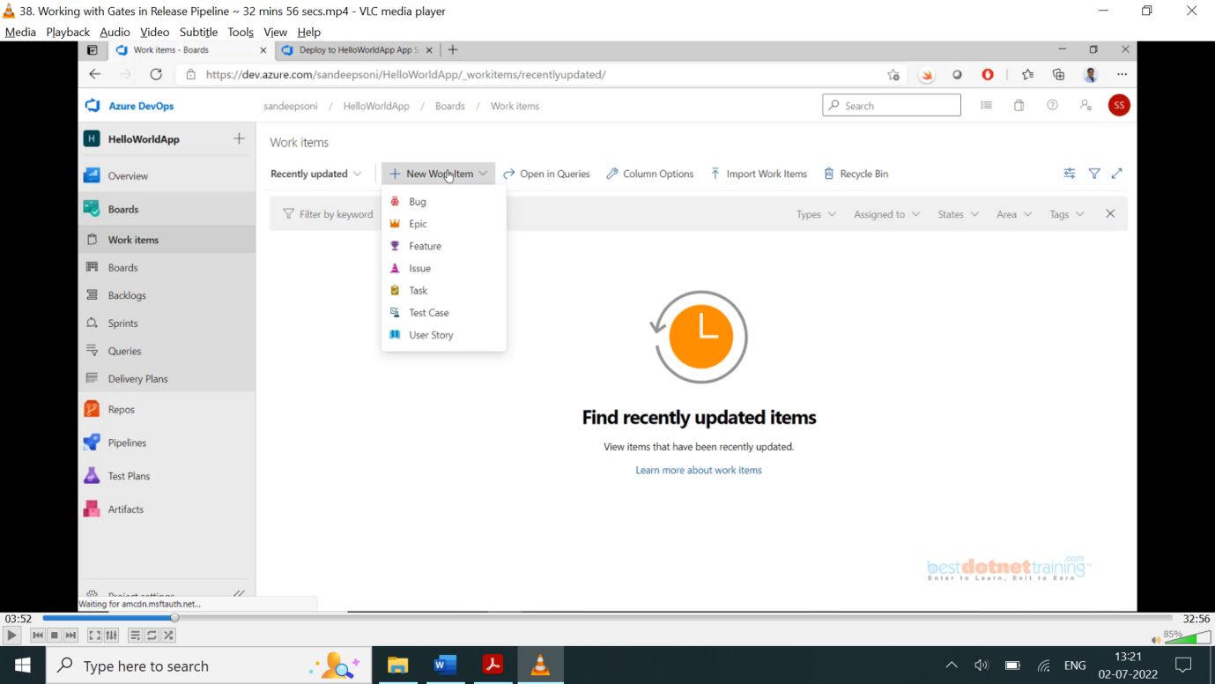

Once bug created, click on Queries and create a new query as in below screenshot and run query you will get 1 new bug and save query with name BugList into one of the folders: “My Queries” (only available to you) and “Shared Queries” it will be available to others also. We use shared queries as we need to use it in pipeline.

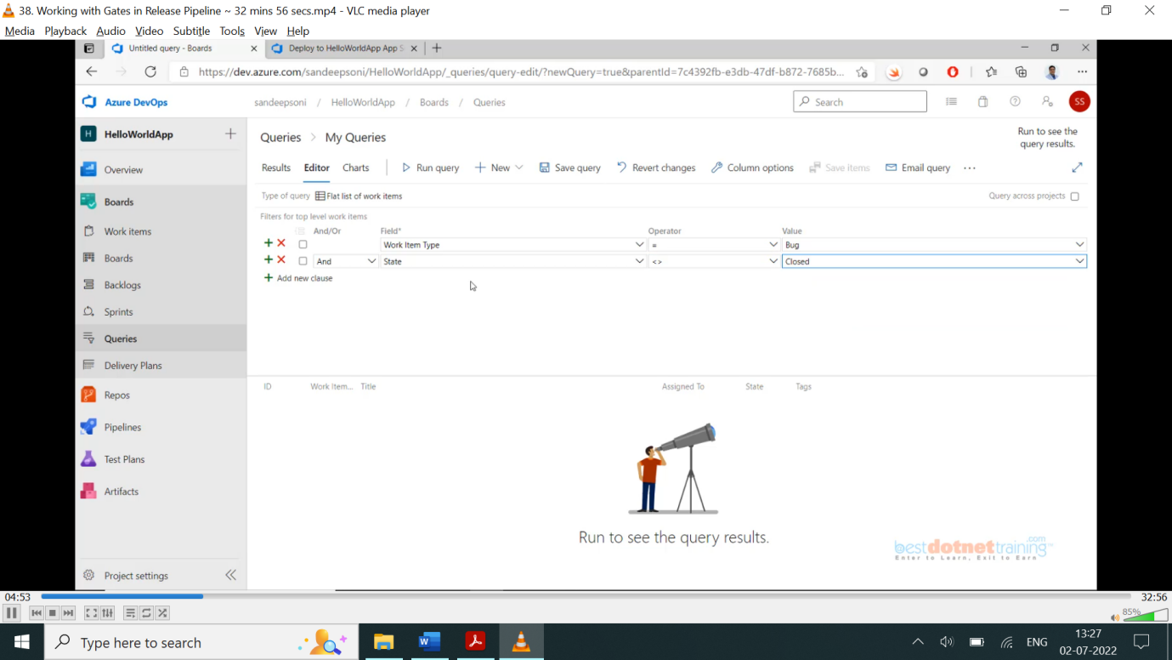

Whenever state is not closed bug is seen deployment will not happen. Now go to pipeline 🡪 release pipeline 🡪 edit 🡪 click pre-deployment condition 🡪 enable Gates 🡪 add Query work items 🡪 Query 🡪 choose value “BugList”.

Some fields: Upper threshold: 0 🡺 means how many bugs are allowed: 0.

Check some other fields and fill appropriate values if needed and finished. It will fail because we allowed 0 bugs and we created one bug. Again, it will run after 5 mins as we given in properties before that time if we fix the bug by changing status to closed, the Gates will allow the release.

Note: - Use the below link if the release fails again, it is security issue:

<https://stackoverflow.com/questions/65592600/error-regarding-query-work-item-gate-in-azure-pipeline>

**Solution:**

Go to boards 🡪 Queries 🡪BugList … click on 3 dots and select *Security* under permissions 🡪 users’ section🡪 HelloWorldApp Build Service 🡪 give read permissions: *Allow*. This will fix error.

**Azure Functions**:

Let’s use Azure function using Gates. Go to 🡪 Azure portal 🡪 search function App 🡪 create function app 🡪 see below: leave rest tabs with default values.

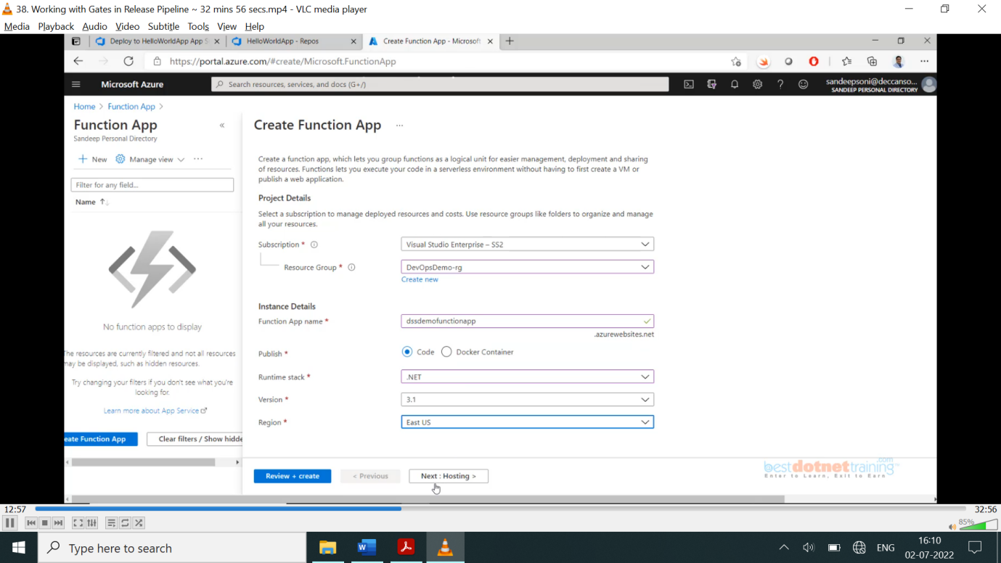

It will create the function app; inside the function app we will create a function. Go to functions 🡪 Add 🡪 we should add a HTTP Trigger function as below: give some name: GetStatus 🡪 create

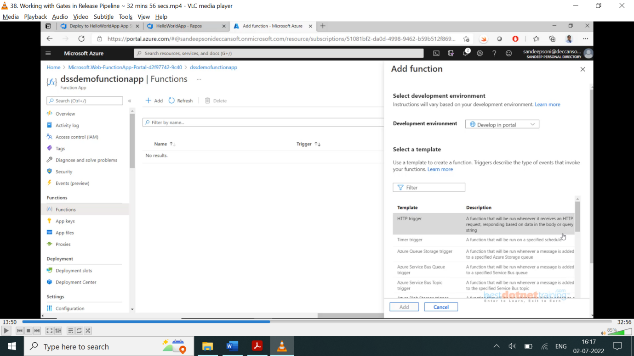

Go to GetStatus function 🡪 some code will be there as shown below:

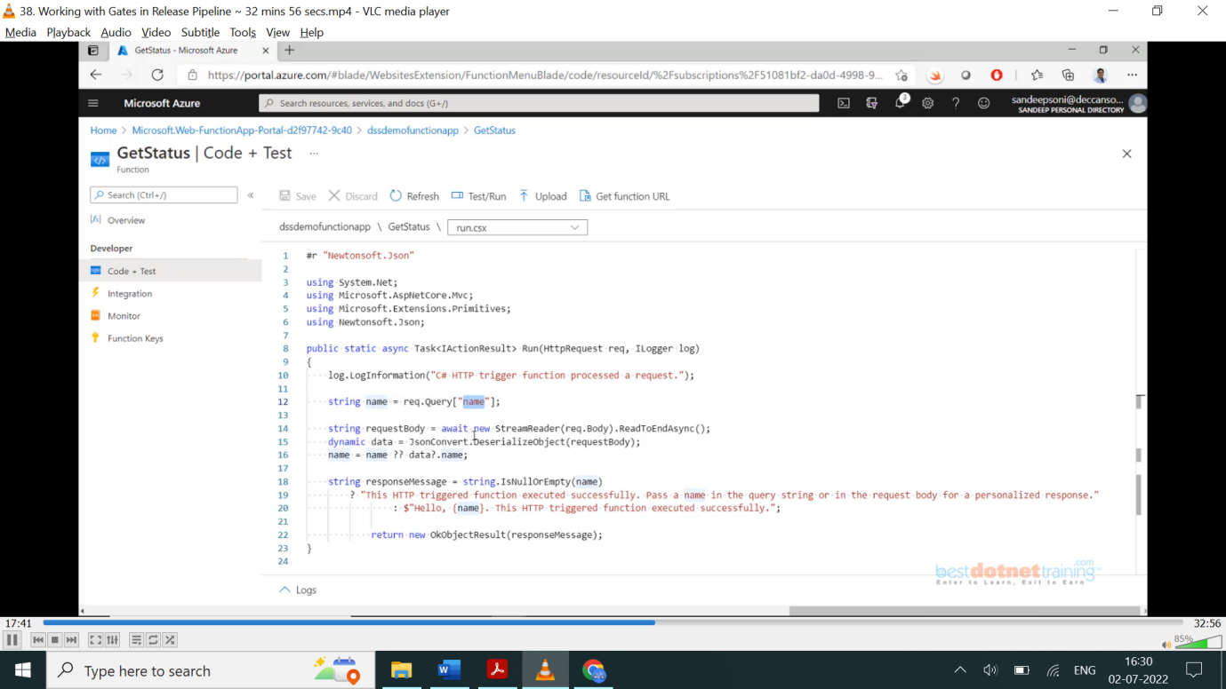

We will modify the function as shown in below screenshot just to test a function: here when you save the function it automatically runs and validates for any errors. Once compiled successfully, go to the devops 🡪 releases 🡪 edit release 🡪 open pre-deployment condition 🡪 Gates 🡪 Disable “Query work items” as we got issue with it, choose “invoke Azure function”. You need *Azure function URL*: you get it from azure function (GetStatus) 🡪 Get function URL (which will have both URL and key. Copy till GetStatus) & *azure function key*: copy from code=” the value will be here”.

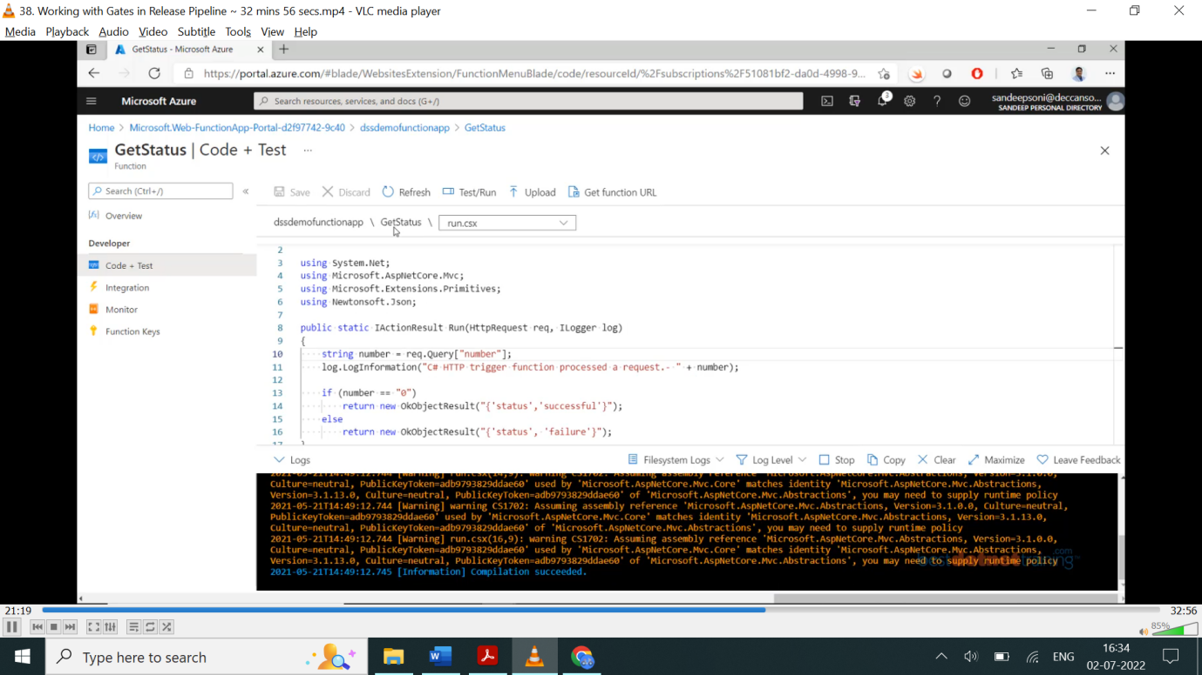

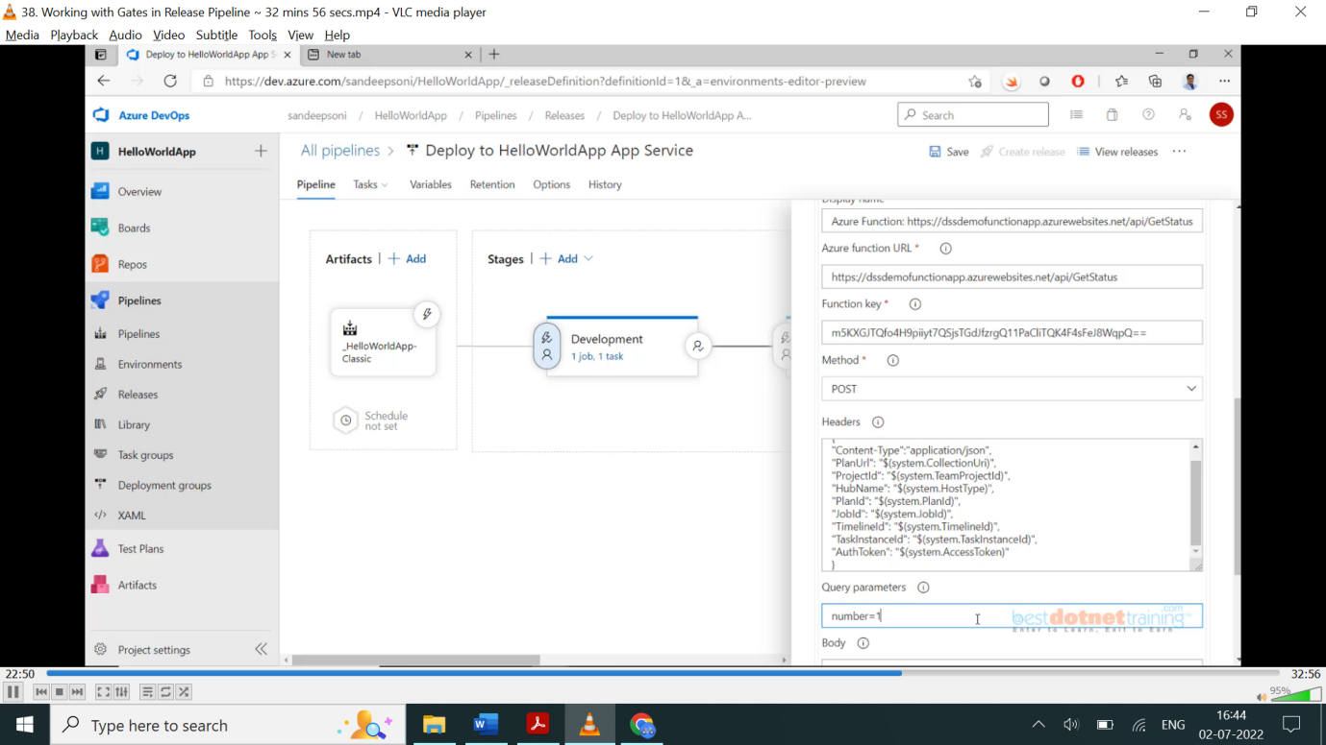

Also, success criteria field is required as below:

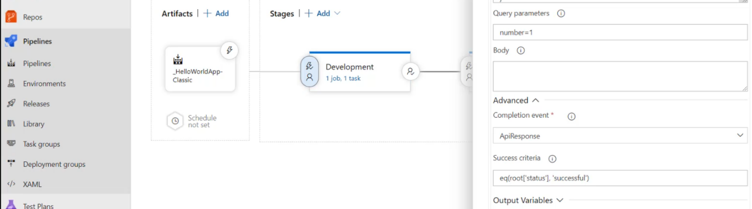

When you run second gate azure function app will fail as the value = 1 we given, and we are checking in the code with value 0. Once we modify code value to 1, it will work.

Now when you run the release pipeline, both the gates will be successful as shown below:

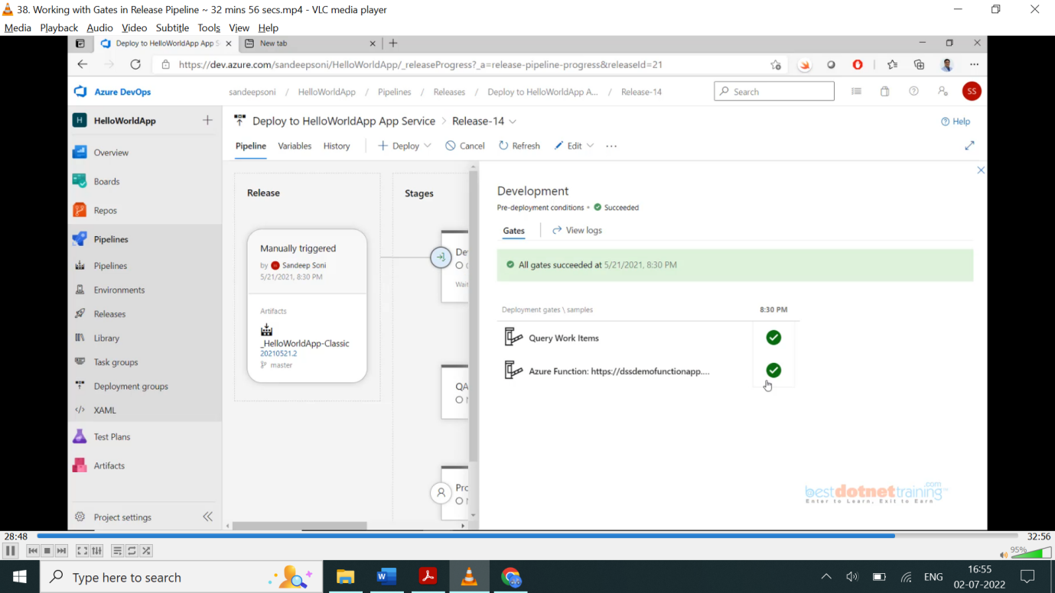

This is how gates can be used for checking with automation. But for production case we should not do automation we need human interaction just to allow/reject. To do this use “agentlessjob” option

And select task “manual intervention”. on release pipeline 🡪 create release it will wait for manual intervention as shown below:

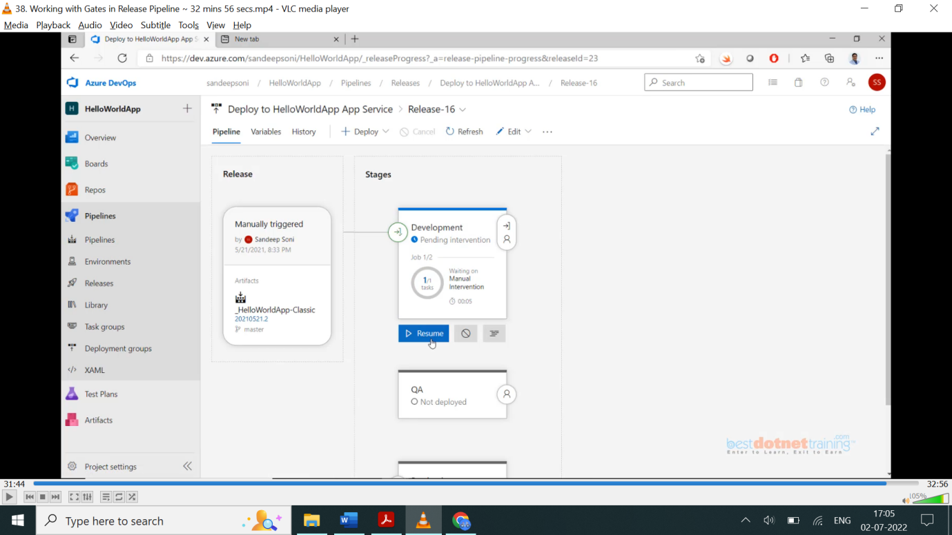

**Folder 7. Continuous Deployment using YAML Pipeline:**

**39. Multistage YAML Pipeline to Deploy to AppService without approvals:**

Now we will do YAML way of deployment to app service. For that as we created YAML pipeline in CI Pipeline (Build pipeline) we can reuse it by adding the content to stages 🡪stage 🡪Jobs 🡪Job.

And the last step we did in build pipeline “PublishBuildArtifacts” has been replaced with latest “publishPipelineArtifacts” (why? publishPipelineArtifact has better performance than buildArtifact).

In YAML we write build and release pipeline in single YAML file only that’s why we edited Build pipeline and also added deployment steps.

Structure of the YAML pipeline:

trigger:

- master

Stages:

- stage: “BuildStage”

Jobs:

- job:

Steps:

After all steps finished final outline YAML looks like below:

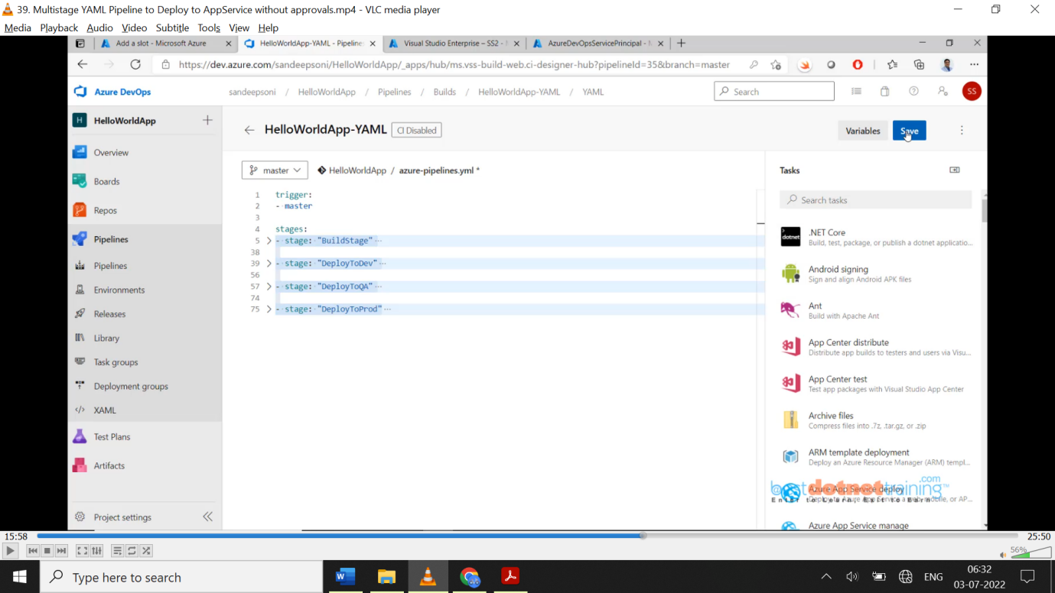

The code being added automatically when we select tasks from the search as below:

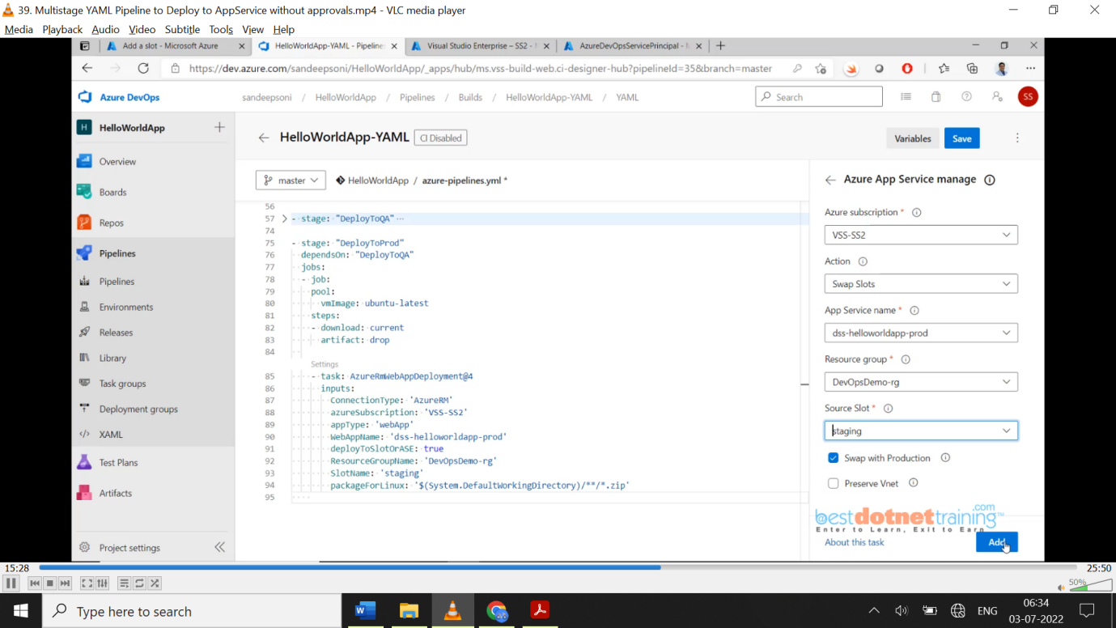

Azure app service manage section after adding looks like below:

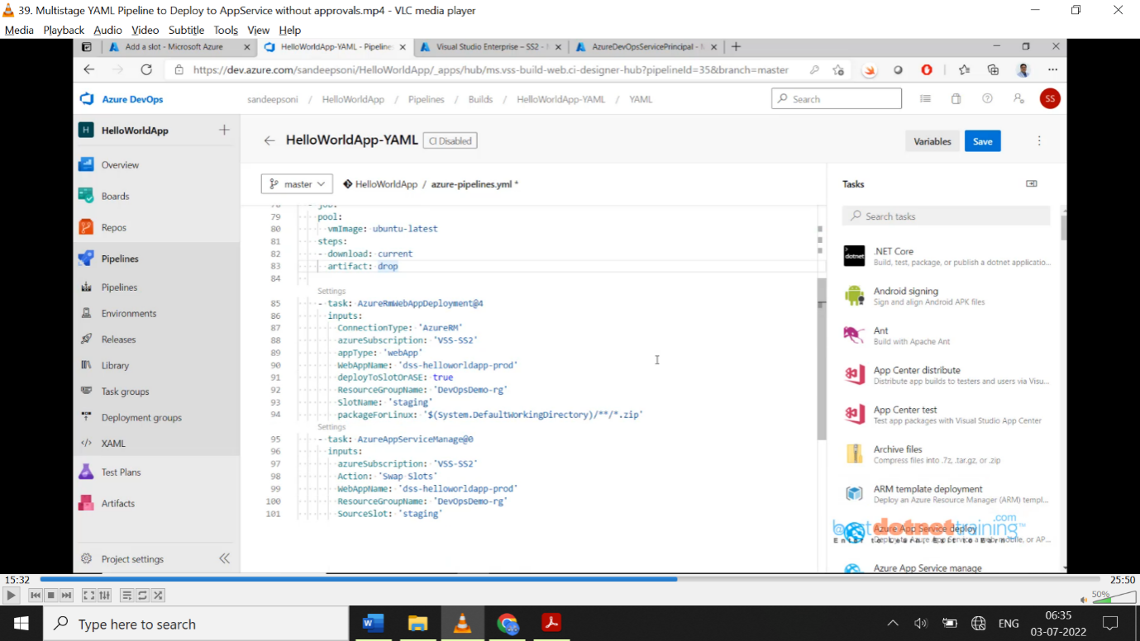  
The total build and deploy script look below: here we are directly using build then deploy without gates and approvals.

trigger:

- none

stages:

- stage: "Build"

jobs:

- job: "BuildJob"

pool:

vmImage: 'windows-latest'

variables:

buildConfiguration: 'Release'

steps:

- task: DotNetCoreCLI@2

displayName: "Restore Project"

inputs:

command: 'restore'

projects: '**/*.csproj'

- task: DotNetCoreCLI@2

displayName : "Build Project"

inputs:

command: 'build'

projects: '**/*.csproj'

arguments: '-c $(buildConfiguration)'

- task: DotNetCoreCLI@2

displayName : "Build Project"

inputs:

command: 'publish'

publishWebProjects: true

arguments: '-c $(buildConfiguration) -o $(build.artifactstagingdirectory)'

- task: PublishPipelineArtifacts@1

displayName: 'Publish Artifact'

inputs:

PathtoPublish: '$(build.artifactstagingdirectory)'

- stage: "DeployToDev"

dependsOn: "Build"

jobs:

- job:

pool:

vmImage: "windows-latest"

steps:

- download: current

artifact: drop

- task: AzureRmWebAppDeployment@4

inputs:

ConnectionType: 'AzureRM'

azureSubscription: 'Azure Connection'

appType: 'webApp'

WebAppName: 'dssdemo1-dev'

packageForLinux: '$(Pipeline.Workspace)/**/*.zip'

- stage: "DeployToQA"

dependsOn: "DeployToDev"

jobs:

- job:

pool:

vmImage: "windows-latest"

steps:

- download: current

artifact: drop

- task: AzureRmWebAppDeployment@4

inputs:

ConnectionType: 'AzureRM'

azureSubscription: 'Azure Connection'

appType: 'webApp'

WebAppName: 'dssdemo1-qa'

packageForLinux: '$(Pipeline.Workspace)/**/*.zip'

- stage: "DeployToProd"

dependsOn: "DeployToQA"

jobs:

- job:

pool:

vmImage: "windows-latest"

steps:

- download: current

artifact: drop

- task: AzureRmWebAppDeployment@4

inputs:

ConnectionType: 'AzureRM'

azureSubscription: 'Azure Connection'

appType: 'webApp'

WebAppName: 'dssdemo1-prod'

deployToSlotOrASE: true

ResourceGroupName: 'DemoRG'

SlotName: 'staging'

packageForLinux: '$(Pipeline.Workspace)/**/*.zip'

- task: AzureAppServiceManage@0

inputs:

azureSubscription: 'Azure Connection'

Action: 'Swap Slots'

WebAppName: 'dssdemo1-prod'

ResourceGroupName: 'DemoRG'

SourceSlot: 'staging'

**40. YAML Pipeline with Approvals using Environment:**

Deploying a web application to app service with Approval using Environment. Now we will work with Approvals at every stage. To work with approvals, create an environment. Go to pipelines 🡪 Environment screen looks below:

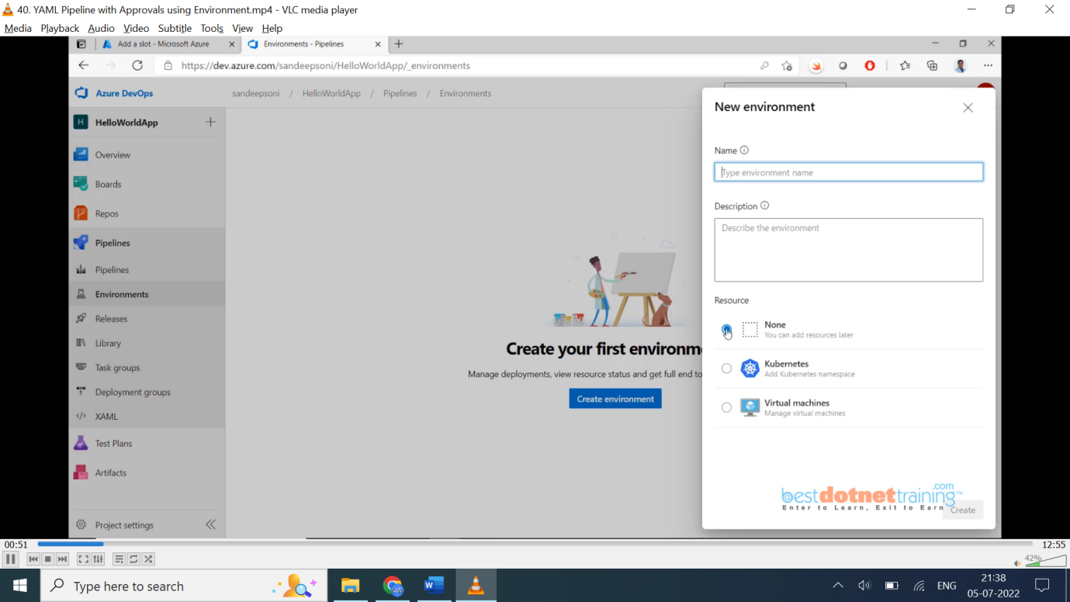

Generally, environment is Dev/ITG/Staging/Prod which is a collection of resource. But environment in devops is going to give us extra benefit. I am now going to replace job with ‘Deployment’ job, and we have to mention the ‘environment’.

**The advantages of using environments include the following.**

* **Deployment history** - Pipeline name and run details are recorded for deployments to an environment and its resources. In the context of multiple pipelines targeting the same environment or resource, deployment history of an environment is useful to identify the source of changes.
* **Traceability of commits and work items** - View jobs within the pipeline run that targeted an environment and the corresponding commits and work items that were newly deployed to the environment. This allows one to track whether a code change (commit) or feature/bug-fix (work items) reached an environment.
* **Permissions** - User permissions and pipeline permissions can be used to secure environments by specifying which users and pipelines are allowed to target an environment. (Will see later)

**Resources:**

While environment at its core is a grouping of resources, the resources themselves represent actual deployment targets. The **Kubernetes resource** and **virtual machine resource** types are currently supported.

**Target Environment from a deployment job:**

A deployment job can be used to target an entire environment (group of resources) as shown in the following **Sample** YAML snippet.

- stage: “DeployToProd”

dependsOn:” DeployToQA”

jobs:

- deployment:

displayName: Deploy Web App

pool:

vmImage: 'Ubuntu-latest'

# Creates an environment if it doesn't exist

environment: 'Production'

strategy:

runonce:

deploy:

steps:

- download: current

artifact: drop

- task: AzureRmWebAppDeployment@4

inputs:

ConnectionType: 'AzureRM'

azureSubscription: 'Azure Connection'

appType: 'webApp'

WebAppName: 'dssdemo1-dev'

packageForLinux: '$(Pipeline.Workspace)/**/*.zip'

**Target a specific resource within an environment:**

environment: 'dssdemoapp-dev.WebServer1'

The deployment job should compulsorily have an ‘*environment’* field.

Job Code (earlier version): the below job is replaced by above deployment

- stage: "DeployToDev"

dependsOn: "Build"

jobs:

- job:

pool:

vmImage: "windows-latest"

steps:

- download: current

artifact: drop

- task: AzureRmWebAppDeployment@4

inputs:

ConnectionType: 'AzureRM'

azureSubscription: 'Azure Connection'

appType: 'webApp'

WebAppName: 'dssdemo1-dev'

packageForLinux: '$(Pipeline.Workspace)/**/*.zip'

**Note**: - if job is modified as “deployment”, you don’t need the step -download:drop & artifact as download is built in for every deployment job.

The moment we add *deployment* job, automatically you will find the environments (production) we given under deployment job as below:

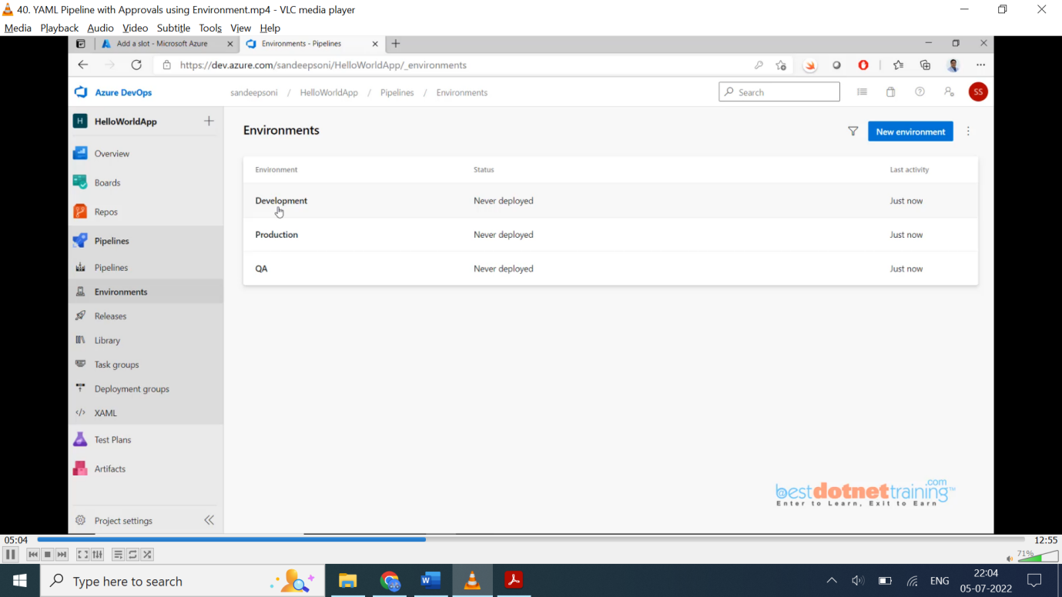

What we need from these environments is we want approval for QA environment. So, click on QA and select “Approvals and checks” as shown below: 🡪 click on Approvals 🡪add Approver email id 🡪 create.

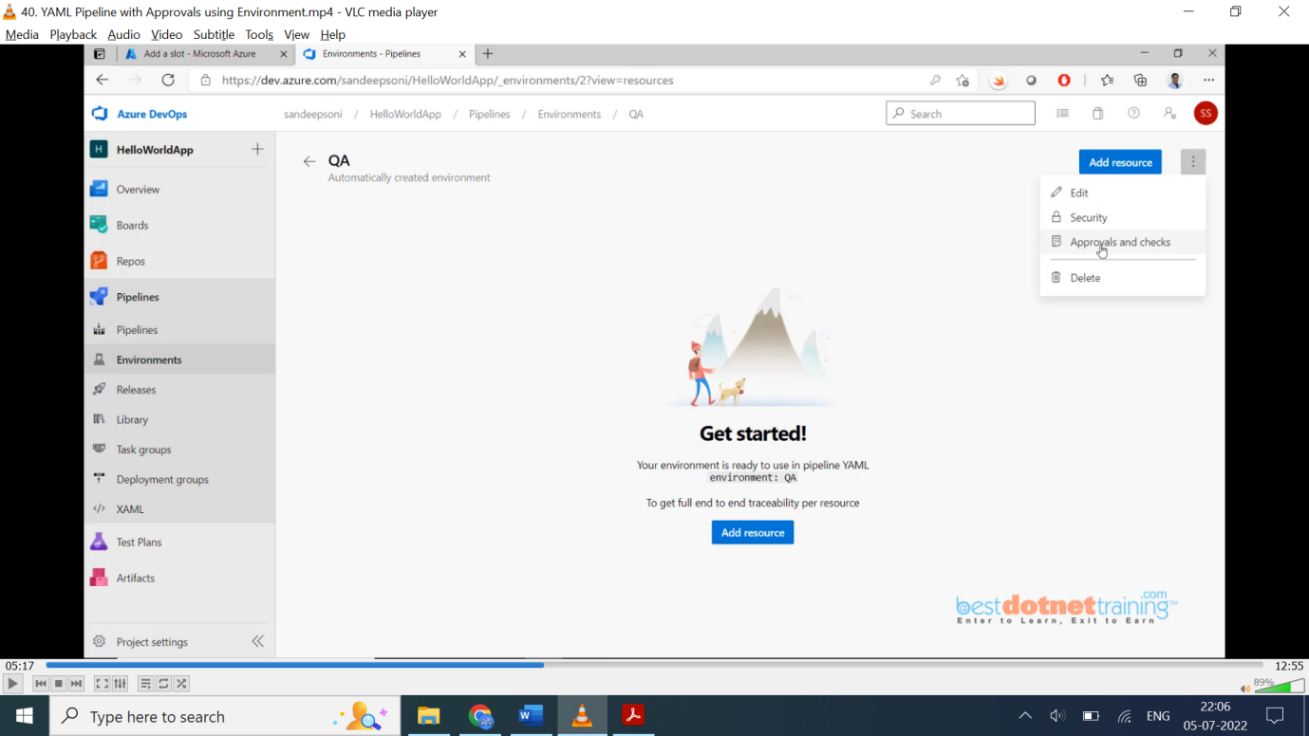

Once created the approver list show as below screen shot:

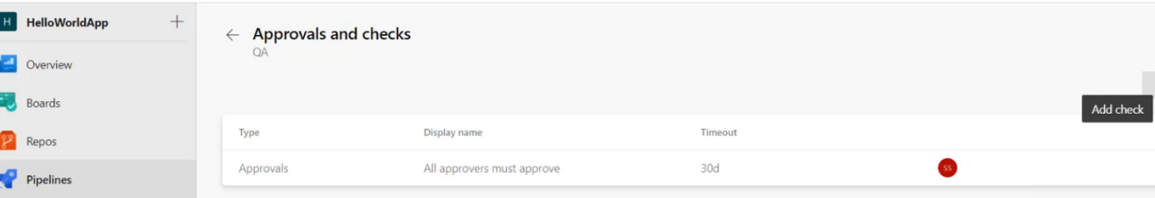

Like this for every environment we can add approvals. Only difference is there is no *pre and post* only *pre*-approvals. For development environment we don’t need approval as when check in to git happens immediately it should deploy to development environment.

We have security concept (can see in above images) which will allow every environment to restrict for few users. Only those users can deploy to the environment who are given permission. 2 types of permissions one is ‘***User Permissions***’ and other is ‘***Pipeline Permissions****’*. (Which, we will see later).

**Security:**

**User permissions:** Set appropriate user permissions to ensure that the users are pre-authorized to define a pipeline that targets the environment.

1. Environment → Click on top right → Security

2. In the **User permissions** blade, click on **+Add** to add a **User or group** and select a suitable **Role**.

**Pipeline permissions:** Pipeline permissions can be used to authorize either all or specific pipelines for deploying to the environment of concern.

**41. Deploying Apps to VM in YAML Pipeline using Environment.**

We have seen “Deployment groups” in classic pipeline while configuring **VM**. This will not work in YAML pipelines. we need to use *Environments*. We have already created environments for app services (above screen shots Development/QA/Production) now we will create new environment for our VM as shown below:

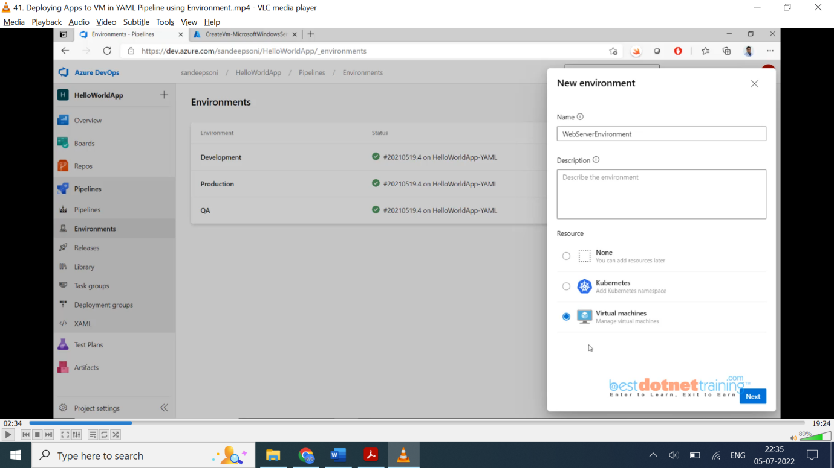

Click Next 🡪 this is the script now we need to run on the virtual machines as shown in below screenshot with mouse highlighted.

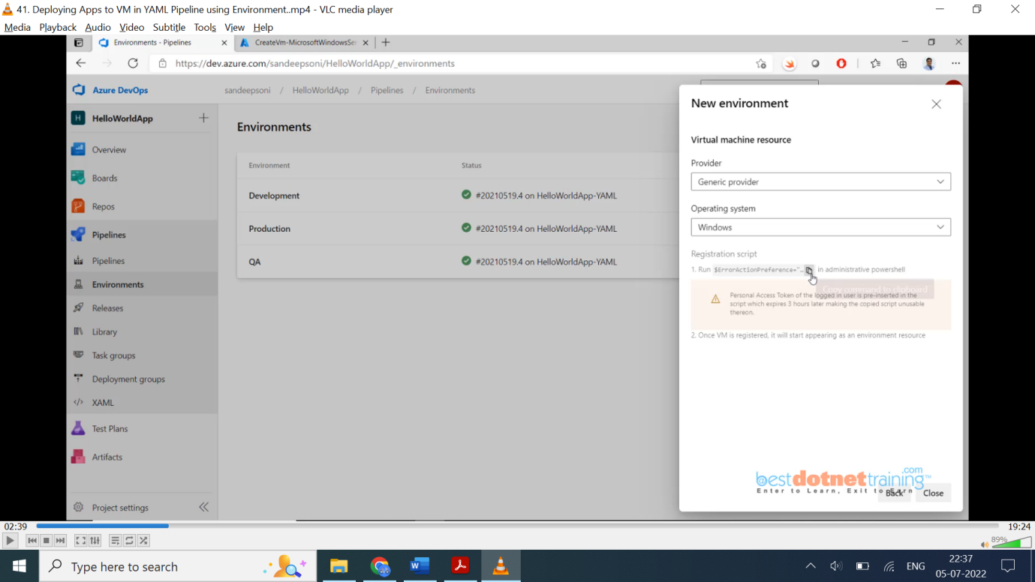

The copied script (also has PAT token) which we need to run on the **VM**, downloads the zip file on the Virtual machine, extracting zip and installs the Agent s/w on the target virtual machine.

Go to the created VM🡪 connect 🡪 download RDP file 🡪 enter credentials 🡪 OK. Go to cmd 🡪 admin mode (or power shell also ok) 🡪 paste the script and enter. Once the agent s/w gets installed, this agent is going to get registered with the environment which we have created in azure devops (WebServerEnvironment). *All story is exactly same which we used in deployment groups concept. To verify registered agent, we can go to devops 🡪 Environments 🡪 we have the added resource “Demo-vm” as shown below:*

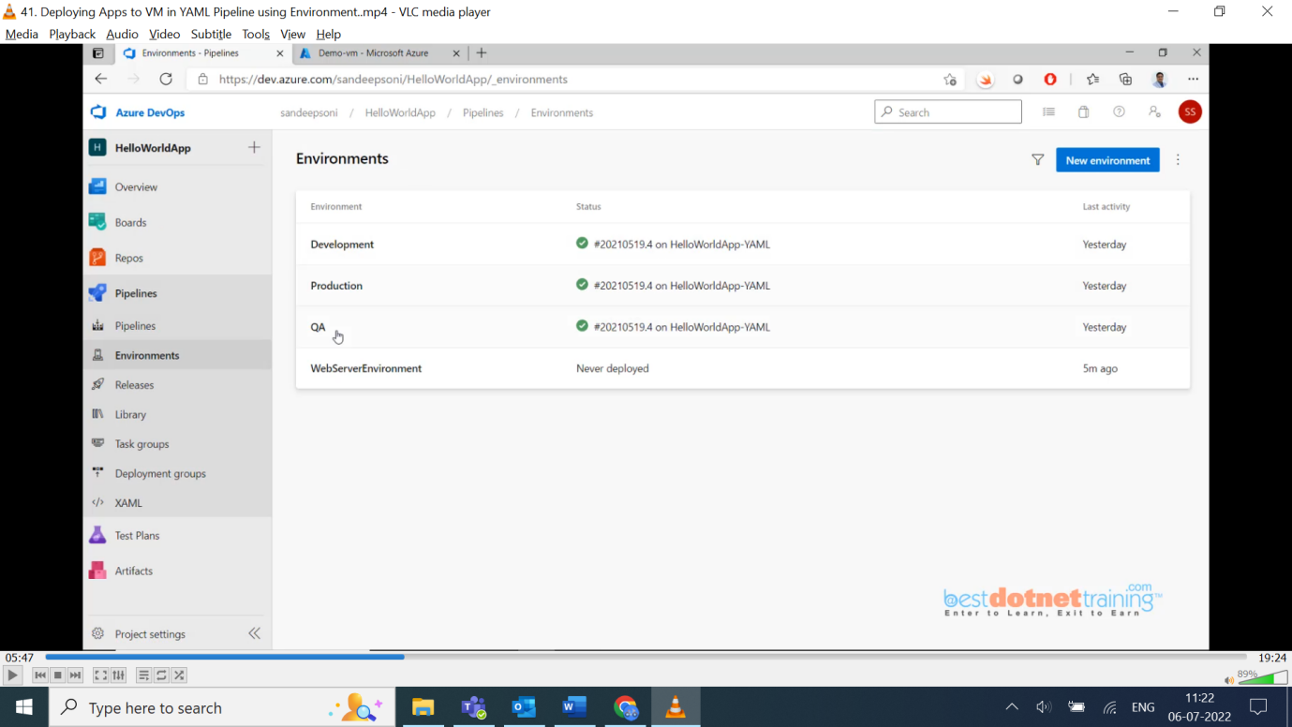

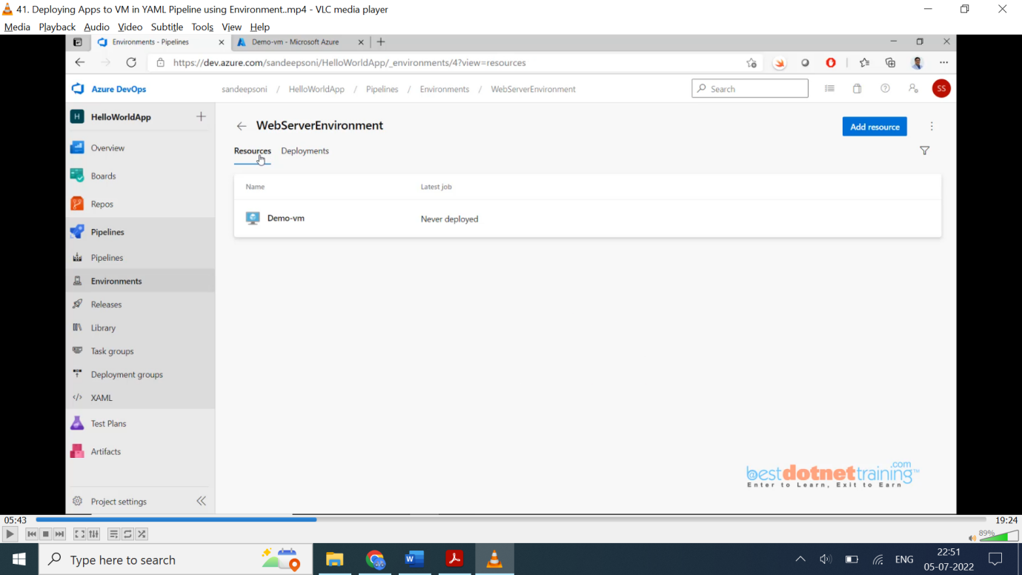

Like this we can create multiple VM here. Once we have the environments created what’s next? The pipeline. We will modify existing YAML pipeline which is already deploying using ‘app service’ to deploy to VM (create new Pipeline and copy the YAML pipeline and modify it to ‘*deploy to VM’* ).

**- stage: 'Deploy'**

displayName: 'Deploy the web application'

dependsOn: Build

jobs:

- deployment: DeployToVM

pool:

vmImage: 'windows-latest'

environment:

name: WebServerEnvironment

resourceType: VirtualMachine

tags: web

strategy:

runOnce:

deploy:

steps:

- task: IISWebAppManagementOnMachineGroup@0

inputs:

EnableIIS: true

IISDeploymentType: 'IISWebsite'

ActionIISWebsite: 'CreateOrUpdateWebsite'

WebsiteName: 'default web site' (Highlighted should match in both sections)

WebsitePhysicalPath: '%SystemDrive%\inetpub\wwwroot'

WebsitePhysicalPathAuth: 'WebsiteUserPassThrough'

AddBinding: true

Protocol: http

IPAddress: 'All Unassigned'

Port: 80

- task: IISWebAppDeploymentOnMachineGroup@0

inputs:

WebSiteName: 'default web site' (Highlighted should match in both sections)

Package: '$(Pipeline.Workspace)/**/*.zip'

TakeAppOfflineFlag: true

We also need to update settings where IIS Bindings need to be given as shown in below screen shot:

Ignore value in ‘Add Bindings’ section. If we add in that fashion, it will not work. Right script is just above you can check.

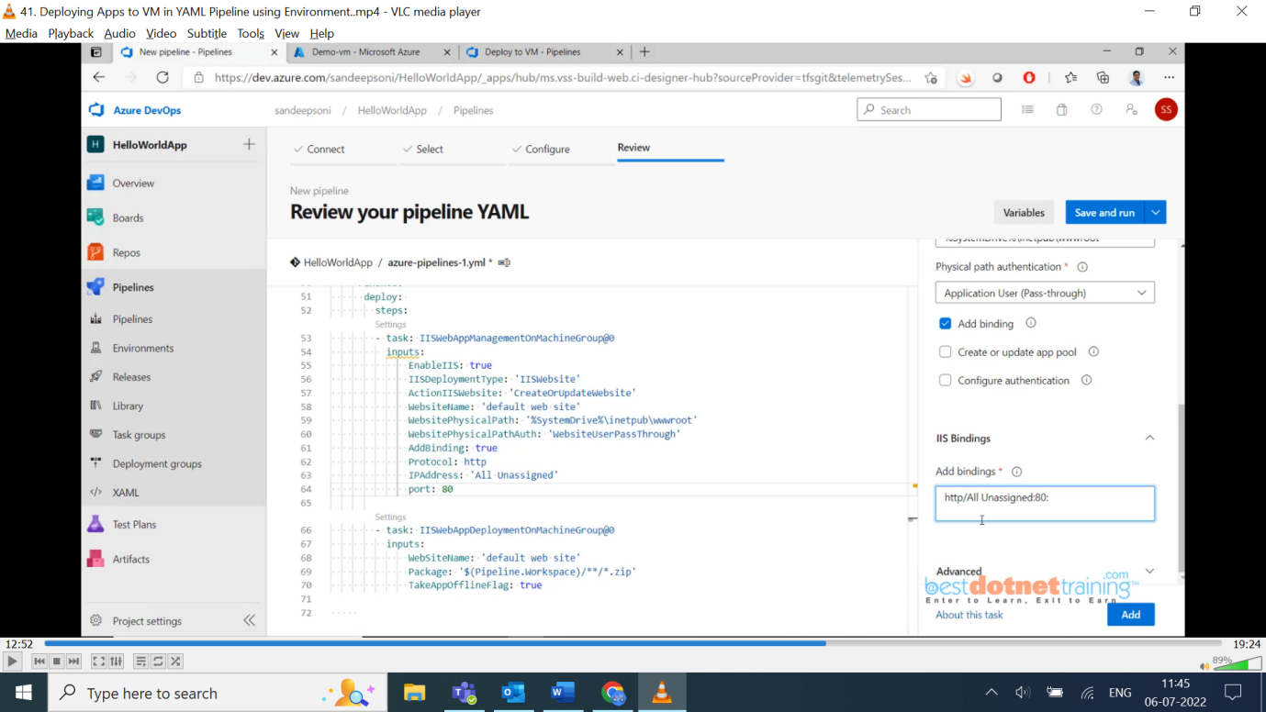

Click on Add.

Save and Run the Pipeline.

First it will install IIS then it will create a website and then our content of web application will be published into the VM. Because it is ‘deployment’ job automatically artifacts are downloaded and wwwroot folder will be created and also, once IIS is installed on VM, we will see on server manager IIS icon will be shown once IIS installation completes check below screen shot:

**View History:** Environment → Click WebServers → Deployments

**Note**: - so for each virtual machine (if we have multiple VMs) we need these 2 steps from above scripts

steps:

- task: IISWebAppManagementOnMachineGroup@0 and

- task: IISWebAppDeploymentOnMachineGroup@0

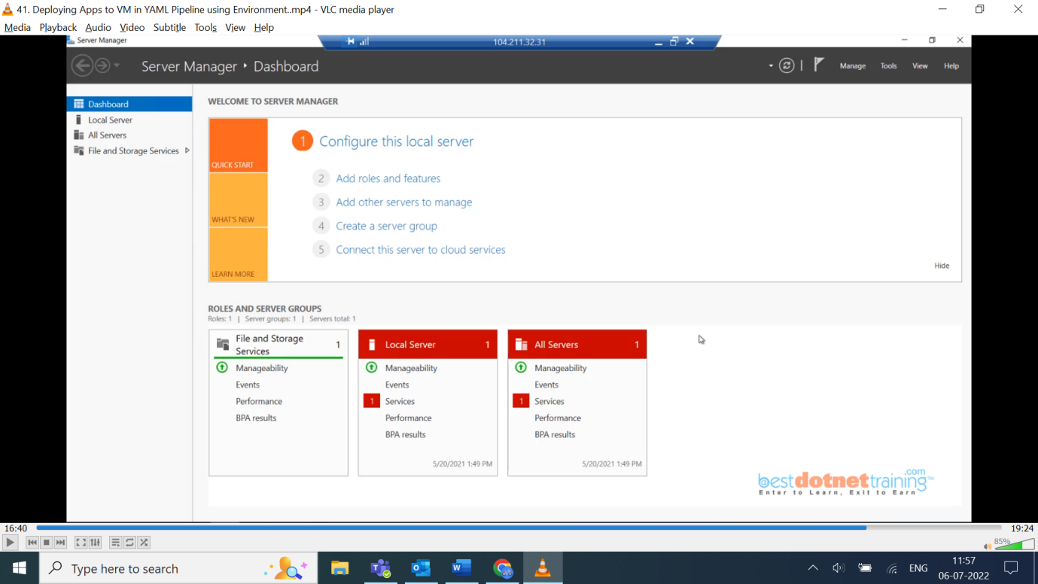

In the above screen shot in the empty space next to All Servers we will get IIS icon also.

**42. Implementing Branching Policy and Deployment to Appropriate Environment:**

YAML for deploying the artifact into respective environment based on the branch in which build is performed.

Now, the process we need to automate from developer point of you is:

When new sprint starts, development & master branch on github will be latest. Developers get the latest version from development branch and create feature branch. Once the development is done, they will raise PR to merge feature branch to development branch.

**2 branches**: *development & master*

***Development*** – Dev & QA environments. (When changes happen on *Development branch (merge from feature)*, **CI & CD** will run and deploy into ***Dev & QA environments***).

***Master*** – once testing done on Dev & QA and everything looks perfect. Pull request will be raise from *Development* branch to *Master* branch 🡪 when merging happens at that time **CI & CD** will run and code will be deployed to ***Production environment***.

Now our task is to automate above process.

Go to the pipeline 🡪 YAML pipeline 🡪 edit 🡪 currently we have 4 stages: BuildStage, DeployToDev, DeployToQA, DeployToProd executing in sequence.

In DeployToDev we have dependency on BuildStage and DeployToQA has dependency on DeployToDev and similarly DeployToProd has dependency only dependency on BuildStage.

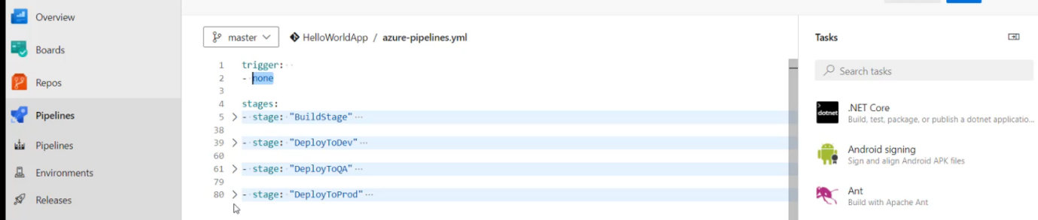

Now our requirement is, *the trigger: - none* should be executed on 2 branches (dev & master). So, changes we will modify *none* to master & development.

trigger:

- master

- development

One condition is the branch should be from development as shown below in highlighted.

- stage: "DeployToDev "

dependsOn: “BuildStage”

condition: eq(variables['Build.SourceBranch'], 'refs/heads/development')

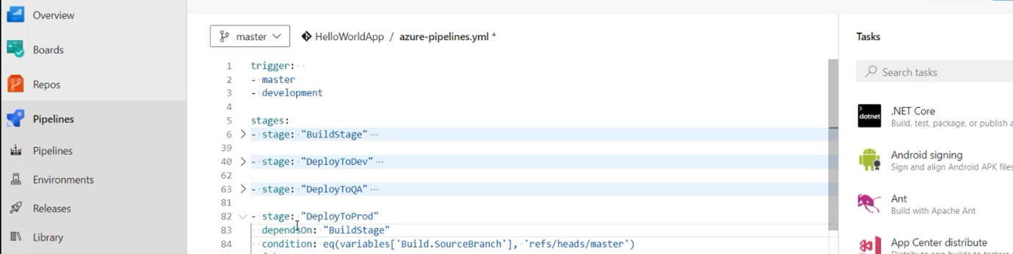

One condition is the branch should be from master as shown below in highlighted.

- stage: "DeployToProd"

dependsOn: “BuildStage”

condition: eq(variables['Build.SourceBranch'], 'refs/heads/master)

here the ‘***dependsOn’*** condition is same i.e., ***BuildStage*** for both development & production environment and source branch which is *dev* branch for dev and *master* branch for *production* env. QA will continue once dev deployment done and hence no changes as QA depended on Dev.

Once dev successful, please raise a pull request which will merge to master. CI & CD of master wait for approval once approved deployment to prod will be done.

Note: - one important thing to notice is as we do changes to development branch:

Build – Yes

DeployToDev – Yes

DeployToQA – Yes

DeployToProd – No (Skipped as it dependent on master branch)

Similarly, when we merge into master, below changes can be seen:

Build – Yes

DeployToDev – No (Skipped as it dependent on dev branch)

DeployToQA – No (Skipped as it dependent on dev branch)

DeployToProd – Yes

This is one way of deployment. Let’s see another way of doing it.

How to achieve this in release pipeline? Go to release pipeline edit deployment through ‘app service’ and check below screen shot:

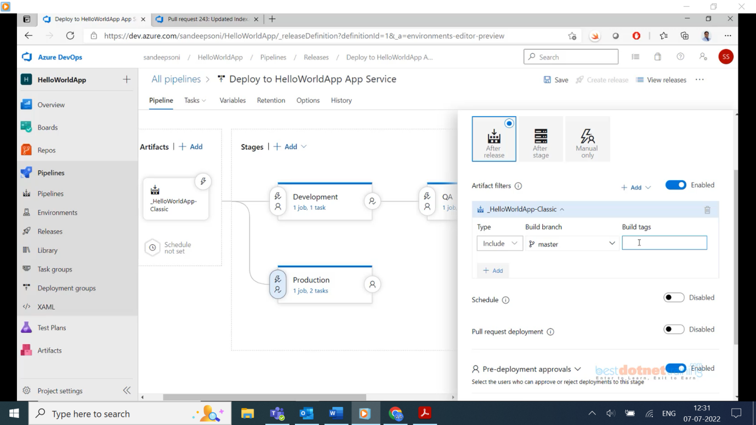

We have included ***Build branch: master*** making production directly depending on CI output (Build artifacts as shown above) by choosing option After release.

Similarly, we can add ***Build branch: Development*** if development is not available while choosing, we need to clone it from master and create development branch.

Note: - Question? How to give development branch for development servers? Go to release pipelines 🡪 After release 🡪 Artifact filters 🡪 Build branch 🡪 select **development**.

How to enable CI on CD pipeline? Click on Artifacts generated by CI on CD and enable “Continuous Deployment trigger”. If you also want to enable CI when pull request is done for a particular branch then you will see “target branch filter section” with target branch option screenshot below:

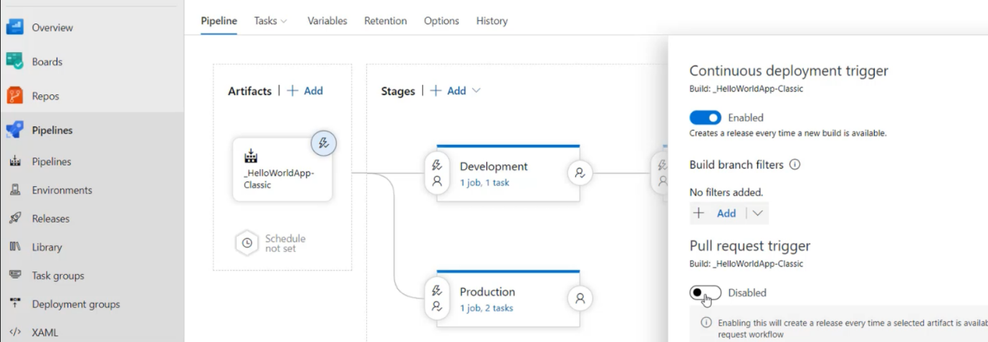

Finally add development branch trigger on trigger section of pipeline (CI) as shown below:

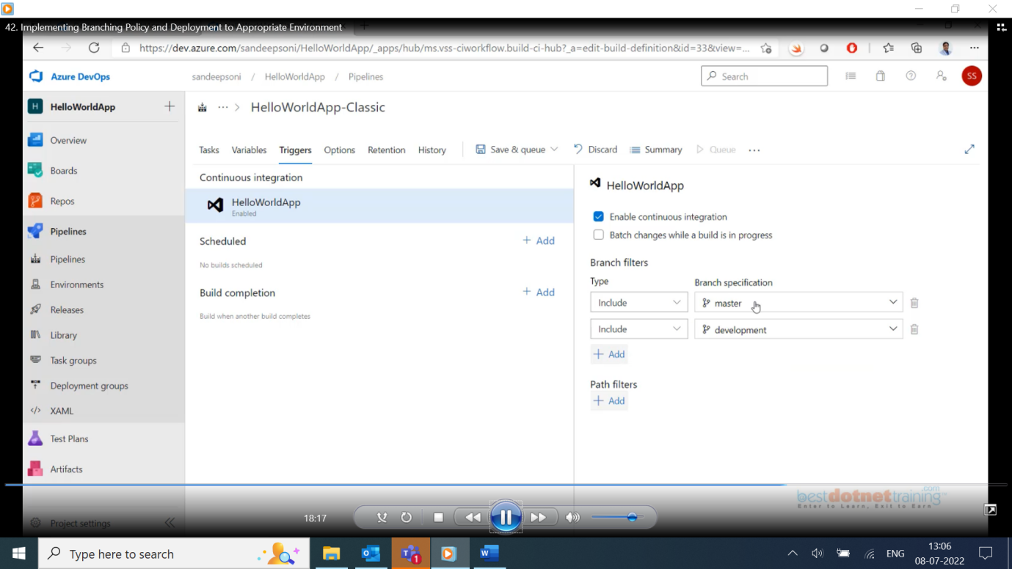

**Test**: - Edit any page and save automatically CI should start once CI pipeline finish automatically Release pipeline will get started (CD) for that particular branch to which pushed code.

**Now test pull request from Dev to Master**: - click on “create pull request” on development branch name it “dev to master” and create. Now master branch CI and CD will happen as we enable trigger for pull request on master branch.

The above steps we used will be same as real time implementation of Azure devops.

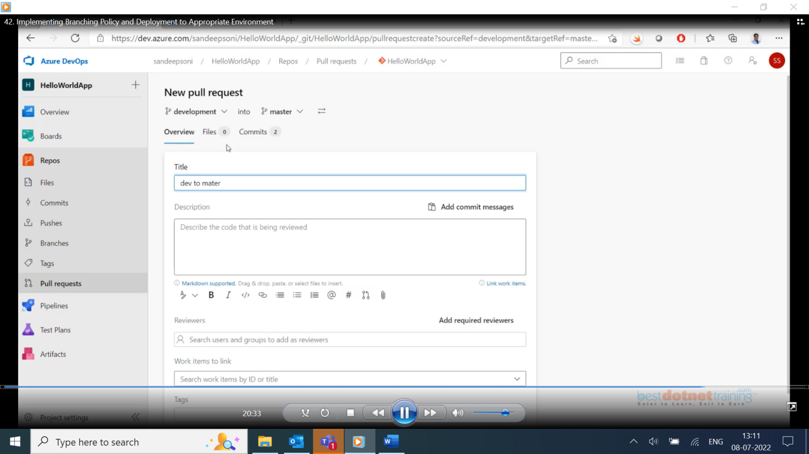

**Folder 8. Deep Dive into CI and CD Pipeline:**

**43. About Agent Pool**:

**Agenda: Manage Pipeline Infrastructure**

Till now we have seen classic build & classic release pipeline. Where classic build pipeline generates artifacts which will be consumed by Classic release pipeline (these artifacts can be used by YAML pipeline it doesn’t matter whether classic/yaml generates build artifacts and the deployment can be done to VM, app service and

Similarly, env. can be AKS, azure function etc., so on. We have seen multistage pipelines with stage and jobs and these jobs has agents. Remember a job needs an agent. We have some jobs without agent like agentless job, deployment job which we will see later.

***What is an Agent pool?***

An Agent is an installable software that runs, builds, deploys job at a time. All the agents that are grouped together in the form Agent pool. When we work with devops what we need is Agent pool.

Go to devops 🡪 organization settings 🡪 Agent pools. By default, every organization will see two default agent pools: ***Azure pipelines*** & ***Default.*** Azure pipeline is an agent pool of all **Microsoft Hosted agents** as shown below:

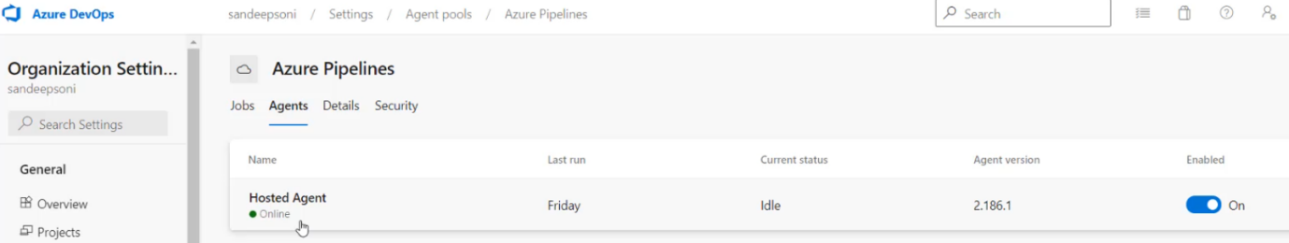

All the jobs under tab jobs are executed by this **Hosted Agent** **pool** by default. **Default Agent** pools are the agents created by us (self-hosted agent).

First of all let us understand what is the use of this Agent pool?

Click on Add pool which will be as below:

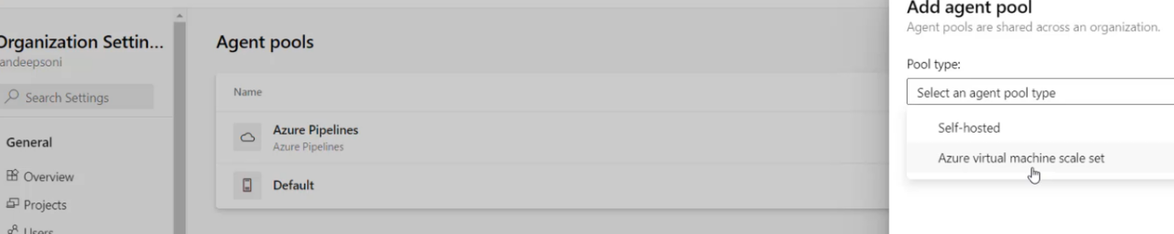

We can create an agent pool where we can put an ‘***Azure virtual machine scale set***’. This set of VMs all of them created using a common image. That means they are identical to each other, the s/w on all of them is same when they are created. One more advantage of this scale set is they are automatically scale up and scale down based on the load on the VM. But if you are interested in only creating a VM individually as a ***self-hosted*** machine then use the option. Check screenshot below:

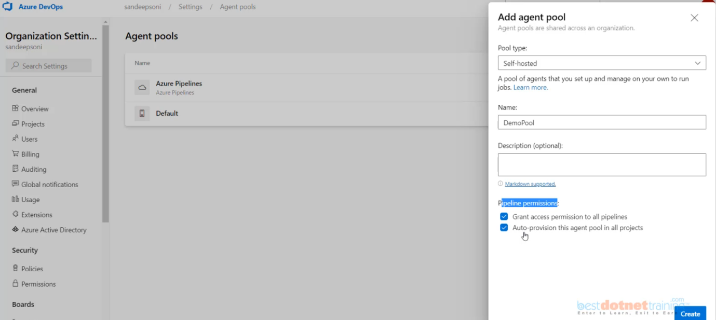

The check box option “*Auto-provision this agent pool in all projects*” is more important. See I am coming and creating an agent pool at an organization level. Under the org we will have multiple projects with a check mark there, this particular agent pool is available for all projects in this particular organization. Obviously before making use of this agent pool, we are supposed to add here self-hosted agents for which there is a procedure we will do it later.

Now go to Organization 🡪 Projects 🡪 project settings🡪 here also we will find Agent pools 🡪 here we see DemoPool Agent pool.

**Copied notes from PDF:**

As you know, a build agent is a piece of installable software that runs one build or deployment job at a time. To build your code or deploy your software you need at least one agent. As you add more code and people, you'll eventually need more than one agent.

**About Agent Pools:**

* Instead of managing each agent individually, you can organize agents into agent pools.
* In Azure Pipelines, agent pools are scoped to the Azure DevOps organization so you can share an agent pool across projects.
* A project agent pool provides access to an organization agent pool.
* When you create a build or release pipeline, you specify which pool it uses.
* Pools are scoped to your project so you can only use them across build and release pipelines within a project.
* To share an agent pool with multiple projects, in each of those projects, you create a project agent pool **pointing** to an organization agent pool. While multiple pools across projects can use the same organization agent pool, multiple pools within a project cannot use the same organization agent pool. Also, each project agent pool can use only one organization agent pool.

**Here are some typical situations when you might want to create self-hosted agent pools:**

1. You're a member of a project and you want to use a set of machines owned by your team for running build and deployment jobs only for your projects.

a. Create Pool at Project Level.

2. You're a member of the infrastructure team and would like to set up a pool of agents for use in all projects.

a. Create Pool at Organization Level

b. Select the option to **Auto-provision corresponding agent pools in all projects**

3. You want to share a set of agent machines with multiple projects, but not all of them.

a. Create Pool at Organization Level.

b. **Uncheck** the option to **Auto-provision corresponding agent pools in all projects.**

c. Go to each of the other projects and create a pool in each of them while selecting the option to Use

an **existing agent pool** from the organization**.**

**Security of agent pools in organization settings:**

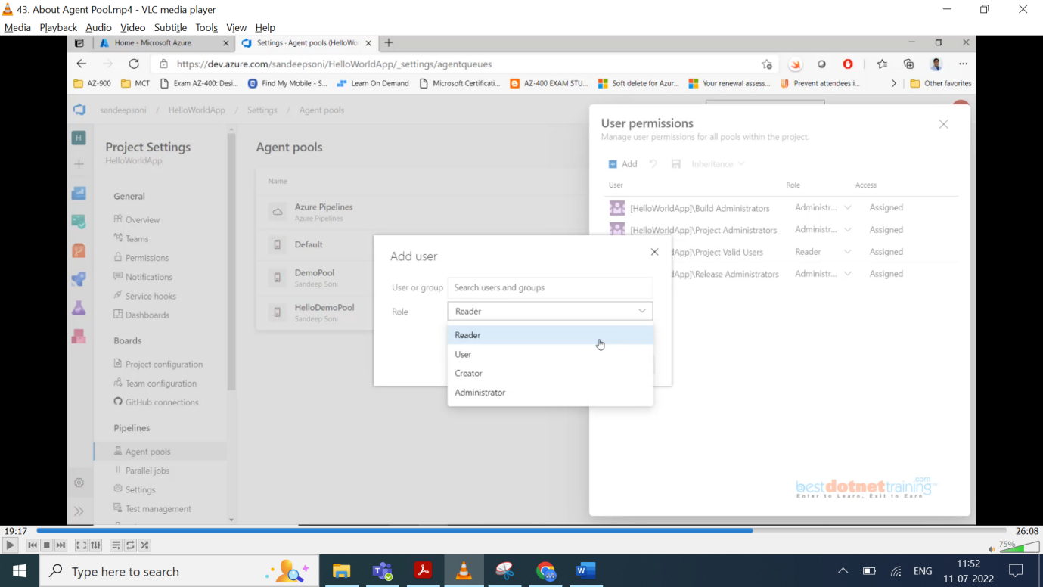

Click on project 🡪 Agent pools 🡪 Security button 🡪 under User Permissions 🡪 click Add 🡪 opens Add user popup 🡪 on Role dropdown you see 4 types: Reader, user, creator, administrator options. So, at project level every user is either Reader/User/Creator/Administrator.

But if you go to Agent pools on Organization Settings 🡪 Agent pools 🡪 security button -> User permission 🡪 click Add 🡪 opens Add user popup 🡪 on Role, drop down you see 3 types: Reader, Service Account, Administrator as shown below:

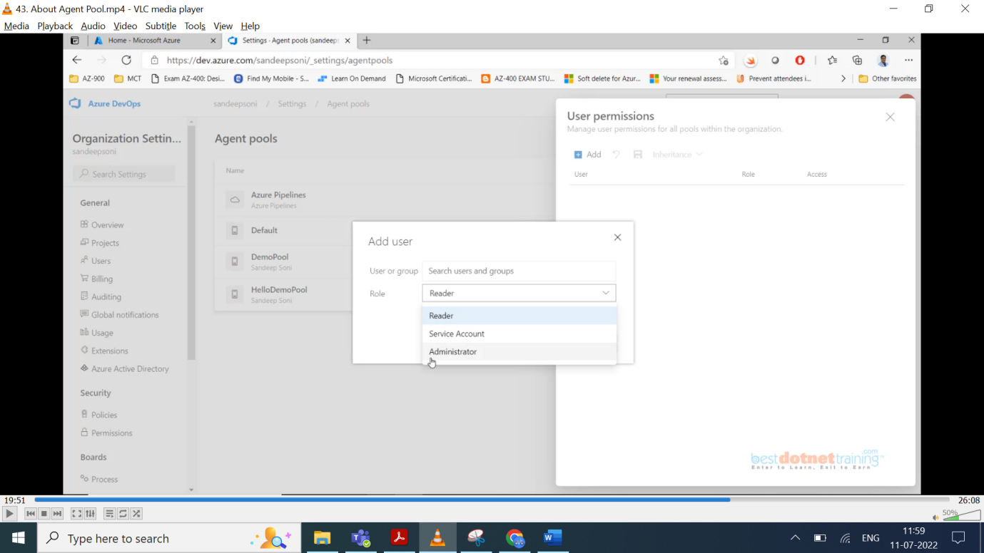

**Security of agent pools in organization settings:**

**1. Reader:** Members of this role can view the agent pool as well as agents. You typically use this to add operators that are responsible for **monitoring** the agents and their health.

**2. Service Account:** Members of this role can use the organization agent pool to **create a project agent pool in a project**.

**3. Administrator**

a. In addition to all the above permissions, members of this role can **register or unregister agents from**

**the organization agent pool**.

b. They can also refer to the organization agent pool when creating a project agent pool in a project.

c. Finally, they can also **manage membership** for all roles of the organization agent pool. The user

that created the organization agent pool is automatically added to the Administrator role for that pool.

**Roles for AgentPools in Project Security Settings:**

1. **Reader**: Members of this role can view the project agent pool. You typically use this to add operators that are responsible for **monitoring** the build and deployment jobs in that project agent pool.

2. **User**: Members of this role can use the project agent pool when authoring pipelines.

3. **Administrator**: In addition to all the above operations, members of this role can **manage membership** for all roles of the project agent pool. The user that created the pool is automatically added to the Administrator role for that pool.

**44. All about Microsoft Hosted Agents:**

Till now we have seen agents are of 2 types: - 1. Microsoft Hosted Agent and 2. Self-hosted Agent we will learn when to use which one.

Now we will learn in this session about ***Microsoft Hosted Agent***. These are Readymade machines which we don’t have to setup. Microsoft has already setup these machines and we just need to create a pipeline and choose one of the types of MSH machines while executing the pipeline. These are type of Hosted Agent machines.

1. **windows-latest** OR windows-2019

2. vs2017-win2016

3. **ubuntu-latest** OR ubuntu-20.04

4. ubuntu-18.04

5. ubuntu-16.04

6. **macOS-latest** OR macOS-10.15

7. macOS-10.14

Pipelines will default to the Microsoft-hosted agent pool. You simply need to specify which virtual machine image you want to use.

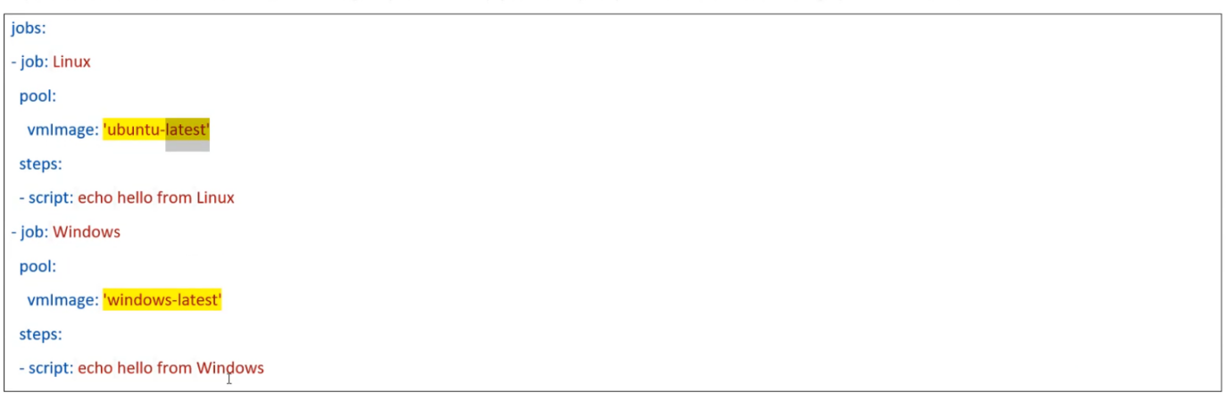

**Microsoft-hosted agents offer:**

🡪You can add software during your build or release using **tool installer tasks(**[**https://docs.microsoft.com/en-us/azure/devops/pipelines/process/tasks?view=azure-devops#tool-installers**](https://docs.microsoft.com/en-us/azure/devops/pipelines/process/tasks?view=azure-devops#tool-installers)**)** . Eg: Use .NET Core installs the specified version of .NET SDK on the agent machine. (All the software’s will be pre-installed, but some outdated s/w like if ex: .net core 1.0 which is old version then you need to add a task and install it as part of pipeline only. But the big disadvantage is it will install the s/w every time pipeline runs. As the machine once performs build & deploy the machine will reset the installations and given back to Agent pool and next time, we will get fresh machine and again installation of s/w happens).

🡪Provide at least **10 GB of storage** for your source and build outputs. (Project code and 2GB for build artifacts)

🡪Provide a free tier:

**=>public project**: **10 free Microsoft-hosted parallel jobs** that can run for up to 360 minutes (6 hours) each time, with no overall time limit per month. Contact us(<https://azure.microsoft.com/support/devops>/) to get your free tier limits increased.

**=>Private project**: **One free parallel job** that can run for up to 60 minutes each time, until you've used 1,800 minutes (30 hours) per month. You can pay for additional capacity per parallel job. Paid parallel jobs remove the monthly time limit and allow you to run each job for up to 360 minutes (6 hours).

🡪Run on Microsoft Azure general purpose virtual machines **Standard_DS2_v2**

🡪Run as an **administrator** on Windows and a **passwordless sudo** user on Linux.

**Microsoft-hosted agents do not offer:**

🡪The ability to sign in (Remote Desktop Login)

🡪The ability to drop artifacts to a UNC file share (//servername/drive/folder).

🡪The ability to run XAML builds. (Xamarin / WPF / UWP Applications)

🡪Potential performance advantages that you might get by using self-hosted agents which might start and run builds faster. (Because we will use same machine every time and req. s/w installations only once).

|  |  |  |  |
| --- | --- | --- | --- |
| **Image** | **Classic Editor Agent Specification** | **YAML VM Image Label** | **Included Software** |
| Windows Server 2019 with Visual Studio 2019 | *windows-2019* | windows-latest OR windows-2019 | [Link](https://github.com/actions/virtual-environments/blob/main/images/win/Windows2019-Readme.md) |
| Windows Server 2016 with Visual Studio 2017 | *vs2017-win2016* | vs2017-win2016 | [Link](https://github.com/actions/virtual-environments/blob/main/images/win/Windows2016-Readme.md) |
| Ubuntu 20.04 | *ubuntu-20.04* | ubuntu-latest OR ubuntu-20.04 | Link |
| Ubuntu 18.04 | *ubuntu-18.04* | ubuntu-18.04 | Link |
| Ubuntu 16.04 | *ubuntu-16.04* | ubuntu-16.04 | Link |
| macOS X 10.15 | *macOS-10.15* | macOS-latest OR macOS-10.15 | Link |
| macOS X 10.14 | *macOS-10.14* | macOS-10.14 | Link |

**45. Create and Use Self Hosted Agent:**

An agent that you set up and manage on your own (on VM (or) on prem physical server) to run jobs is a **self-hosted agent**. The Agent s/w we install on that machine makes it as Agent machine and that will join an agent pool. We will have full control on that VM whatever s/w which are required to perform build of your project through a pipeline (or) whatever tasks which can execute and deploy the application on the destination on those s/w we can install on that Agent machine, and it is one time. If it is the same machine will be used by multiple pipelines.

Copied from notes:

* An agent that you set up and manage on your own to run jobs is a **self-hosted agent**.
* Self-hosted agents give you more control to install dependent software needed for your builds and deployments.
* Also, machine-level caches and configuration persist from run to run, which can boost speed.
* You can install the agent on Linux, macOS, or Windows machines. You can also install an agent on a Docker container.

Agents run on a separate server and install and execute actions on a *deployment* target. By having an agent installed in this way, you need to have permissions to access the *target environment*.

The target environment needs to *accept incoming traffic*. When you use **Hosted agents**, running in the cloud, you cannot use these agents to deploy software on your on-premises server.

**To overcome this issue**, you can run agents in your local network that communicate with the central server.



**To Create Self-hosted Windows agents**

**Step1: Make sure your machine has these prerequisites:**

* Windows 7, 8.1, or 10 (if using a client OS)
* Windows 2008 R2 SP1 or higher (if using a server OS)
* PowerShell 3.0 or higher
* .NET Framework 4.6.2 or higher

Recommended:

* Visual Studio build tools (2015 or higher)



To ensure your organization works with any existing firewall or IP restrictions, ensure that **dev.azure.com** and **\*.dev.azure.com** are allowed domains.

In addition, we recommend you **open port 443** to all traffic on these IP addresses and domains.

**IPv4 ranges**

* 13.107.6.0/24
* 13.107.9.0/24
* 13.107.42.0/24
* 13.107.43.0/24

**IPv6 ranges**

* 2620:1ec:4::/48
* 2620:1ec:a92::/48
* 2620:1ec:21::/48
* 2620:1ec:22::/48

About Firewall permissions – Read here: <https://docs.microsoft.com/en-us/azure/devops/pipelines/agents/v2-windows?view=azure-devops#im-running-a-firewall-and-my-code-is-in-azure-repos-what-urls-does-the-agent-need-to-communicate-with>

**Step2: Authenticate with a personal access token (PAT)**

**1**. Azure DevOps → **Profile** → Personal access tokens, and then select **+ New Token**.

**2**. Name your token, **select the organization** where you want to use the token, and then choose a lifespan for your token.

**3**. Select the **scopes** for this token to authorize for ***your specific tasks***.

**4**. When you're done, make sure to **copy** the token. You'll use this token as your password.

**Step3: Download and configure the agent**

**1**. Log on to the machine using the account for which you've prepared permissions as explained above.

**2**. In your web browser: **Organization Settings** → **Agent pools** → **Default** → **Agents Tab**

**3**. **Get the agent** dialog box → Windows Tab → **Download** the agent

**4**. Open PowerShell **in Administrator mode.**

**5**. Unpack the agent into the directory of your choice.

**6**. Then run **config.cmd**.

This will ask you a series of questions to configure the agent.

1. When setup asks for your server URL, for Azure DevOps Services, answer:

[https://dev.azure.com/{your-organization](https://dev.azure.com/%7byour-organization) } .

1. When setup asks for your authentication type, choose **PAT**.

Then paste the PAT token you created into the command prompt window.

**Step 4: Run the agent**

**7**. **Run interactively**: If you configured the agent to run interactively, to run it:

PS c:\agent:>**.\run.cmd** (PS means power shell)

**Run as a service**: If you configured the agent to run as a service, it starts automatically. You can view and control the agent running status from the services snap-in. Run **services.msc** and look for one of:

* "Azure Pipelines Agent (*name of your agent*)".
* "VSTS Agent (*name of your agent*)".
* "vstsagent.(*organization name*).(*name of your agent*)".

Also, another way you go to devops and check under Agent tab, the new agent we created will be there.

More About Agents: <https://docs.microsoft.com/en-us/azure/devops/pipelines/agents/agents>

**Pipeline Demands:**

Not all agents are the same. We've seen that they can be based on different operating systems, but they can also have different dependencies installed. To describe this, every agent has a set of capabilities configured as name-value pairs. The capabilities such as machine name and type of operating system that are automatically discovered, are referred to as **system capabilities**. The ones that you define are called **user capabilities.**

Some tasks won't run unless one or more demands are met by the agent. For example, the Visual Studio Build task demands that **msbuild** and **visualstudio** are installed on the agent.

**Manually entered demands:**

You might need to use self-hosted agents with special capabilities. For example, your pipeline may require **SpecialSoftware** on agents in the Default pool. Or, if you have multiple agents with different operating systems in the same pool, you may have a pipeline that requires a Linux agent.

**To add a single demand to your YAML build pipeline, add the demands: line to the pool section.**

job: Build

pool:

name: Default

demands:

- SpecialSoftware # Check if SpecialSoftware capability exists

- Agent.OS -equals Linux # Check if Agent.OS == Linux

1. **Organization Settings** → Agent Pools → Default

2. Switch to Agents Tab → Select the desired agent



3. Choose the **Capabilities** tab → Add a new capability

4. Add something like the following entry:

|  |  |
| --- | --- |
| **First box** | **Second box** |
| SpecialSoftware | C:\Program Files (x86)\SpecialSoftware |
| Key1 | Value1 |



**Note:** Please read the System capabilities.

Microsoft-hosted agents don't display system capabilities as they have pre-defined list of software’s

<https://docs.microsoft.com/en-in/azure/devops/pipelines/agents/hosted>

**You can specify certain demands that the agent must meet.**

Edit Build Pipeline → **Options Tab** → Under Demands → +Add

**46. Deep Dive into Jobs:**

Till now we learnt about Agent now let’s see how these agents will be used in Job.

You can organize your pipeline into jobs. Every pipeline has at least one job. A job is a series of steps that run sequentially as a unit. In other words, a job is the smallest unit of work that can be scheduled to run.

Your pipeline may have multiple stages, each with multiple jobs. In that case, use the stages keyword.

stages:

- stage: A

jobs:

- job: A1 (Each job will be assigned with an Agent pool and 1 agent will be picked from pool automatically for execution of tasks & scripts in steps (sequential order)).

- job: A2

- stage: B

jobs:

- job: B1

- job: B2

A job is a collection of tasks & scripts executed as steps in sequential order.

**Build job** will support 2 types of agents: **Agent Job & Agentless job**. **Release job** will support 3 types of agents: **Agent job, Agentless job**, **Deployment group job**.

Coming to YAML pipeline, we have a single pipeline (for both build & release)

**Folder 12. Azure Key Vault:**

**60. Azure Key Vault:**

Azure key vault is a secure way of storing credentials as a service in Azure. This will be used by everyone like devops engineer/developer etc…

**Folder 19. Working with Containerization using Docker:**

**79. Introduction to Containers and Comparison with VM:**

First, we look at VM, every computer is made up of some hardware like processor, hard disk, graphics, n/w etc. To manage all these devices there is an O/S which mainly contains device drives which will take high level instructions from the applications and converts them to low level instructions which h/w understands. O/S is a bunch of device drivers which will be used by O/S itself (or) some other applications which are running on O/S. on top of O/S we will have our applications basically binary files. The exe’s which we execute as separate process. All these processes will share the O/S resources. Example the kernel/file system will be shared by all the applications. Because of this sharing there will be some possibility of overlapping happens. To make one app work properly we may break other applications. Like different versions of same applications. We will have constraint of O/S dependency of the applications.

To overcome all these problems, industry has come up with concept of **VMs**. what we do in VM is we take same h/w of course which will be managed by base O/S and on top of it we install some kind of **VM monitoring** s/w like **VMWare**/**Hypervisor** etc. on top of these s/w we will create VM. VM is just virtual otherwise we can say it’s just a file. 1 VM is a 1 file. On single machine we can create multiple VMs which will have their own O/S which will use the **virtual h/w** which in turn mapped to physical h/w **by** vmware or hypervisor v s/w.

Like **Ex**: **Host O/S** will have 64 GB RAM and the 2 VMs on top of these we give 16 GB for each VM and remaining 32 GB for underlying host O/S. Every VM is going to borrow certain resources from the underlying physical h/w managed by VMWare/Hyper-V. The biggest advantage of the VM is the applications running in VM are going to only use resource available on **Guest O/S** as below diagram:

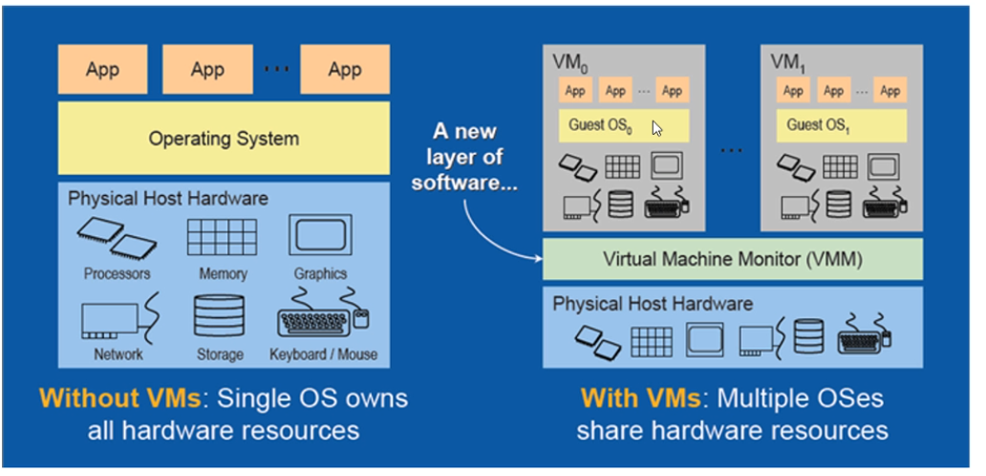

So, **isolation** of VM’s will be big advantage in VMs as we can have **Linux VM on windows O/S**. people started creating with in their organization huge no. of VMs on their data centres they created Virtualization layer. They started creating VM on this like test env and once testing is done, they destroy their VMs. All good but there is a small problem with VMs in some special circumstances. What is that problem? **The major problem with the VMs is the Guest O/S** because it will consume huge amount of memory like as we already have **Kernel** with host O/S why should the same kernel get repeated by the host O/S why can’t VM use the same Kernel by host O/S. One more problem is say like ex: if we allocate 16 GB each for 2 VMs and 1 VM require more than 16 GB and 1 may be just use 2 GB but the allocation will go waste as it is fixed memory usage. So, we want the benefit of a **single O/S** **multiple applications** with the **VM isolation** and that is how **containerization** has evolved.

VMs Vs Containers:

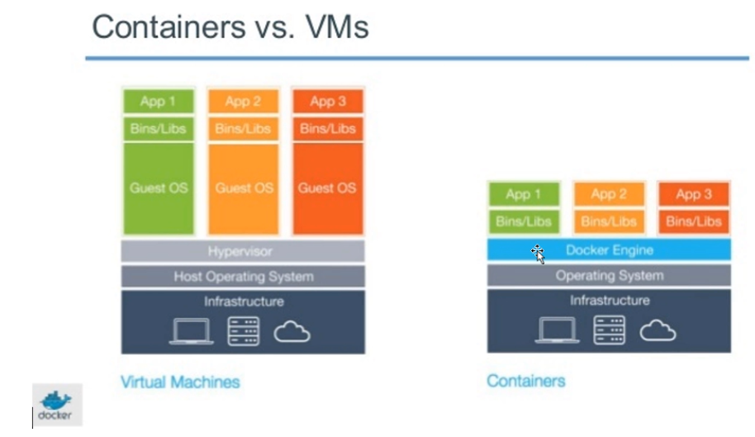

**Container = VM – O/S**

The **advantage** of containers is it **doesn’t require Guest O/S** as in VMs. It utilizes host O/S directly. This is why Containers are **light weight**. The only **disadvantage** is the container image is dependent on O/S. if we have Linux Container Image, we cannot use it in windows O/S.

Though only 1 O/S in Containers it will have its **own IP, Own N/W & own File System** for App1/Binaries Libs which will be **completely different** for App2/Binaries. So **how connection** **happens** b/w different Apps and O/S? all connect to each other using Virtual Network. You can think of a Container as separate process running on that O/S.

Containers are light weight, and they don’t need extra load of hypervisor, but run directly within the host machine’s Kernel. Which means we can run more containers than VMs. **But something is responsible for creating a n/w between these containers** something which is responsible for **assigning IPs** for these containers something which is responsible for **mapping** **file** **system** of container to host O/S and that is what is **Docker Engine** does. You can even run **Docker Containers** within host machines that are actually **Virtual** **Machines**! This is what happening in most of the companies.

So finally, what is **container**?

**Containerization** is an **approach** to s/w development in which an **application or service, its dependencies, and its configurations** are packaged together as a **container image**. Only thing you need to run this image on your machine is **Docker**. Docker is of course the **Engine** which will be responsible for converting your request from the application to the underlying host Kernel. Basically, the communication between the application containers and the O/S and hardware is thru docker. Docker will manage your containerization environment.

Placing software into Containers makes it possible for developers and IT professionals to deploy **across** **environments** with little or no modification.

So how about the **saving of data into files on containers which** will be gone if container goes down how will other container pickup/use these files as containers are isolated? For this we have to **map containers file system to O/S file system which will be persistent** where any container on that machine can use the file system. So, like this the life cycle of the **containers is managed by Docker.**

**80. Understanding Docker Architecture:**

**What is docker and what are its benefits?**

To implement containerization, we need something like Docker. Containerization with Docker is most popular than other competitors. With docker you can manage your infrastructure in the same way you manage your application.

The **Docker platform** uses the **Docker Engine** to quickly build and package apps as **Docker Images** created using files written in the **Dockerfile** format that then is deployed and run in a layered **container**.

**How does actually Docker work? Docker Architecture and its Taxonomy**?

Docker Engine is a client-server application with these major components:

* A **server** which is a type of long-running program called a **daemon** process (running continuously).
* A **REST-API** which specifies interfaces that programs can use to talk to the daemon and instruct it what to do.
* A Command Line Interface (CLI) **client** (the docker command).

Docker **client** and **daemon** can **run on the same system**, or you can **connect** a docker client **to a remote Docker daemon**. The docker client and daemon communicate using a REST API, over **sockets or a network interface**. The docker **client** can communicate with **more than one daemon**.

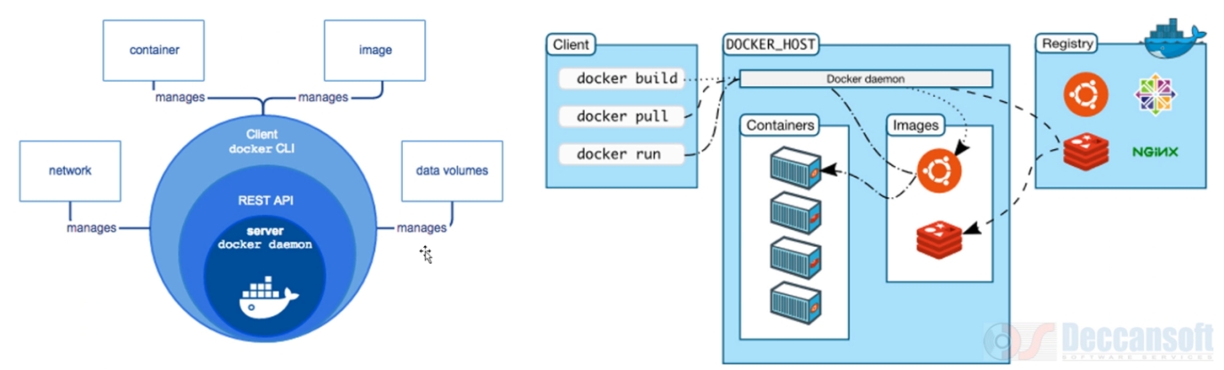

**Docker Server** will receive instructions from **Docker client (CLI).** But how does docker CLI send instructions to docker daemon? It is through **REST API.** All the CLI commands will get converted to REST API calls and reaches to server. The daemon on server will perform action based on the command. So, on docker daemon (on server) everything happening where the **Containers are created**, where the **Images are built**, where the **images are pulled**. One need to understand the 4 terms deeply to understand Docker i.e., **network**, **container**, **image**, and **data volumes**.

**Between** **different** Docker **containers** there will be **Virtual Network** created. The **Docker Engine** is **responsible** for **managing that network**.

With the help of **Images** which are built **docker engine** is **responsible for creating containers**. A container is a running instance of an Image. Your s/w will actually be **in Image**. But **to run the s/w we built a container**.

If **my s/w has to make use of the file system of underlying o/s** we want to do some kind of **persistent storage**, **then we go for data volumes**. Data volumes are responsible for **mapping** the data in docker **container** to the file system of underlying **host O/S**. docker is responsible for **pushing and pulling** an Image into and from **registry** (like Dockerhub) whenever needed. Like wise we have got **azure container registry** (which is also docker registry).

The below image is the lifecycle of an image. This can be used in pipeline where once build, it can be pushed to docker registry and also can be given to deployment into various environments with approvals & gates.

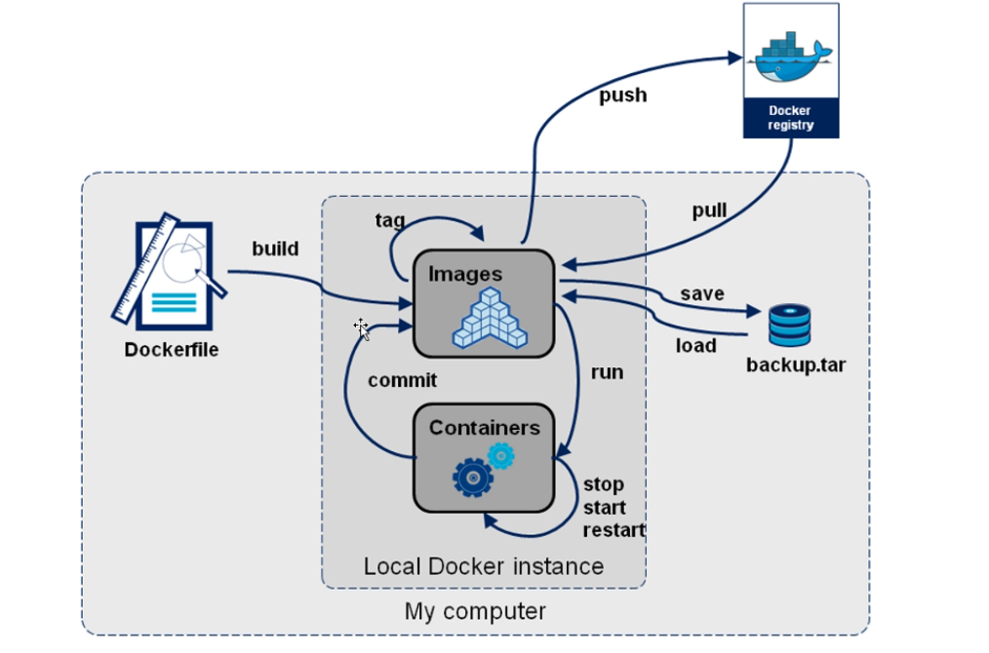

**Dockerfile**: A text file that contains **instructions for how to build a Docker image**.

**Build**: The action of building a container image based on the information and context provided by its Dockerfile as well as additional files in the folder where the image is built. You can build images by using the ***docker build*** command.

**Repository (also known as repo)**: A collection of related Docker images labelled with a tag that indicates the image version. Some repositories contain multiple variants of a specific image, such as image containing SDKs (heavier), an image containing only runtimes (lighter), and so on. Those variants can be marked with tags. A single repository can contain platform variants, such as a Linux image and a windows image. **Where are these repositories created? In Docker registry.**

**Registry**: A service that provides access to repositories. The default registry for most public images is **Docker Hub** (owned by docker as an organization). A registry usually contains multiple repositories from multiple teams. Companies often have private registries to store and manage images that they’ve created. ***Azure Container Registry*** is another example.

**81. Creating a Docker Image using Dockerfile**:

**Create an Image Manually**:

You should know the manual procedure then only you can do devops automation like dotnet ***build*** and ***publish*** ***manual steps.*** As you know you can automate similarly java and other applications.

Create new dotnet MVC project: HelloWorldApp.

Now, we need to **create a file** in our **root** directory (where we have csproj) of our project with name **dockerfile.** A file with all the instructions required by our application as below:

Dockerfile is an instruction set for creating a Docker Image and the first statement always is going to be FROM.

FROM mcr.microsoft.com/dotnet/core/sdk:3.1 as build

WORKDIR /app

# Copy csproj and restore as distinct layers

COPY *.csproj ./

RUN dotnet restore

# Copy everything else and build app

COPY . . /

WORKDIR /app

RUN dotnet publish -c Release -o out (-c 🡺 configuration Release and -o is output ./🡺 current directory)

FROM mcr.microsoft.com/dotnet/core/aspnet:3.1 as runtime

WORKDIR /app

COPY --from=build /app/out ./

ENTRYPOINT [“dotnet”, “helloworldapp.dll”]

The above code command is multistage whenever it starts with FROM

Below is docker command to build an image:

D:\dockerdemo\helloworldapp>**docker build -t bogeram/helloworldapp:v1** **pathofdockerfile[.]**

Here: **bogeram**: Dockerhub account

**Helloworldapp**: repositoryname

**v1**: tag

**-t:** tag here **tag** as bogeram/helloworldapp

**pathofdockerfile**: path where dockerfile located, if in root directory just give a **dot.**

So, when we run the docker command, the first FROM case will build, restore, and publish to out and second FROM case will copy published code to app/out folder and it marks entry point as helloworldapp.dll and dotnet.

Running the application:

D:\dockerdemo\helloworldapp>dotnet d:\out\helloworldapp.dll and enter the application will run in localhost.

Sdk is 750 MB which will be used to build, restore, and publish. But **aspnet** (this image will have **castrol** server, .net core runtime, required O/S) is enough for running the application.

How to **check** which **O/S the image** is created on. Just type command **docker version.**

When you build an image in **windows 10** there is a facility to run the image either on Linux/windows by switching as shown in below image (will be used during development):

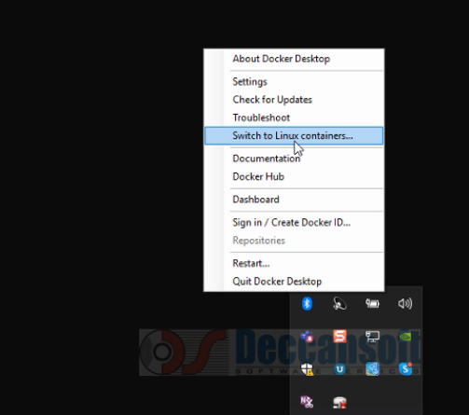

Command to check all the available images:

>docker images

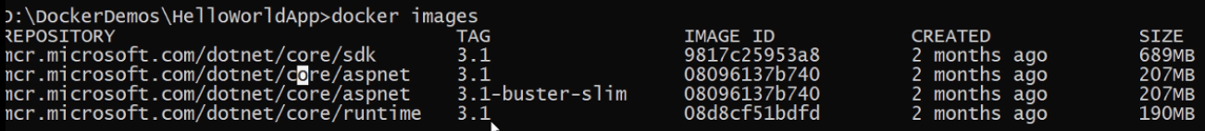

From Linux you can see the size of containers is still reduced compared to windows and the commands for Linux and windows are same.

***Note***: - Challenges faced, we need to install .net core 3.1 instead of latest because in the dockerfile we used sdk:3.1 and aspnet runtime 3.1 versions. The above code to create docker image is Linux code.

**82. Pushing Image to Docker Hub and Azure Container Registry**:

In above video we created an Image now we need to push that image into docker hub i.e., <https://hub.docker.com> . created an image log in with your credentials.

When you click on repositories tab you will find below page with no repo’s. Once we push image to docker hub then you will find your image on docker hub.

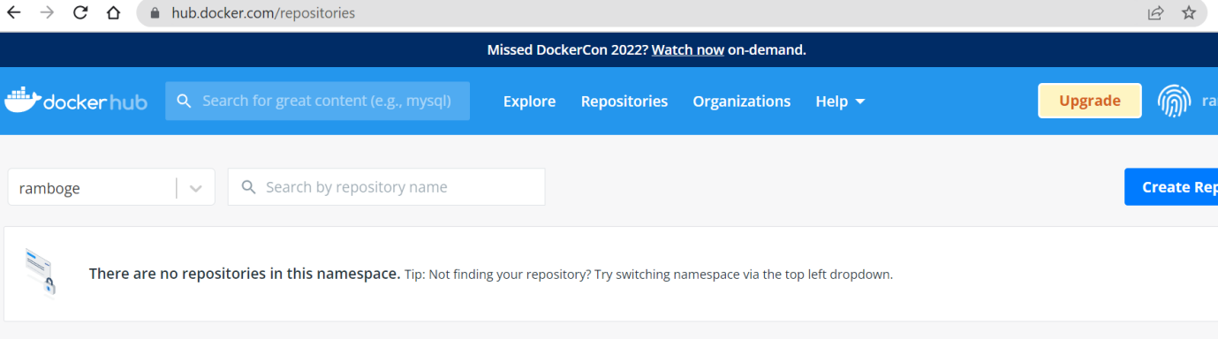

*To push a docker image into dockerhub repository*:

D:\dockerdemos\helloworldapp>**docker push ramboge/helloworldapp:v1**

Once the above code is executed we will see the image in dockerhub repository.

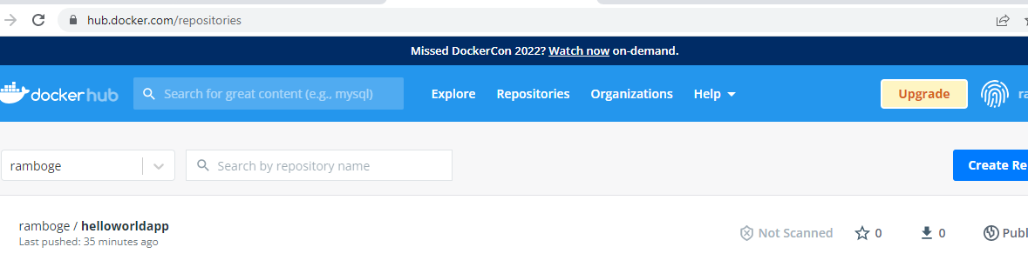

If we have given tag ‘**v1**’ while **creating** an **image** we should give tag ‘**v1**’ while **pushing** to dockerhub repository. Otherwise push will fail. Because if we don’t give tag it will try to push default tag ‘latest’ but it will not able to find it.

Command **docker version** will shown windows & Linux OS Architecture.

*To add a tag if we forgot to add*: **docker tag ramboge/helloworldapp ramboge/helloworldapp:v2**

Below same image (with same image ID) with 2 different tags can be seen.

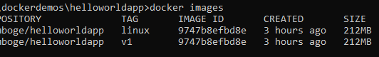

*Azure Pipeline for Build and Publish Docker Image to Docker Hub*:

Go to Azure portal, search for **container registry** and crate as shown below:

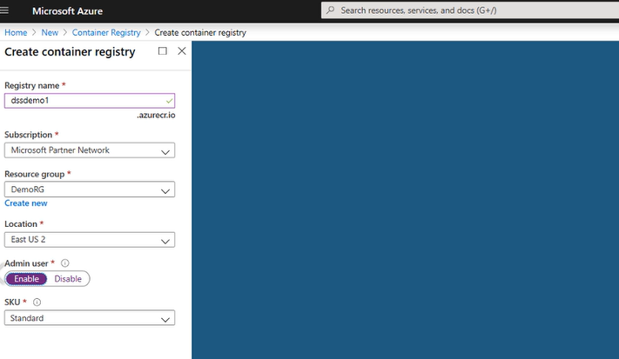

Once you create container registry the difference between docker container and azure container registry is as below:

*While pushing images to repositories:*

[**docker.io/ramboge/helloworldapp**] for dockerhub

*But for azure container registry it is:*

**Registryname.azurecr.io/ramboge/helloworldapp**

Also, for container registry we need to go into registry and get accesskey which will have password for registryname. Copy that and use to login from command prompt with username and password:

Once we push image to azure container registry it looks as below:

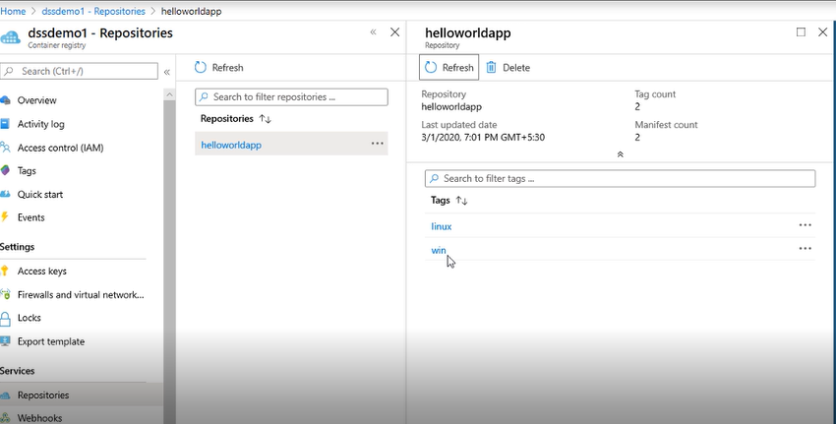

Steps copied for handout:

**Use Azure Container Registry to:**

1. Store and manage container images across all types of Azure deployments

2. Use familiar, open-source Docker command line interface (CLI) tools

3. Keep container images near deployments to reduce latency and costs

4. Simplify registry access management with Azure Active Directory

5. Maintain Windows and Linux container images in a single Docker registry

**Create Container Registry Using Portal**

**1. Create a resource** → **Containers** → **Azure Container Registry.**

2. Under **Admin user**, select **Enable**. Take note of the following values:

• Login server

• Username

• password

3. Login to ACR

docker login --**username** dssdemo --**password** X3bI/uVbrNJ8lgfLXqjDV4zQVWRJgOI1 **dssdemo.azurecr.io**

4. Tag Local Images

docker image **tag** sandeepsoni/hellowebapp:v1 dssdemo.azurecr.io/hellowebapp:v1

5. Push images to ACR

docker **push** dssdemo.azurecr.io/hellowebapp:v1

1. **Deploying Docker Images in App Service and Container Instance**:

Now we have got 2 images on dockerhub repository and 2 images on azure container registry. How to publish these to App service?

Go to portal, search app service --> create new with below details:

